Landscape scenarios to
Archived at http://orgprints.org/7985
evaluate the impact of organic farming on selected animal species.

C.J. Topping & Peter Odderskær,
Department of Wildlife Ecology & Biodiversity,
NERI,
Grenåvej 14, 8410 Rønde
Denmark

Introduction
This report is based on a presentation given to an internal seminar for the ‘Nature Quality in Organic Farming’ project in June 2004 and one given at a concluding workshop held in December 2005. It presents the final results of Task 3 ‘Modelling of consequenses of crop rotations, tillage and landscape structures on mobile organisms’ within Work Package 4 (Ecosystem diversity and function of the fields in organic farming) within the project mentioned above. The present report indicates the expected impact of organic farming for three species, a beetle (Bembidion lampros), a spider (Erigone atra) and the skylark (Alauda arvensis).
The scenarios presented here are performed on the study area of the project close to Herning. For this reason the scenarios are not those that would have been chosen from an experimental point of view to elucidate the impacts of organic farming, but represent an attempt to evaluate impacts within the Herning landscape and for the specific configuration of farms present. Likewise, the landscape itself is not an optimal landscape for the skylark since it is dominated by hedgerows and therefore in large part not suited to the skylark.
The modelling approach used is that of Topping et al (2003) and is a relatively new approach which has been previously applied to a number of impact assessments and ecological studies (Topping & Odderskær, 2004; Pertoldi & Topping, 2004; Jepsen et al , 2004). This approach allows the integration of a range of factors including the lanscape topography, farm management and climate, with the behaviour and ecology of the species modelled. In this was impacts with spatio-temporal aspects, such as most farm managements, can be integrated with the phenology and distribution of the species modelled. This allows the impacts of these factors to become an emergent property of the model resulting from the integration of space, time and impact. This provides a very sophisticated management assessment tool.
This project sought to elucidate the overall impact of organic agriculture on some key species of animal in the agricultural landscape. It does not base its results on previous studies of organic farms but on the integration of current farm practices and timings with the ecology of the species considered. In this way the scenarios presented here are independent of studies relating to biodiversity on organic farms. This is a very positive step since organic farming has undergone many changes over the last 20 years and the only thing which is certain is that it is different now than 20 years ago. Therefore old relationships between organic farming and biodiversity may no longer hold.

Methods

An extension of the ALMaSS system (Topping et al., 2003), using the beetle module (Bilde & Topping, 2004) and the spider module (Thorbek & Topping, 2004), together with a modified version of the skylark model described by Topping & Odderskær (2004) were used for these simulations. The properties of the model system are briefly described below, with the extensions described in more detail.

Model Description
The model consists of two separate but interacting models, a landscape simulation and animal models (beetle, spider and skylark). The animal models are agent-based models describing animal behaviour as a set of states linked by transitions, requiring the landscape simulation to act as a data server. The full skylark model is described by Topping & Odderskær (2004) and unless noted below the values for parameters in the model are taken from Topping & Odderskær (2004). Hence only the key differences between the agent-based model and the implementations of more traditional models are briefly described here:

- The model is spatially explicit with a spatial resolution of 1m² and a total landscape of 10 x 10 km² is modelled.
- Each vegetated landscape element is modelled separately with vegetation height, green- and total-biomass, and insect biomass sub-models, each driven by day-degree relationships.
- A landscape element may be subject to management by man. Fields, and linear habitats are managed in this way by mowing or other agricultural activities. These activities interact with the vegetation and insect models altering their values (e.g. insecticide spraying reduces insect abundance by 80% on the field where it is sprayed, insect abundance recovers back to pre-spray levels over a three-week period).
- Individual farms manage crop rotations, and all fields are assigned to farm units. Fields are managed following crop husbandry plans designed to closely simulate the real management of each crop modelled in terms of logical and temporal relationships between agricultural operations. Any agricultural activity on a field is recorded and this information is available to any skylark in the simulation. These managements include the use of normal insecticides, herbicides, fungicides and growth regulators as the default.

Specific Animal Components:
- Breeding skylarks are spatially located within the landscape and have a 250m-radius home range from which to find food. The location is dependent upon territory quality, which is expressed in terms of vegetation structure.
- Development of chicks and eggs utilises the ambient temperature and the period of time the female spends incubating to determine the development rate of the eggs. Incubation time is determined by the time required for the female to fulfil her daily energy budget, which in turn depends on food availability and accessibility within the home range of the bird. Likewise, nestling growth and survival is determined by the rate of food supply by both parents. The energy balance of the nestlings determines their growth, and birds with negative growth rates for two consecutive days are assumed to die. The time to nest leaving is determined by the size of the nestling, and hence slower developing birds will leave the nest later. Nestlings that do not reach fledging weight after 14 days are assumed to die. Fledglings follow the same rules as nestlings, but gradually become self-sufficient, finding a linearly increasing proportion of their own food daily until total independency at 30 days old.
- The spatial nature of the model permits explicit foraging behaviour to be modelled. Insect biomass is modelled explicitly for each vegetated element in the landscape, and the availability of insects is determined by the structure of the vegetation (see Model extensions below).
- Over-wintering mortality is modelled as a probabilistic mortality for the individual varying each year and being evenly distributed between 0.3 to 0.7.
- Other mortalities modelled explicitly are a daily probability of predation for all stages during the breeding season, estimated from Odderskær et al, (1997), and estimates of direct mortalities resulting from agricultural operations such as mechanical weeding.
- Beetles and spiders are simpler models driven mostly by the ambient temperature and its effects on development, and by their dispersal patterns. Agricultural operations also affect dispersal and have mortalities assciated with them as described in Thorbek & Bilde (2004).
- The key differences between the beetle and spider models used here is their dispersal capabilities. The spider is based upon Erigone atra, and is capable of dispersing over wide areas by ballooning flight. The beetle is based on Bembidion lampros and is flightless, therefore dispersal is limited to walking along the ground. The models simulate reproduction and phenology as closely as possible based on literature data.

Skylark Model Extensions

Nest location is a critical part of the skylark’s behaviour since the availability of nesting locations will determine the suitability of a territory. ALMaSS used vegetation height alone to determine nest site quality (Topping & Odderskær, 2003), however this has since been extended to use a combination of height and vegetation density to reflect the fact that skylarks can nest in relatively tall, but open crops. Hence a nest location is valid if the following logical equation holds true:

Equation 1
(0.03m<H<1.10m AND D<50) AND NOT(H<15 AND D<9) AND NOT(H>70 AND D>10) AND NOT(H>30 AND D>15)

where H is the height of the vegetation and D is B/(H+1), where B is the vegetation biomass in g dry matter m⁻²

Similarly the evaluation of an area by the male skylark for its suitability as territory also incorporates a density measure applied to vegetation between 0.03 and 1.1 m tall:

Equation 2
Territory Assessment Score = S – (1.1^{D-15} –1) + P

where S is the maximum score possible for non-patch vegetation, D is B/(H+1), where B is the vegetation biomass in g dry matter m⁻², and P is zero unless the habitat is patchy. This relationship has the property of penalising habitats with dense uniform vegetation.

D is also used in addition to height to determine the hindrance factor associated with foraging in tall dense vegetation. Vegetation is assumed totally accessible if less than 30cm tall and with a D or 15 or less, above this the hindrance factor is calculated as 114.3D^{-1.75}, where D is calculated as for eq.1. This function rapidly decreases accessibility for vegetation with a D above 15. The hindrance factor calculated in this way is multiplied by the insect food biomass present at that location to determine the effective available biomass for the skylark.

There are a number of other constraints to nest location, also present in the original model. These are that the nest may not be within 50m of very tall structures (>3m), and must be inside the territory (not the home range). The search pattern determining the placement of the nest is a spiral search pattern starting at the centre of the territory and spiralling outwards. Hence, if suitable nest locations occur closer to the territory centre they will be selected over those in the periphery.

It should also be remembered that this selection will be time-specific. This is because the vegetation structure is changing on a daily basis, hence what would be a viable selection in May (e.g. in winter wheat), may no longer be viable in June. In this way the breeding window of Schläpfer (1988) is explicitly incorporated in the model.

Landscape and Farm Definitions
The main scenarios were run on a detailed 10 x 10 km landscape map from central Jutland, near Herning (NW corner, UTM zone 32: 487000, 6236500) Fig. 1A), whilst some comparative scenarios were also run on a separate landscape (NW corner, UTM zone 32: 536987, 6251063) from near Bjerringbro. For each scenario conducted, ten replicate runs of 55 years duration were run. In all cases the scenarios utilised the same historical weather pattern from the landscape from 1989-2000, which was looped five times to provide 55 years of weather.
A)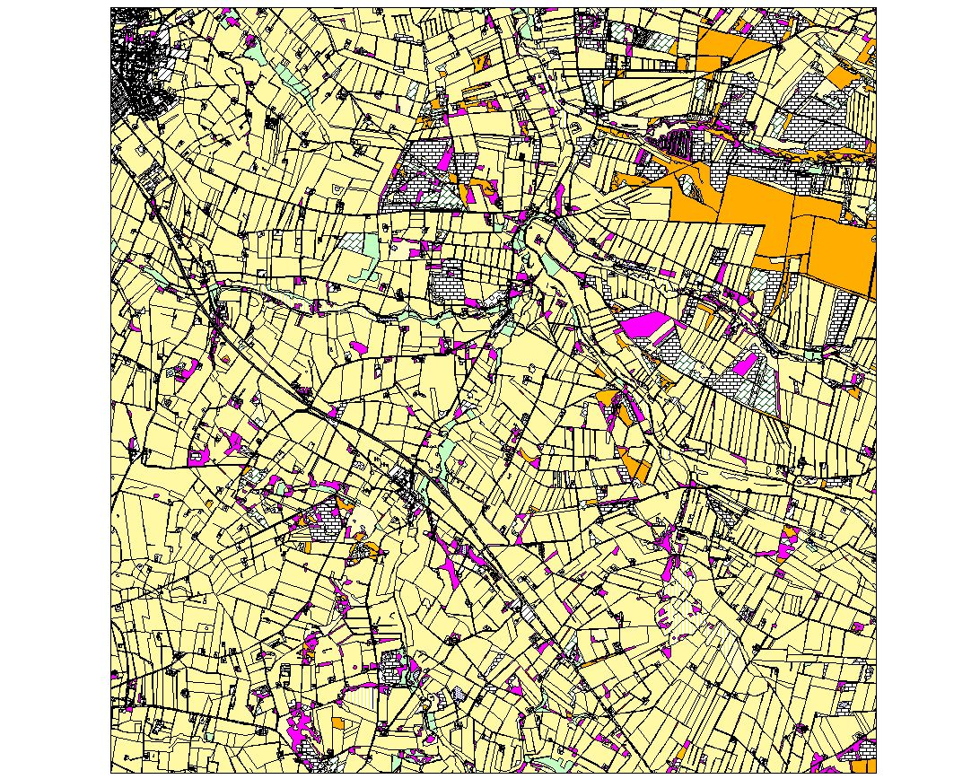
B)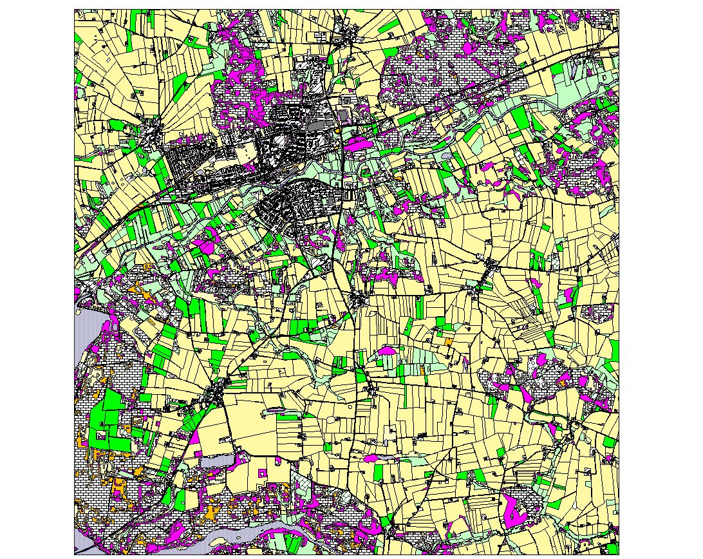
Figure 1 A) The main scenario landscape close to Herning. B) An alternative landscape, close to Bjerringbro used for comparative simulations

Of key interest in these scenarios was the impact of those organic farms that were already found within the Herning landscape. Their location is represented by the white fields drawn in Fig. 2. Due to technical limitations and the fact that these fields were so widely distributed it was not possible to consider only the organic fields themselves, hence a buffer area was defined around the organic areas which was analysed separately in the scenario results (Fig. 2).
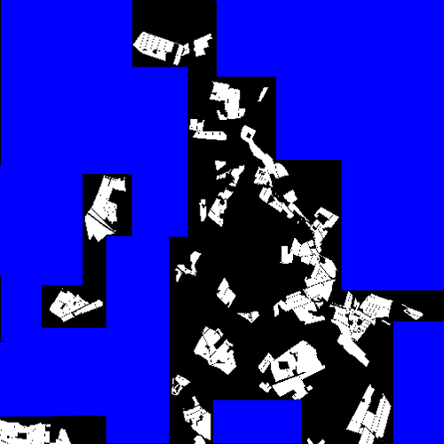
Figure 2: The pattern of existing organic fields in the Herning landscape. The black area is the buffer area analysed as being ‘organically influenced’, the blue is considered to be ‘conventionally influenced’.

The organic farms were classified in collaboration with subproject ‘Localisation, diversification and extensification in organic farming’ (Work Package 2, Cross Cutting 7) into five farm classes with varying proportions of the organic area represented by each class. The conventional farms were also divided into classes, in this case three representing dairy, pig and arable farms (Table 1).

Table 1 : The classification of farm types in the Herning landscape and the percentage area covered by each.
Farm Type | Percentage Area Covered
Conventional
Conventional Dairy | 45%
Conventional Arable | 10%
Conventional Pig | 45%
Organic
Organic Dairy Simple | 28%
Organic Dairy Diverse | 50%
Organic Beef | 3%
Organic Mixed | 9%
Organic Pig | 10%
Where organic farms already existed in the landscape, those farms were allotted the correct farm type based on information from Task 4 (Production, diversity and nature practice on existing farms) in the subproject mentioned above. In scenarios which compared effects of changing from conventional to organic farming, the farm types were applied pro rata to obtain the correct proportion of area covered by each farm type. In all cases no attempt was made to allocate conventional farm types realistically; these were always allocated on a pro rata basis.

It was necessary to define a rotation for each farm type which simulates the changes of crops grown from year to year on a particular field, but at the same time creates the correct mean area covered for each crop type. These rotations were defined in conjunction with WP2 and within the limitations of the crops that were already available in ALMaSS. A final rotation was also defined intended to represent an attempt to define a ‘nature friendly’ rotation. This farm type is given the designation ‘Nature’. These rotations are listed in Tables 2-4.

Table 2. Crop rotations for the organic beef, and dairy farms.
Key to crops: OBarleyPeaCloverGrass – Organic barley undersown with peas, clover and grass; OCloverGrassGrazed1 & 2 – Organic grass and clover sward, grazed and for silage, 1st and 2nd year; OSpringBarley – organic spring barley; OFieldPeas – organic field peas; OOats – organic oats; OWinterWheatUndersown – Organic winter wheat undersown with grass; OWinterRye – organic winter rye; Setaside – unsown setaside;

Organic Beef

Organic Dairy Diverse

Organic Dairy Simple

OBarleyPeaCloverGrass
OCloverGrassGrazed1
OCloverGrassGrazed2
OSpringBarley
OFieldPeas
OOats
OWinterWheatUndersown
OWinterWheatUndersown
OSpringBarley
OOats
OWinterRye
OWinterWheatUndersown

OPotatoes
OBarleyPeaCloverGrass
OCloverGrassGrazed1
OCloverGrassGrazed2
OCloverGrassGrazed2
OBarleyPeaCloverGrass
OCloverGrassGrazed1
OCloverGrassGrazed2
OCloverGrassGrazed2
Setaside
OWinterRye
OOats

OBarleyPeaCloverGrass
OCloverGrassGrazed1
OCloverGrassGrazed2
OCloverGrassGrazed2
OBarleyPeaCloverGrass
OCloverGrassGrazed1
OCloverGrassGrazed2
OCloverGrassGrazed2
OBarleyPeaCloverGrass
OCloverGrassGrazed1
OCloverGrassGrazed2
Setaside

Table 3. Crop rotations for mixed organic, organic pig, and 'Nature' farms.
Key to crops: OBarleyPeaCloverGrass – Organic barley undersown with peas, clover and grass; OCloverGrassGrazed1 & 2 – Organic grass and clover sward, grazed and for silage, 1st and 2nd year; OSpringBarley – organic spring barley; OFieldPeas – organic field peas; OOats – organic oats; OWinterWheatUndersown – Organic winter wheat undersown with grass; OWinterRye – organic winter rye; Setaside – unsown setaside; Ocarrots – organic carrots; OGrazingPigs – outdoor pigs;

Organic Mixed

Organic Pig

Nature

OBarleyPeaCloverGrass
OCloverGrassGrazed1
OCloverGrassGrazed2
OWinterRye
OFieldPeas
OWinterWheatUndersown
OBarleyPeaCloverGrass
OCloverGrassGrazed1
OCloverGrassGrazed2
OOats
OFieldPeas
OWinterWheatUndersown
OBarleyPeaCloverGrass
OCloverGrassGrazed1
OCloverGrassGrazed2
OSpringBarley
OFieldPeas
OWinterWheatUndersown
OBarleyPeaCloverGrass
OCloverGrassGrazed1
OCloverGrassGrazed2
OWinterBarley
OFieldPeas
OWinterWheatUndersown
Setaside

OWinterBarley
OGrazingPigs
OCarrots
OBarleyPeaCloverGrass
OGrazingPigs
Setaside
OWinterRye
OOats
OWinterWheatUndersown
OGrazingPigs
Setaside
OSpringBarley

OBarleyPeaCloverGrass
OCloverGrassGrazed1
OCloverGrassGrazed2
OWinterRye
OOats
OSpringBarley
Setaside
OOats
OWinterBarley
OFieldPeas
OWinterRye
Setaside
OFieldPeas

Table 4. Crop rotations for the three conventional farm types.
Key to crops: CloverGrassGrazed1 & 2 – grass and clover sward, grazed and for silage, 1st and 2nd year; SpringBarley –spring barley; SpringBarleyCloverGrass –spring barley undersown with clover grass, for conventional pig farmers these are used for green manure; SpringBarleySeed – spring barley harvested for seed; SpringBarleySilage – spring barley harvested for silage; FieldPeas – field peas; Maize – maize; WinterWheat – winter wheat undersown with grass; WinterBarley – winter barley; WinterRye –winter rye; Setaside – unsown setaside; WinterRape – winter oilseed rape; SeedGrass 1 & 2 – first and second year seed grass sward; Potatoes – potatoes for eating or industry.

Conventional Dairy

Conventional Pig

Conventional Arable
SpringBarleyCloverGrass
CloverGrassGrazed1
CloverGrassGrazed2
Maize
SpringBarleySilage
FodderBeet
SpringBarley
Setaside
SpringBarleyCloverGrass
CloverGrassGrazed1
CloverGrassGrazed2
Maize
Setaside
SpringBarleySilage
Maize
SpringBarleySilage
Maize
SpringBarleySilage
SpringBarleyCloverGrass
SpringBarleySilage
Maize

WinterBarley
WinterRape
SpringBarleyCloverGrass
WinterWheat
SpringBarley
WinterRye
SpringBarley
FieldPeas
WinterWheat
SpringBarleyCloverGrass
Setaside
SpringBarleyCloverGrass
WinterBarley
WinterRape
WinterWheat
WinterBarley
SpringBarley
WinterRye
WinterWheat
SpringBarleySeed
SeedGrass1
SeedGrass2
SpringBarley
WinterWheat
SpringBarley
Setaside
SpringBarleyCloverGrass
Setaside
SpringBarleyCloverGrass
SpringBarley

WinterRape
WinterBarley
SpringBarleySeed
SeedGrass1
SpringBarley
WinterRye
WinterWheat
SpringBarley
WinterWheat
SpringBarleySeed
SeedGrass1
Setaside
SpringBarleySeed
SpringBarley
FieldPeas
WinterWheat
SpringBarleySeed
Potatoes
SpringBarleySeed
Setaside
WinterBarley
WinterRape
WinterRye
SpringBarleySeed
Triticale
SpringBarley
WinterWheat
Potatoes
SpringBarleySeed
SpringBarleySeed
Setaside
WinterBarley
SpringBarleySeed
WinterWheat
Potatoes
SpringBarleySeed

Scenario Definition
Two main assumptions were made in the development of these scenarios. The first is that organic crop biomass and density is approximately 10% lower than the conventional counterpart. The second assumption is that the crop structure is uniform between farms. This means that within the model farms with weedy crops do not exist, all farmers behave as they ought to according to the farming advisory services, and it assumed this means relatively weed free and dense crops.

Seven main scenarios were defined and run on the Herning landscape. These being:

(0) Conventional – whole landscape is conventional, including those farms now organic.
(1a) Oko12 – As above, but the current organic farm types are used, 18 farms are organic as in the real landscape, and cover 12% of the farmed area.
(2a) Oko100 – all farms are organic, using the same proportion of each farm type as in the real landscape.
(1b) Oko12Ext & (2b) Oko100Ext – As Oko12 & Oko100, but with exensification* of the organic farms.
(3a) Nature12, (3b) Nature100 – as Oko12 & Oko100 but with all organic farms following the ‘Nature’ rotation and extensive management*.

*Extensive management was defined as a 50% reduction in mechanical weeding, grazing intensity and watering.

In addition to the main scenarios a set of simulations was run comparing landscapes with 100% of each farm type for the skylark. A further simulation was run on the Bjerringbro landscape comparing 100% organic farming (2a) between the two landscapes for the skylark alone.

In all cases the results of the simulations were total population size for the landscape as a whole, and for the area considered to be ‘organically influenced’.

In addition to this statistic the total number of surviving fledglings coming from each habitat type was determined and standardised by division by the total area of habitat. In this way a measure of habitat productivity was achieved.

Results
The main scenarios indicated that organic farming was generally positive for all species although the beetles and spiders were considered to benefit more than the skylark (Table 5).

Table 5: Predicted population sizes relative to the '0' conventional scenario for the three species modelled. Organic represents the population size in the organically influenced area, total is the population size in the whole lanscape.
 | Beetle |  | Spider |  | Skylark
 | Organic | Total | Organic | Total | Organic | Total
Conv | NA | NA | NA | NA | NA | NA
Oko12 | 1.12 | 1.06 | 1.16 | 1.10 | 1.10 | 1.01
Oko100 | 1.40 | 1.32 | 1.53 | 1.44 | 1.09 | 1.09
Oko12Ext | 1.27 | 1.21 | 1.32 | 1.16 | 1.10 | 1.03
Oko100Ext | 1.40 | 1.33 | 2.25 | 2.05 | 1.12 | 1.11
OkoNat12 | 1.02 | 1.01 | 1.07 | 1.06 | 1.13 | 0.99
OkoNat100 | 1.26 | 1.23 | 1.17 | 1.14 | 1.12 | 1.12

The responses of the three species were always in the same general direction but differed in details. The spider responded most strongly to the standard organic farm types, but the beetle showed a much stronger response to the ‘Nature’ type. The skylark’s response was the lowest of the three in all cases. One interesting feature of the results was that in the case of Oko100, Oko110Ext and OkoNat100, the increase in the total landscape was smaller than the proportional increase in the organic areas. This is however, explained by the fact that the total landscape also had areas not affected by farming, where populations would not expected to be affected (e.g. heathland).

The extensive and Nature farm management was originally intended to benefit the skylark, but although beneficial to this species it was the beetle and spider which seemed to benefit most.

The results of the individual farm type scenarios for skylarks are shown in Table 6. Although only a single replicate of each scenario was run, and therefore the figures can only be used as a guide, it is clear that the different farm types have different impacts on the skylark. Relative to conventional arable, some organic types are detrimental others positive. The overall effect of the main scenarios will therefore depend on the balance of these types within the landscape and any interactions between them.

Table 6: The population size change for skylarks with different farm types relative to conventional arable farm type
Rotation | Pop. Size Relative to Conv. Arable
Øko Dairy Simple | 1%
Øko Dairy Diverse | -2%
ØkoNat | 18%
Øko Beef | 6%
Øko Pig | -14%
Øko Mixed | 12%
Conv Pig | -2%
Conv Dairy | -5%
Conv Arable | NA

Table 7 shows the relative number of fledglings produced from each habitat in the Herning landscape. The comparative scenario performed using the Bjerringbro landscape resulted in the same kind of distribution of habitat productivity, but in this landscape the figures were increased by 60-70%. This is an indication that the structure of the Herning landscape is not conducive to large lark populations, which is due to the abundance of hedgerows in this landscape.
Those crops with low skylark productivity are mostly tall or intensively managed crops, high productivity habitats are organic cereals and conventional spring crops and setaside. Natural grass is a category of unmanaged grass and scores very low, but this is an artefact of the fact that most ‘natural grass’ is found along hedgerows, roads and other narrow features which are not used for skylark nests.

Table 7: The fledgling output per unit area for all crops from the main scenarios. The figures presented are arbitrarily chose to be representative for those scenarios where that crop occured in large areas. Red 0-1.15, black, 0.16-0.34, blue 0.35+.
Crop
Standard Scores
Crop
Standard Scores
CloverGrassGrazed1
0.23
OWinterRye
0.16
CloverGrassGrazed2
0.31
OWinterWheatUndersown
0.42
FieldPeas
0.16
PermanentGrassGrazed
0.24
FodderBeet
0.11
PotatoesEat
0.15
Maize
0.00
SeedGrass1
0.32
NaturalGrass
0.05
SeedGrass2
0.32
OBarleyPeaCloverGrass
0.40
Setaside
0.48
OCarrots
0.00
SpringBarley
0.34
OCloverGrassGrazed1
0.24
SprBarleyCloverGrass
0.35
OCloverGrassGrazed2
0.29
SpringBarleySeed
0.35
OFieldPeas
0.15
SpringBarleySilage
0.36
OGrazingPigs
0.01
Triticale
0.03
OOats
0.42
WinterBarley
0.20
OPotatoesEat
0.05
WinterRape
0.00
OSpringBarley
0.54
WinterRye
0.31
OWinterBarley
0.20
WinterWheat
0.19

Discussion
Essential to the intepretation of these scenarios for the skylark is the fact that the assumptions concerning the crop structure were that the organic farms have a more open crop, but that they are well managed and not invested with weeds. The precise phenology of the crops grown will determine a window for breeding of the skylarks (Schläpfer, 1988), whilst the structure of the crop will determine access to food and the amount of food available (Wilson et al, 1997). Therefore if the majority of organic farms had more weedy and open crops than expected under modern organic farm management, then the results of these scenarios would be altered in favour of organic farms.
Another interesting result from the skylark simulation concerns the benefit of mixing farm types. It is clear from the single farm type scenarios that the Nature farm type gave an 18% increase compared to the conventional arable type, but only a 12% increase in the main scenario when compared to the mixture of three types. This is odd because the other two conventional types are less advantageous than the arable type. The reason is that by having three types in the landscape the whole landscape is more heterogenous, giving a benefit to larks trying to find a place to forage. In an homogenous landscape there will always be periods where forage or nesting are prohibited by the crop phenology or farm management. By mixing even poor farm types a beneficial effect of heterogenous management can be achieved.
For the beetles and spiders the question which might be asked is why the organic scenarios are not more beneficial if no pesticides are used. The answer to this lies in the fact that other agricultural managements, especially soil tillage, are detrimental to these species causing direct mortality as well as disturbance of the habitat. Fig. 3 shows this process in action as the open areas where beetles are not present are the result of autumn or spring agricultural operations.
Given the previously held assumption that organic farming is always better than conventional farming, there is a need to determine to what extent this is true. For the skylark the critical factor is the structure of the crop and hence if organic farmers were to be as efficient as conventional farmers at growing dense high-yielding crops, then it would be hard to imagine much positive benefit from organic farms for this species. Similarly if soil tillage is more prevalent in organic farming, then beetle and spiders will also suffer. There is therefore a need to evaluate the farming practices of current organic farms as well as resulting crop structures so that a realistic estimate of the impact of organic farming could be achieved. There is a further need to explicitly evaluate components of the system, e.g. mechanical weeding, or specific crops, in this way a much more comprehensive view of the likely impacts of future changes could be developed. In addition, as the poor showing of the ‘Nature’ farm type indicates, the task of developing a more nature friendly farm type would be facilitated by this kind of detailed analysis.
Figure 3 : A screen shot of a beetle simulation running. The red dots represent the positions of the beetles on 18 May in year 14.

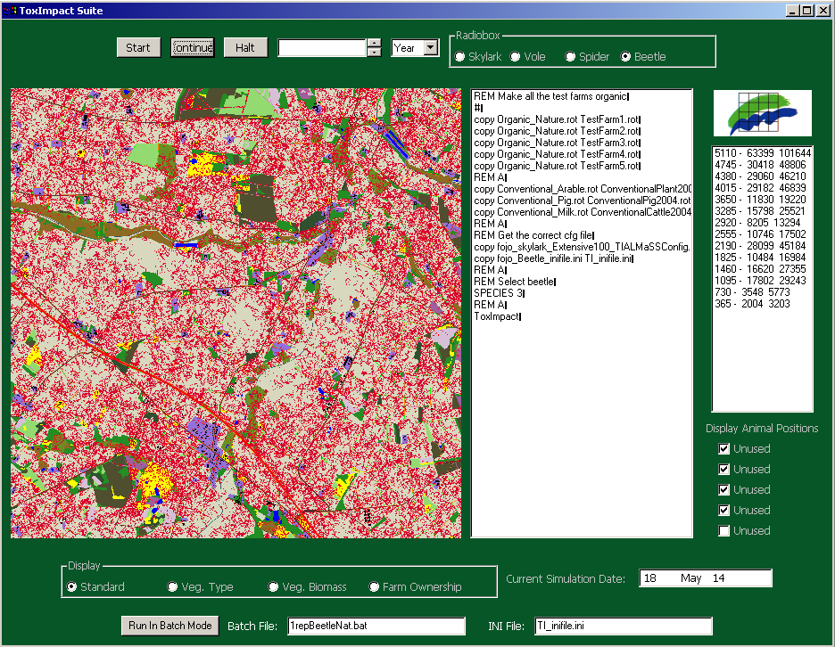

In general these scenarios suggest a general benefit of organic farming to the three species evaluated here. However, note that if all organic farms were pig farms there would be a considerable disbenefit. Therefore the fact that organic farming in 100% of the Herning landscape gave rise to a predicted 9-120% increase in these species should not be taken as an indication of what would happen on a national level. In order to assess this a more representative landscape would be needed, as well as statistics on the national distribution of organic farm types.

Conclusions
Organic scenarios indicated that organic farming was beneficial for all species considered. However, the impact varied depending upon the crops grown.
The impact of the current organic farms on the landscape as a whole was measurable, but not large
100% organic farming led to a 9-120% increase in numbers depending on species given the rotation schemes and proportion of farm types present in the Herning study area.
Extensification of management had clear beneficial impacts on spiders and skylarks, but not beetles.
The ‘nature’ rotation was better for skylarks, but although better than conventional agriculture, inferior to the standard organic rotations for beetles and spiders.

References
Bilde T. and Topping, C.J. 2004. Life-history traits interact with landscape composition to influence population dynamics of a terrestrial arthropod: a simulation study. EcoScience 11(1): 64-73
Jepsen, J.U., Topping, C.J., Odderskær, P. and Andersen, P.N. 2004. Evaluating consequences of land-use strategies on wildlife populations using multiple species predictive scenarios. Agriculture Ecosystems & Environment. (in press)
Odderskær, P., Prang, A., Poulsen, J.G., Elmergaard, N., Andersen, P.N. 1997. Skylark reproduction in pesticide treated and untreated fields. Pesticide Research 32. Ministry of Environment and Energy, Copenhagen, Denmark.
Pertoldi, C. & Topping, C.J. 2004. The use of Agent-based modelling of genetics in conservation genetics studies. Journal of Nature Conservation (in press).
Schläpfer, A. 1988. Populationsokologie der Feldlerche Alauda arvensis in der intensive genutzten Agrarlandschaft. Ornithologische Beobachter 85: 309-371.
Thorbek, P. & Topping, C.J. 2004. The influence of landscape diversity and heterogeneity on spatial dynamics of agrobiont linyphiid spiders: an individual-based model. BioControl in press.
Thorbek, P. and T. Bilde. Declines of generalist arthropod predators due to mortality, emigration, or habitat disruption after tillage and grass cutting. J. App. Ecol., 41: 526-538.
Topping C.J. & Odderskær, P. 2004. Modeling the influence of temporal and spatial factors on the assessment of impacts of pesticides on skylarks. Environmental Toxicology & Chemistry 23, 509-520.
Topping C.J., Hansen, T.S., Jensen, T.S., Jepsen, J.U., Nikolajsen, F. and Odderskær, P. 2003. ALMaSS, an agent-based model for animals in temperate European landscapes. Ecological Modelling 167: 65-82.
Wilson, J.D., Evens, J. Browne, J. King, J.R. 1997. Territory distribution and breeding success of skylarks Alauda arvensis on organic and intensive farmland in southern England. Journal of Applied Ecology, 34: 1462-1478.

