Phytochemicals under organic and low input crop production systems – Potential influences on health and nutrition in humans and animals

R.N. Bennett and E.A.S. Rosa

Abstract – Phytochemicals (plant secondary metabolites) have received considerable interest in the last three decades in relation to their biosynthetic regulation in plants and also their health effects in animals and humans. There is increasing evidence from epidemiological data, from in vitro cell studies, and from animal and human intervention studies that certain phytochemicals can significantly affect nutrition and health. Some of these effects are positive (e.g. reductions in the risk of developing cancers, coronary heart disease and immune dysfunctions) whereas others can be negative (e.g. toxic non-protein amino acids and pro-carcinogenic furanocoumarins). Levels of phytochemicals and other plant defence compounds are modulated by many genotype-independent factors such as light, water, CO₂, oxygen and ozone, nutrient supply, pesticides, levels of diseases and herbivore damage. Therefore different production methods for crops (conventional, low input and organic) have the potential to significantly affect the levels of the phytochemicals in the crops, and subsequently affect health and nutrition in the consumers.

Introduction
Globally humans cultivate and consume a very large number of plant species from diverse plant families. Plants are used as major dietary crops, for oil production, as herbs and spices, as sources of medicinal compounds, and also as animal feed (Nigg and Seigler, 1992). Crop species are cultivated using organic, low input and conventional farming practices.
Plant foods are physically and chemically complex. They contain primary metabolites (amino acids, proteins, sugars, polysaccharides, fatty acids, lipids, waxes, nucleic acids [DNA and RNA]), vitamins, minerals and phytochemicals (plant secondary metabolites). The term phytochemical is used to define a wide range of compounds with incredibly diverse chemical structures; examples of some of the major classes include terpenoids (e.g. limonene in Citrus species), alkaloids (e.g. piperine in black pepper), glucosinolates (e.g. progoitrin in Brassica species), phenolics (e.g. chlorogenic acids in plums and coffee; furanocoumarins in celery), stilbenes (e.g. resveratrol in grapes, wine and peanuts), flavonoids (e.g. rutin in many food plants) and non-protein amino acids (e.g. S-methyl-cysteine sulfoxide in Allium and Brassica species) (Bennett and Wallsgrove, 1994; Wink, 1999a and 1999b).
There is extensive data on the positive health effects of primary metabolites, vitamins and minerals. But in the last three decades there has also been considerable research done on phytochemicals and their health effects (both positive and negative) (D´Mello, Duffus and Duffus, 1991; Watson, 1998; Raskin et al., 2002, Ferguson, Philpot and Karunasinghe, 2004).
It must always be remembered that plant foods are consumed as ´whole foods` and not individual compounds i.e. a mixture of primary metabolites and phytochemicals. It is therefore the balance of plant compounds that create the overall health effects upon consumption. Therefore subtle changes in the concentrations of various phytochemicals could have large effects on health. It is also clear that consumption of bioactive plant compounds as part of whole foods is generally much more effective than as “pills” (Shoji and Nakashima, 2004). Various strategies are being developed (e.g. use of wild species) to improve the composition of food plants so that health effects are optimised (Grusak and DellaPenna, 1999).

Role of phytochemicals in the plant
Phytochemicals are primarily involved in various stress and defence responses in plants. This includes inhibition and toxic effects against plant pathogenic bacteria and fungi (phytoalexins) and formation of physical barriers to infection (e.g. lignin) (Bennett and Wallsgrove, 1994; Wink, 1999b). They can act as germination inhibitors of seeds of competing plants (allelopathic chemicals). They are insect deterrents (pheromone blockers, inhibitors of insect digestion and directly toxic to insect larvae and adult insects). Some are important attractants for pollinating insects (Wink, 1999b). They are involved in plant antioxidant mechanisms preventing damage by oxygen-generated free radicals and ozone. They are involved in symbiotic associations formed between N-fixing bacteria (nodule-forming bacteria) and mycorrhizal fungi; associations that improve nutrient uptake and assimilation (Vierheilig and Piche, 2002; Gonzalez and Marketon, 2003).

The importance of primary metabolite pools
The biosynthesis of phytochemicals is often complex involving many steps. However, in all cases their precursors are primary metabolites e.g. products of photosynthesis (sugars and organic acids) and amino acids. These precursors exist in “pools”. The size of these pools can be influenced by genotype (the genetic background of the plant) and also by external factors (Figure 1).

Non-genotype environmental factors that can affect phytochemical levels
There are many different factors that modulate levels of phytochemicals in plants. These factors can lead to increases or deceases in primary metabolites and thus phytochemical content, and subsequently affect plant growth and crop yields (Figure 1). Sadly, in the modern world, we can now also add synthetic chemical pollutants (organic chemicals) and heavy metals (e.g. cadmium, lead, and mercury) as additional modulators of phytochemicals.

Crop production methods: current knowledge on how they affect phtyochemical levels
Based on the various factors that can affect phytochemical levels and profiles it is obvious that differences in cultivation conditions will have effects. Conventionally-grown crops live a life of “luxury” receiving both high nutrient inputs and chemical control of pests and diseases, whereas organically-grown crops receive nutrients through potentially slower but more natural processes and control of pests and diseases is done via non-chemical processes (e.g. biocontrol). In the case of conventional production there are clearly major negative effects due to pesticide residues in the crops and also problems with nitrate leaching into water supplies. In the case of organically-grown crops there could be a higher level of stress (due to increased pest and disease damage) and therefore a higher level of certain phytochemicals. It is clear that further research is needed to determine the pros and cons of the different production methods in relation to animal and human health and nutrition.

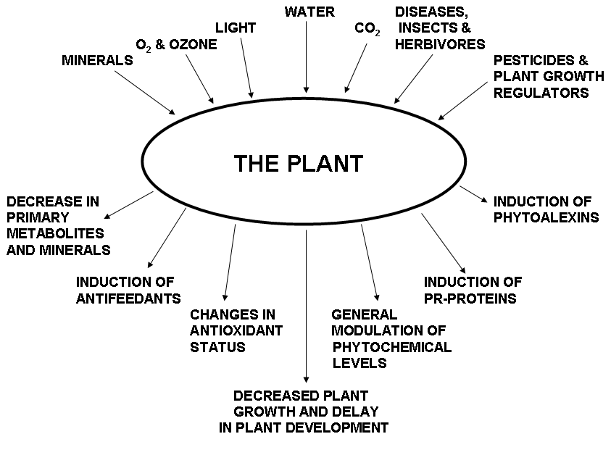
Figure 1. Examples of non-genotype environmental factors and their subsequent stress effects on plant metabolism.
Conclusions
Various non-genotype external factors can significantly affect the levels and profiles of phytochemicals in plants and thus affect health and nutrition in animals and humans. In some cases elevated levels of phytochemicals would benefit human health (e.g. higher levels of anti-cancer compounds) but in other cases there could be negative health effects (e.g. induction of toxic non-protein amino acids and procarcinogenic furanocoumarins). Phytochemicals are also characteristic flavour and odour compounds, therefore changes in phytochemical levels and profiles can affect flavour and palatability.

Acknowledgement
We gratefully acknowledge the financial support from the Portuguese Foundation of Science and Technology (RNB and EASR) and from the European Community for the Integrated Project QUALITYLOWINPUTFOOD,FP6-FOOD-CT-2003- 506358. (RNB).
References
Bennett, R.N., and Wallsgrove, R.M. (1994). New Phytologist (Tansley Review No. 72) 127:617-633.

D´Mello, J.P.F., Duffus, C.M., and Duffus, J.H. (1991). In “Toxic Substances in Crop Plants”, eds. J.P.F.D´Mello, C.M. Duffus, and J.H. Duffus (The Royal Society of Chemistry, Cambridge, UK).

Ferguson, L.R., Philpott, M., and Karunasinghe, N. (2004). Toxicology 198:147-159

Gonzalez, J.E., and Marketon, M.M. (2003). Microbiology and Molecular Biology Reviews 67:574-592

Grusak, M.A., and DellaPenna, D. (1999). Annual Reviews in Plant Physiology 50:133-161.

Nigg, H.N. and Seigler, D. (1992). In "Phytochemical Resources for Medicine and Agriculture", eds H.N. Nigg and D. Seigler. (Plenum Press, New York).

Raskin, I., Ribnicky, D.M., Komamytsky, S., Ilic, N., Poulev, A., Borisjuk, N., Brinker, A., Moreno, D.A., Ripoll, C., Yakoby, N., O´Neal, J.M., Cornwell, T., Pastor, I., and Fridlender, B. (2002). Trends in Biotechnology 20:522-531.

Shoji, Y., and Nakashima, H. (2004). Journal of Drug Targets 12:385-391

Vierheilig, H., and Piche, Y. (2002). Advances in Experimental and Medical Biology 505:23-39.

Watson, D.H. (1998). In “Natural Toxicants in Food”, ed. D.H. Watson (CRC Press, Sheffield, UK)

Wink, M. (1999a). In “Biochemistry of Plant Secondary Metabolites” (Annual Plant Reviews Vol. 2), ed. M. Wink (CRC Press, Sheffield, UK)

Wink, M. (1999b). In “Functions of Plant Secondary Metabolites and Their Exploitation in Biotechnology” (Annual Plant Reviews Vol. 3), ed. M. Wink (CRC Press, Sheffield, UK).

R.N. Bennett is with CECEA, Universidade de Trás-os-Montes e Alto Douro (UTAD), Vila Real, Portugal (rnbennett@utad.pt). E.A.S. Rosa is with CECEA, Universidade de Trás-os-Montes e Alto Douro (UTAD), Vila Real, Portugal (erosa@utad.pt).

