Systems for testing the efficacy of

biofungicides and resistance inducers against grapevine downy mildew

(REPCO project)

Schweikert, C., Mildner, M., Vollrath, C. , Kassemeyer, H.-H.

Abstract –At present grapevine downy mildew is controlled by fungicides mostly not suitable for organic viticulture. The aim of REPCO (Replacement of Copper Fungicides in Organic Production if Grapevine and Apple in Europe) is to find new copper replacing products. Also the activation of the innate defence response by resistance inducers is a potential approach for the biological control of grapevine downy mildew in organic viticulture. The efficacy of potential biofungicides and resistance inducers against grapevine downy mildew was tested on leaf discs and on cell suspension culture, respectively. In a first step the direct effect on the pathogen is assessed in a leaf disc test. The activation of defence response is determined in a cell suspension culture. Molecules from microbes, products from the secondary plant metabolism and oligosaccharides from animals and plants showed an efficacy against the pathogen and induced resistance response.

Introduction
Grapevine downy mildew is the most important disease in the European viticulture. In organic viticulture copper is used to control the disease. Permanent applications lead to an accumulation of copper in the soil. The objective of the REPCO project is to replace copper by biofungicides and resistance inducers.
Plants are able to defend themselves against the attack of fungi, oomycetes and bacteria with a set of defence mechanisms. This innate resistance is induced by elicitors from the surface of the pathogens and by breakdown products of the plant’s cell wall. These elicitors comprise oligosaccharides, peptides and lipids. In grapevine pathogens such as downy mildew induce hypersensitive response (HR) and an oxidative burst, biosynthesis of phytoalexines, expression of pathogenesis related proteins (PRPs) and cell wall reinforcement (Busam et al. 1997a, b, Seibicke 2002). The application of elicitors on leaf discs and cell suspension culture of grapevine can also induce the resistance responses described above (Jänich, 2003).
Test systems have been established to assess the efficacy of substances on the control of grapevine downy mildew. In a leaf disc test the direct effect of potential resistance inducers is assessed. To measure the activation of defence response such as oxidative burst, biosynthesis of phytoalexins and the opening of ion channels, a cell suspension culture of grapevine is used (Lachmann, 2002). Potential resistance inducers were obtained from animal and plant extracts and purified microbial compounds.

Material and Methods
The screening test for candidate compounds for the control of Plasmopara viticola. The eighth unfolded leaves, counted from the apex, of greenhouse-grown Vitis vinifera cv Müller-Thurgau were surface-sterilized. Leaf discs (13 mm diameter) were taken and then placed, upper surface down, on wet agar (0,8%) in transparent boxes. The test solution was applied on the leaf discs in a droplet (60µl) 24 hours before infection with Plasmopara viticola zoospores (50µl of a suspension containing 2 x 10⁵ sporangia ml⁻¹). The leaf discs were incubated in a growth chamber under long-day conditions (white light 300 µmol m⁻² s⁻¹ 16 h, darkness 8 h) at 25 °C and >95% RH. 6 days after infection the leaf discs were checked for sporulation of P. viticola.
Screening test for potential resistance inducers. The pH of the medium of cell suspension culture (Vitis vinifera cv Pinot noir; 10 ml) was recorded continuously. 50 µl of the test substance was added and the pH-shift of the medium indicating the opening of ion channels was registered.
Symptom assessment. Symptoms were assessed using a predefined scale ranging from 1 (no sporulation) to 5 (full covering sporulation). For each compound and concentration tested ten discs of leaves from different plants were taken in one set. The disease severity index was determined from at least three autonomous sets.
Disease severity indices of less than 2,5 are signs for good P. viticola control. Indices below 3,5 indicate substances that worth further investigation. No considerable effect on P. viticola control is expected from substances with an index of 3,5 and higher.
Extracts of plants and fungi. Materials from plants or fungi were grinded using pestle and mortar and diluted in extraction medium. The solvent used was water if not indicated otherwise. The media used for raising fungi, plant culture and bacteria were taken as controls and tested in the same set.

Results and Discussion
Isolates from bacteria, plants and fungi were made for extraction of compounds inducing resistance in plants.
New copper replacing products studied and developed within REPCO were first tested on leaf discs.
The test solutions were applied in aqueous solution of various concentrations to define the range of the dosage preventing the sporulation of P. viticola but not harming the plant tissue. Several substances inhibited sporulation (Fig. 1).
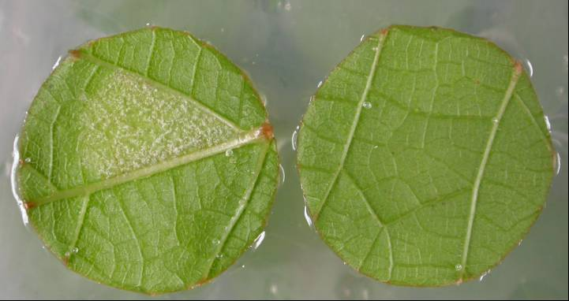
Figure 1. Leaf discs 6 days after infection with P. viticola. The leaf discs were pre-incubated 24 h before the infection with different solutions. White spots on leaf discs indicate sporulation. A: water B: 1% Chitoplant.
A
B

Compounds who prevented sporulation when applied to the lower surface of leaf discs 24h pre infection showed a decrease in their efficiancy when direct interaction of the compound and the spores was excluded either by washing the lower surface after incubation or by application on the upper surface of the leaf discs. To improve the uptake of active compounds into the leaf and their rain fastness surfactants and stickers were used. Their influence on the leaf disc tissue and sporulation of P. viticola without and with active compounds were tested.
Products studied and developed within REPCO were also tested for potentiators of resistance in Vitis.
An early cellular reaction on pathogen attack is the transport of H+- ions through the plasmalemma (Felix et al. 1993, Nürnberger et al., 1994). In cell suspension cultures the influx of H+- ions results in an alkalinisation of the culture medium (Fig. 2). This alkalinisation was measured using Vitis vinifera cell culture as an indicative of increased plant defence. Molecules from microbes, products from the secondary plant metabolism and oligosaccharides from animals and plants showed an efficacy against the pathogen and induced resistance response.

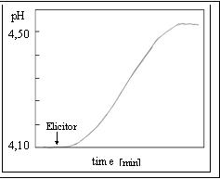
Figure 2. Changes of the pH measured in the medium of the cell suspension culture from V. vinifera after addition of an elicitor.

Substances showing a positive effect on the control of P. viticola or causing a shift in pH in the cell suspension culture system worth further investigation on plant level

Acknowledgement
The experiments were supported by REPCO (Project No. 501452, 6th FP, priority 8.1), founded by the European Commission.

References
Busam, G., Junghanns, K.T., Kneusel, R.E., Kassemeyer, H.-H., Matern, U. (1997) Characterization and expression of Caffeoyl-coenzyme A 3-O-methyltransferase proposed for the induction for the induced resistance response of Vitis vinifera L. Plant Physiol. 115, 1039-1048.

Busam, G., Kassemeyer, H.-H., Matern, U. (1997): Differential expression of chitinases in Vitis vinifera L. responding to systemic acquired resistance activators or fungal challenge. Plant Physiol. 115, 1029-1038.

Felix, J., Regenass, M., Boller, T. (1993) Specific perception of subnanomolar concentrations of chitin fragments by tomato cells: induction of extracellular alkalinization changes in protein phosphorylation, and establishment of a refractory state. Plant J. 4, 307-316

Jänich, S. (2003) Host-Pathogen-Interactions on Vitis species. Master-Thesis, University Freiburg.

Lachmann, S. (2002) Inducible defence response in cell susprension culture of Vitis rupestris. Master-Thesis, University Freiburg.

Seibicke, T. (2002) Investigations on the induced resistance of Vitis species. PhD-Thesis, University Freiburg.

Nürnberger, T., Nennstiel, D., Jabs, T., Sacks, W., Hahlbrock, K. Scheel, D. (1994) High affinity binding of a fungal oligopeptide elicitor to parsley plasma membranes triggers multiple defense responses. Cell 78(3), 1994. 449-460.

Authors are with Staatliches Weinbauinstitut, Department of Biology, D-79100 Freiburg im Breisgau (Germany) Carmen.Schweikert@wbi.bwl.de Manuel.Mildner@wbi.bwl.de Claudia.Vollrath@wbi.bwl.de Hanns-Heinz.Kassemeyer@wbi.bwl.de

