Development of organic farming in distant
rural Māori communities in New Zealand

Huub Kerckhoffs

Abstract - A unique programme was initiated between scientists and distant rural Māori communities in New Zealand’s East Coast to help these communities with the transition from extensive agriculture to intensive organic horticulture. Through intensive collaboration and interaction with local organic Māori growers (organised within a growers’ trust), scientific, educational and extension services have been provided to develop and implement best organic vegetable growing practices. Initial topics were soil (fertility) and weed management, and these were illustrated in a range of workshops, fieldwalks and fieldtrials.

Introduction
The East Coast
The Tairawhiti district (Fig.1) is located on the East Coast of the North Island of New Zealand. The Māori name for the district, Tairawhiti, means “the coast upon which the sun shines across the waters”. Gisborne is the main centre of the district, and is the first city in the world to greet the sunrise every day. The total population is 45,000, a third of which is spread sparsely throughout the rural countryside or in small townships along the extensive coastline. Almost 50% of the population are of Māori origin, and the predominant iwi (tribe) in the region is Ngati Porou. The Tairawhiti district covers 8330 square kilometres – almost 5% of New Zealand’s total area. This district contains 40.000 ha of rich alluvial riverflats, which combined with mild temperatures, makes this region an ideal area for growing maize, sweetcorn, popcorn, kumara, potatoes, pumpkin, squash, kiwifruit, citrus, grapes and subtropical fruits. The hinterland is mainly hill-country, well suited to farm sheep, cattle, poultry, deer and goats.

The East Coast Organic Producers’ Trust
An increasing number of Ngati Porou people over the years had a strong desire that more could be done with their land – for the betterment of themselves, their whanau (extended family) and Ngati Porou as a people. They realised that numerous tracts of whanau land were uneconomic for conventional farming and were often lying fallow, and so began investigations and trial crops organically, particularly taewa Māori (traditional Māori potatoes) and kumara (sweet potato) (Fig. 2). Around 50 growers with access to land areas ranging from a half an acre to several hectares, formed the East Coast Organic Producers’ Trust (ECOP), based in Ruatoria.
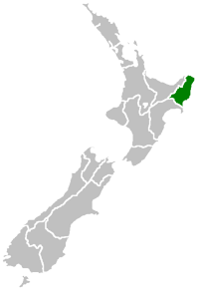
Figure 1. Tairawhiti district (green) situated on the East Coast of the North Island of New Zealand.

Earlier in 1999, the Ministry for Economic Development established taskforces to assess how economic development might be fostered in various under-developed regions in New Zealand. One such taskforce was the Tairawhiti Organics Steering Group Taskforce which identified organic production as a viable use of under-utilised Māori land on the East Coast. Crop and Food Research (CFR) was subsequently asked to help realise the potential of organics in region. Members of ECOP were also on this taskforce, and subsequently a relationship between CFR and ECOP developed.

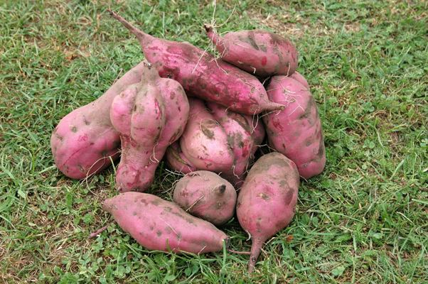

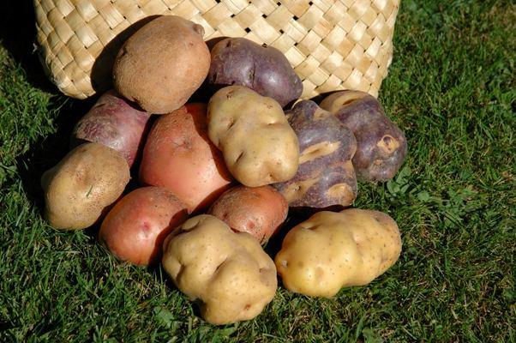
Figure 2. Kumara (top) and Māori potato (bottom).
Crop Science for Māori Programme

Three cultures: Māori, pakeha and science
After this relationship had been established, CFR successfully applied to the Foundation of Research, Science and Technology (FRST) for a program called “Science for Community Change: Crop Science for Maori”. This project joins ECOP Trust with agricultural scientists from various disciplines from Crown Research Institutes (Crop and Food Research, AgResearch), extension specialists (private consultancy), and social scientists (University of Auckland). The broad aim is to improve access for Māori to advances in cropping science, resulting in greater uptake by them of science findings. In practical terms the program assist East Cape Māori to make the transition from extensive agriculture to intensive organic horticulture. The work with ECOP Trust is in effect a case study that will help ECOP Trust while at the same time teaching science providers how to identify and address the real science needs of rural Māori. The project commenced in October 2003. Underlying the whole project is a need to get the best out of three cultures: Māori, pakeha (non-Māori, i.e. ‘New Zealand Europeans’), and science.
Efforts are divided into three main areas. (1) The Knowledge Pathway - transferring existing knowledge and skills through workshops, field days, and visits to successful growers in the region. A hui (gathering) in October 2003 identified the key topics to be covered and a schedule of workshops, covering the principles of land and crop management for organic vegetable production. (2) The Research Pathway - acquiring new knowledge through experiments designed with the ECOP Trust members, viewed from tikanga Māori (Māori customs and traditions), ecological, economic and educational perspectives, given the remoteness of the ECOP Trust and their financial constraints. (3) Sharing our experiences with other communities. Success here will encourage other groups of scientists and Māori to undertake research together. ECOP Trust is keen to spread the benefits of its experiences to the wider community.

Workshops
Workshops and field walks are designed in consultation with the community to address land management issues and concerns that the members of the communities raised, like soil (fertility) and weed management, crop selection, winter cover crops, interacting and access to markets, all within the principles of organic farming. The workshops are interactive and hands-on involving small groups of 5-10 people (Fig. 3), often based around a marae (communal meeting house), promoting healthy and vigorous debate. Extensive question-answer sessions are encouraged and proved successful. Workshops are widely advertised and open to anyone with an interest. As they run at several locations over a 1-2 day period, they bring people together with a shared passion for organics, sharing their successes and failures; the involved scientists are able to facilitate access to other needs for (expert) information, like pathways to organic certification.

Fieldtrials
Field trials are also developed with local communities addressing issues like enhancing currently low phosphate levels of the soil and weed control strategies (Fig. 4). It also helps to extend the information and knowledge provided through the workshops. Other information is provided in hand-outs (in bimonthly newsletters and at the website). The field trials were extended by active monitoring and evaluating current practices of (a selection of) individual community members and their paddocks to interact and debate science and matauranga (traditional Māori knowledge) and other factors involved in successful organic cropping.

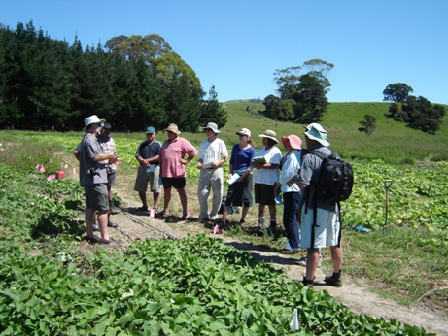
Figure 3. Field walk, visiting a kumara (left) and squash paddock (right).

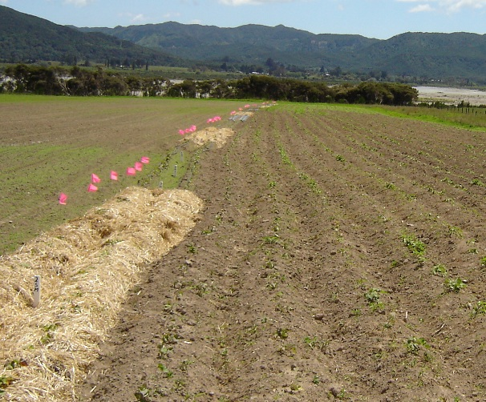
Figure 4. View of a trial site in a kumara garden, looking into the options of mulches in weed control.

Conclusion
The programme is now running for over two years, and it is clear that the networks and long-term relationships that have evolved between the scientists and the communities have already extended well beyond expectation. What has emerged clearly is an increasing and on-going sharing of existing and new knowledge amongst all parties. Most (if not all) growers involved in the project are encouraged with the positive results in their organic cropping sofar.

See the website: www.panui.org.nz for additional information and references.

Dr LHJ (Huub) Kerckhoffs is with the NZ Institute for Crop and Food Research, RD2, 265 Lawn Road, 4201 Hastings, New Zealand; (kerckhoffsh@crop.cri.nz; Ph +64 6 870 0514; Fax +64 6 870 0750).

