Long-term effects of cropping systems on the earthworm populations in a loam soil

Reidun Pommeresche¹, Sissel Hansen¹, Ragnar Eltun² and Audun Korsaeth²

Abstract - Six cropping systems, ranging from conventional arable without livestock to organic livestock farming dominated by ley, have been compared since 1990 in SE Norway. Earthworm density (ED), earthworm biomass (EB), channel density (CD) and species of worms were measured in the topsoil (0-25 cm) in 1994 and 2004. Ley in the crop rotation increased EB, ED and CD in both organic and conventional systems, but a ley proportion higher than 25 % only increased CD. Among the arable systems, the organic system hosted more individuals (ED) and a higher biomass (EB) of earthworms as compared to the conventional systems. The conventional arable systems had low values in 2004, and only minor changes in EB and ED during the period compared with the other systems. The earthworm species observed were field worm (Aporrectodea caliginosa), pink worm (A. rosea) and night crawlers (Lumbricus terrestris).

Introduction
Since earthworms are important for improving and maintaining good soil fertility and soil structure (Edwards and Lofty, 1977; Marinissen, 1994), it is important and interesting to study the long-term effect of different cropping systems and different management on earthworm populations.

Material and Methods
Cropping systems
Six different cropping systems (Tab. 1) were established on a loam soil in 1990 in the central part of southeast Norway, at Apelsvoll. Systems 1, 2 and 3 reflect arable cereal production, and systems 4, 5 and 6 fodder production, with 2-3 years of ley (grass-clover mix) in the rotation. In system 1, which reflects the conventional arable practice in Norway in 1985, the soil is ploughed annually in autumn. In system 2, which incorporates perceived system improvements, spring rotor harrowing is practised rather than ploughing. In the remaining systems, the soil is ploughed in spring in all but the ley years.

All systems have a 4-year crop rotation, with each crop present every year (25 % ley means one out of four years in ley). Animal manure (cattle slurry) is used in systems 4, 5 and 6. Some changes in rotations and fertiliser levels were made after the first 10 years, but the main features, such as manure use and incidence of ley, have been maintained throughout the period. An exception is system 6, which was conventional fodder production with reduced input of fertilizer and chemical plant protection (integrated management) in the first 10 years.

Table 1. The dominant management and amount of ley in the cropping systems studied at Apelsvoll.
System | Management
1. Con ar | Current arable cereal, no slurry, NPK, 0% ley
2. Opt ar | Optimised arable cereal, no slurry, NPK, 0% ley
3. Org ar | Organic arable cereal, no slurry¹, 25% clover ley
4. Opt fo | Optimised fodder, with slurry, NPK, 50% ley
5. Org fo | Organic fodder, with slurry, 50% clover ley
6. Org fo | Organic fodder, with slurry, 75% clover ley
Slurry = wet-composted cattle slurry, 4.8% DM, applied at 36 (system 4), 28 (system 5) and 40 (system 6) Mg ha⁻¹ yr⁻¹.
Inorganic fertilisers with N as NH₄NO₃ were applied in systems 1, 2 and 4 in both periods, and in system 6 in the first period). ¹ Some slurry was applied to the clover ley the first 10 years.

Sampling of earthworms
Earthworm data were sampled under the wheat crop from each system (two replicates) in autumn 1994 and 2004, with the exception of system 6 in 2004, where sampling was performed in the third ley year. Worms were hand-sorted from three soil blocks (50 cm x 50 cm x 25 cm depth) at each site, and the density of juvenile and adult worms (ED = worms m⁻²) and the dead fresh weight (EB = g m⁻²) were measured. Channel density was recorded on the horizontal face (50 x 50 cm) at 25 cm depth in the soil (CD = earthworm channels m⁻²) under each soil block.
A typical specimen of the field worm (Aporrectodea caliginosa) the most common earthworm in Norwegian agricultural soils.
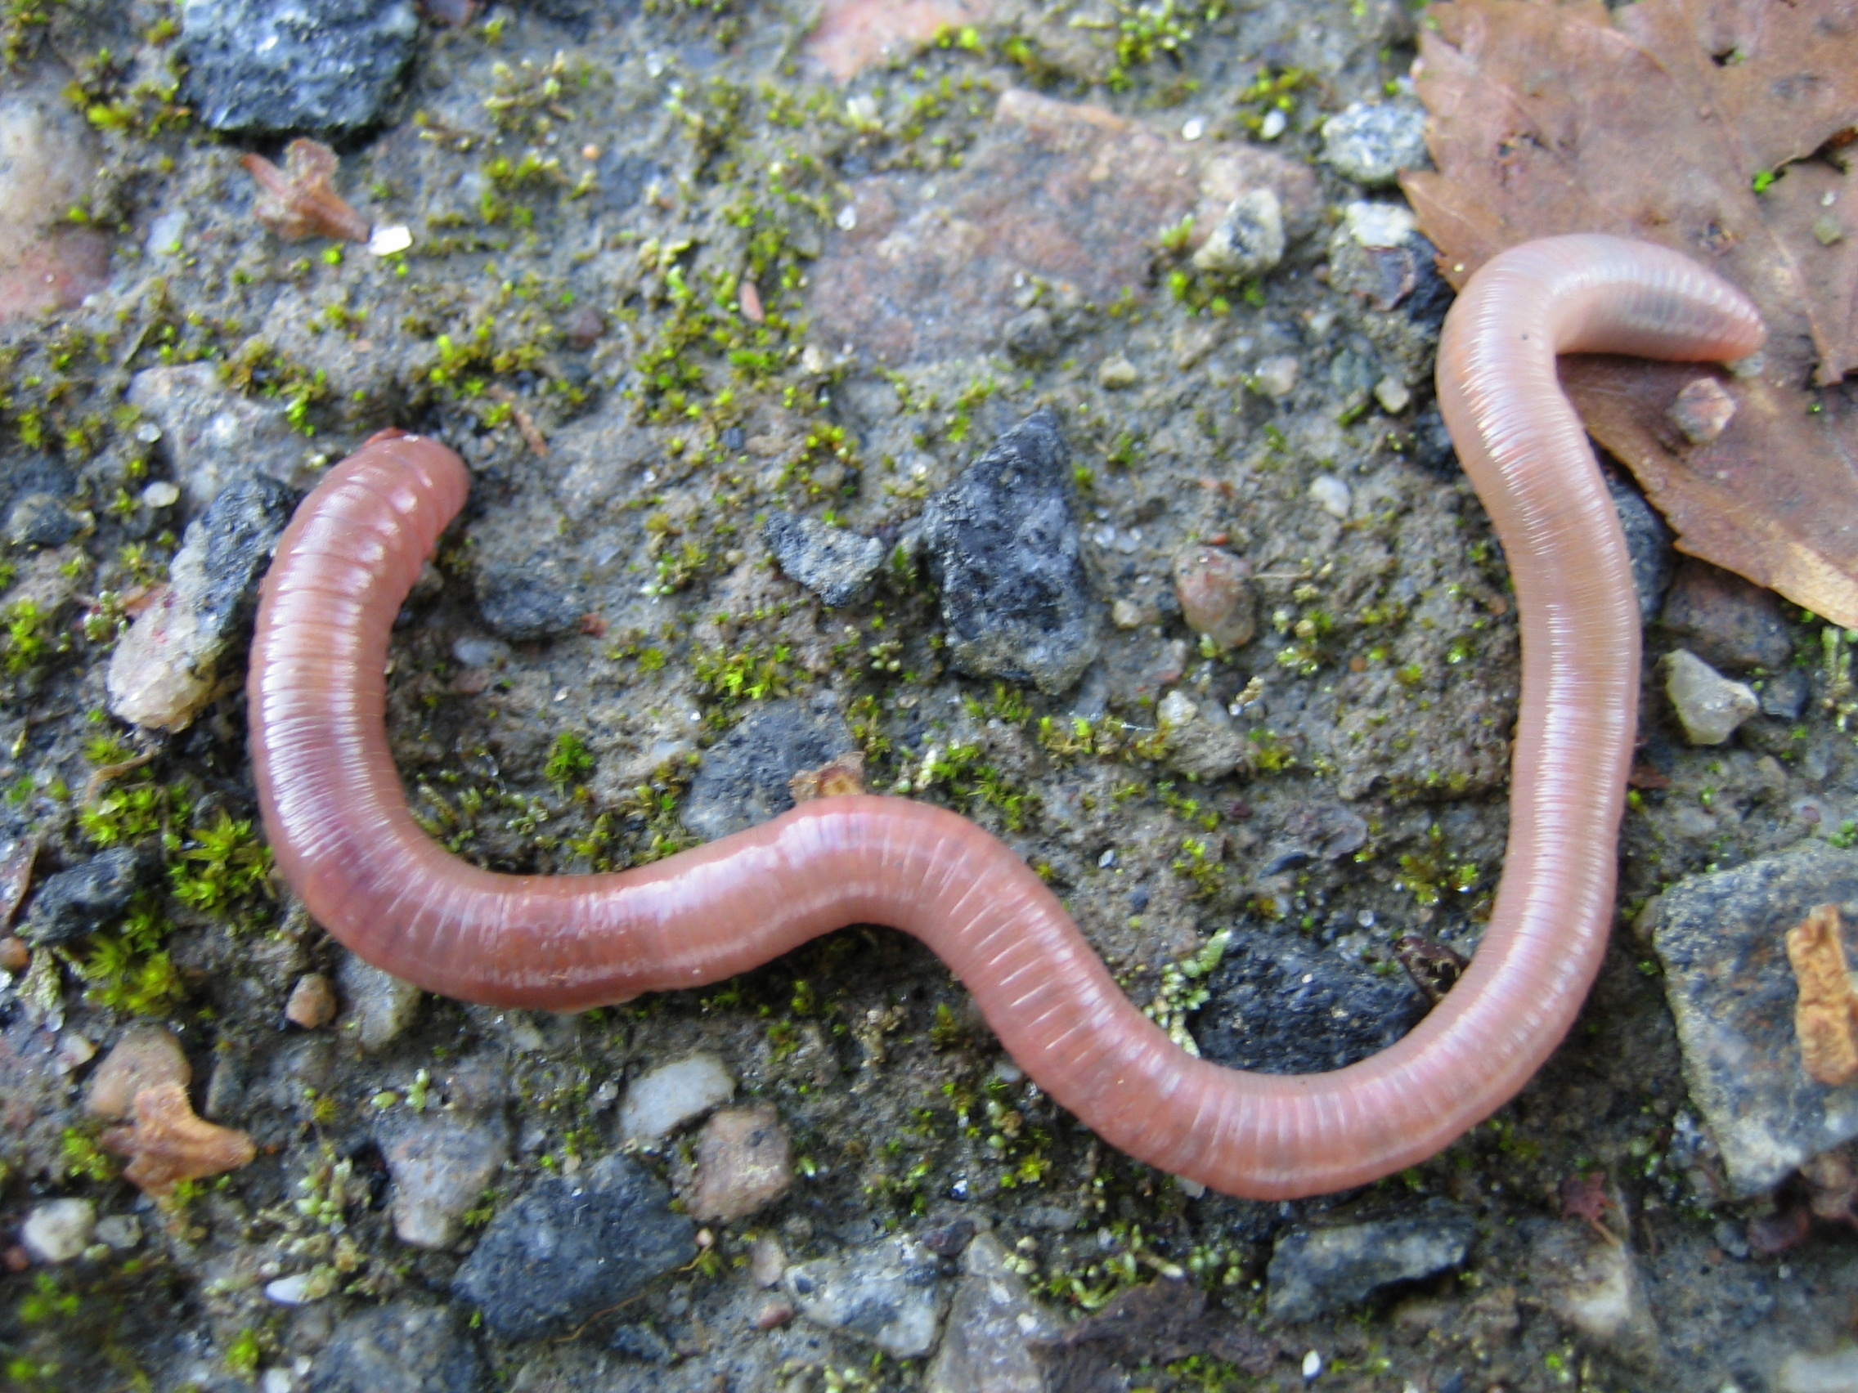

Results
The earthworm species observed were field worm (Aporrectodea caliginosa), pink worm (Aporrectodea rosea) and night crawlers (Lumbricus terrestris). In systems 1, 3, 5 and 6 the number of each species was in decreasing order, field worms > pink worms > night crawlers (Figure 1). Systems 2 and 4 differed, with pink worms representing the smallest and the largest worm fraction, respectively.
Figure 1. Earthworm density (ED) for each species within each cropping system in 2004

The conventional fodder system (4), using both animal manure and inorganic fertiliser, had the highest ED in 2004, but this was not significantly higher than the organic arable system (3) with no manure or fertilisers (Fig 2). Only systems 3 and 5 had a significant increase in ED in the period.
Figure 2. Earthworm density (ED). Different capital letters over the bars indicate significant differences within 1994 values, small letters differences within 2004 values. The symbols under the bars indicate significance levels of the changes between 1994 and 2004. The vertical lines show +/- standard error.

Figure 3. Biomass of earthworms (EB). Legends as in Fig. 2.

The systems organic arable (3), conventional fodder (4), and organic fodder (5) showed large increases in biomass (EB) from 1994, and had the highest levels of EB in 2004 (Fig. 3).

The two conventional arable systems (1 and 2) had the lowest ED and EB, and the level was almost unaltered from 1994 to 2004.

The channel density (CD) was highest in the organic fodder system (6) with three out of four years (75 %) in clover leys, and in the conventional fodder system with two out of four years (50 %) in ley (4). In systems 3 to 6 the CD significantly increased from 1994 to 2004 (data not shown). Again, the lowest 2004-values were found in the conventional arable systems (1 and 2).

Discussions
In accordance with Edwards and Lofty (1977) and Scullion et al. (2002), our results (2004 data) show that leys in the crop rotation positively affect earthworm populations (ED, EB and CD). Grass and clover produce more organic matter accessible to the soil fauna than do cereals. Some of this enters the soil through dying roots, foliage, and root exudates. Among the fodder systems, there were significant differences in ED between conventional (4) and organic management (5, 6), but not in CD and EB. These three systems are more similar in management and crop rotations than are the three arable systems. Hence, the smaller variations among the fodder systems regarding earthworm-related properties were expected, and are in accordance with the findings of Scullion et al. (2002). The reason for the higher ED in system 4 than in 5 and 6 may be the greater supply of nutrients in system 4 (more than double the amount of cattle slurry + NPK-fertilisers). The large positive effects of one year of ley in the organic arable system (3) as compared to the two conventional systems may have several explanations related to crop rotation, management and pesticide use.

References
Edwards, C. A. and Lofty, J. R. (1977). 309 pp. (Chapman and Hall, London).

Marinissen, J. C. Y. (1994). Agriculture, Ecosystems & Environment 51:75-87.

Scullion, J., Neale, S., and Philipps, L. (2002). Soil Use and Management 18: 293-300.

All authors work at Bioforsk - Norwegian Institute for Agricultural and Environmental Research, Norway. Reidun Pommersche and Sissel Hansen are with the Organic Food and Farming Division, NO-6630 Tingvoll. (reidun.pommeresche@bioforsk.no) (sissel.hansen@bioforsk.no). Ragnar Eltun and Audun Korsaeth are with the Arable Crop Division, NO-2849 Kapp (ragnar.eltun@bioforsk.no) (audun.korsaeth@bioforsk.no)

