Ecological and agronomic evaluation of crop rotations in organic farming systems

J. Bachinger, K. Stein-Bachinger, S. Fuchs

Abstract - The integration of nature conservation measures in organic farming requires special know-ledge about potential goal conflicts between ecological and agronomic requirements. The aim of this paper is to introduce a generation and evaluation tool for crop rotations that allows an assessment of the complex interdependencies of different biotic and abiotic parameters. The interdisciplinary ‘Nature Conservation Farm Brodowin’ project provides the experimental basis for developing practical solutions and compromises in this context. Two generated six-course crop rotations are presented as examples of this approach. The results show the sensitivity of the evaluation tool and its usability for improving crop rotations with regard to nature conservation.

Introduction
Organic farming (OF) is one of the expanding agrarian sectors in Germany. Significant environmental benefits of OF are already described (e.g. Hole et al. 2005). However there are also increasing conflicts, both between long term conservation of abiotic resources and biodiversity on the one hand and short term economic production constraints on the other, as well as between different objectives of nature conservation.
The present discussion about the effectiveness of agri-environmental schemes and the shortage of funds in this sector emphasises the necessity (i) of identifying conflicts between specific farming practices and the aims of nature conservation (e.g. intensive use of machines for weed control, mowing, stubble breaking), (ii) of working out and testing compromise solutions and (iii) of drafting suggestions for adequate financial reward for real ecological improvements. The project ‘Nature Conservation Farm Brodowin‘ addresses these challenges (www.naturschutzhof.de). The focus is on improving the living and reproductive conditions of typical farmland wildlife species in large-scale OF.

Research area
The investigations took place in the Demeter farm ‘Ökodorf Brodowin GmbH and Co.KG’ (1240 ha; 90 % arable land with sandy to loamy soils from glacial deposits, mean soil rating index 33; 270 dairy cows and 250 young cattle; 540 mm mean annual precipitation) located in the Schorfheide-Chorin Biosphere Reserve in Brandenburg near Berlin. Research concentrated on arable land use because of the significant lack of knowledge about potential conflicts with the objectives of nature conservation and their practical solution.

Methods
The effects of modified field operations for improving the habitat quality and the reproductive success of selected farmland species as well as the effects on yield and quality of the crops were investigated at the level of the entire farm (Stein-Bachinger et al. 2005). Here we focus on crop rotation as a method of promoting diversity and territory densities of farmland birds (Skylark (Alauda arvensis), Corn Bunting (Miliaria calandra), Yellow Wagtail (Motacilla flava) and Whinchat (Saxicola rubetra)). The effects for example on breeding success with regard to specific management practices (changing the tillage and mowing practices during the reproductive season) adapted for the purposes of nature protection will be further explored in future publications.
The design and evaluation of crop rotations was performed with ROTOR (decision support tool for generation and evaluation of organic crop rotations for organic farming systems) (Bachinger and Zander 2006). ROTOR is based on a set of manually assembled site specific, annual crop production activities (CPAs). The CPAs were used to generate automatically 3- to 8-course crop rotations. In a next step agronomically sustainable rotations were selected using criteria such as N-balance, weed infestation risks (winter, spring annuals, perennials; each with an index of –4 to 4) and phytosanitary restrictions. Abiotic (NO₃-leaching), biotic (species diversity, territory density) and economic criteria were additionally used for multi-goal evaluation.

Species Diversity
The number of farmland bird species for the investigated crops ranged from one to four, depending on the suitability of the crop. The results showed a clear ranking: legume-grass forage (LGF) > spring crops > winter cereals and maize. In legume-grass forage all four species could be found regularly. In spring cereals and pulses up to three species were present, while in winter cereals usually only the Skylark was found, with the exception of winter wheat with up to three species.
Abundance of the Skylark
The territory density of the Skylark was above average, but differed depending on the crop. Table 1 shows the mean maximum density per crop. In most crops these densities are found in short periods of the breeding season only. This has a strong influence on the number of breeding attempts that can be performed and thus, on the reproductive success of the species. Therefore a time-restricted suitability factor (TRS) for each crop was introduced (see Table 1). For example, the relatively low density on LGF is compensated by the suitability of this crop over the whole breeding season.

Table 1. Territory densities of the Skylark on the demeter farm Ökodorf Brodowin in relation to the type of crop (data from 2001-2002) .
 | Territories per 10 ha | TRS-factorª | Territories per 10 ha (weighted)
Legume-grass forage  Winter rye | 4.4  3.5 | 2.0  0.8 | 8.8  2.8
Triticale | 4.7 | 0.8 | 3.8
Winter wheat | 5.8 | 1.2 | 6.9
Other winter cereals | 4.7 | 1.0 | 4.7
Spring wheat  Oats  Other spring cereals  Silage maize  Lupine | 6.4  6.4  6.4  11.5  7.5 | 1.0  0.8  1.0  0.5  1.0 | 6.4  5.1  6.4  5.8  7.5
ª Time-restricted breeding suitability factor.

Evaluation results of crop rotations
Taking into account the fodder demand of a dairy farm, two generated six-course crop rotations (without nature conservation optimised CPAs) are evaluated with ROTOR. Both rotations start with two years legume-grass forage. In rotation 1 they are followed by winter wheat, silage maize, triticale and winter rye, in rotation 2 by winter wheat, oats, lupine and spring barley.
Figure 1 shows the sensitivity of the evaluation procedures implemented in ROTOR. The nature protection objectives (i) increasing the number of farmland bird species and stabilising the populations of the less frequent species (the farm species diversity) and (ii) improving the territory density of the Skylark (the farm species abundance) could be better achieved with rotation 2. In contrast, rotation 1 has a lower risk of NO₃ leaching and weed infestation by summer annuals.
Rotation 2 uses crops with high diversity rankings and high weighted Skylark abundance values: LGF, spring crops and winter wheat show relatively low crop heights over a long time period and higher shares of dicotyledons (legumes or weeds). These are basic breeding requirements of the bird species considered. Thus, a higher number of species and of individuals would be present on larger parts of the whole farm if rotation 2 is implemented. To reduce the risk of N-leaching a higher proportion of catch crops should be included.

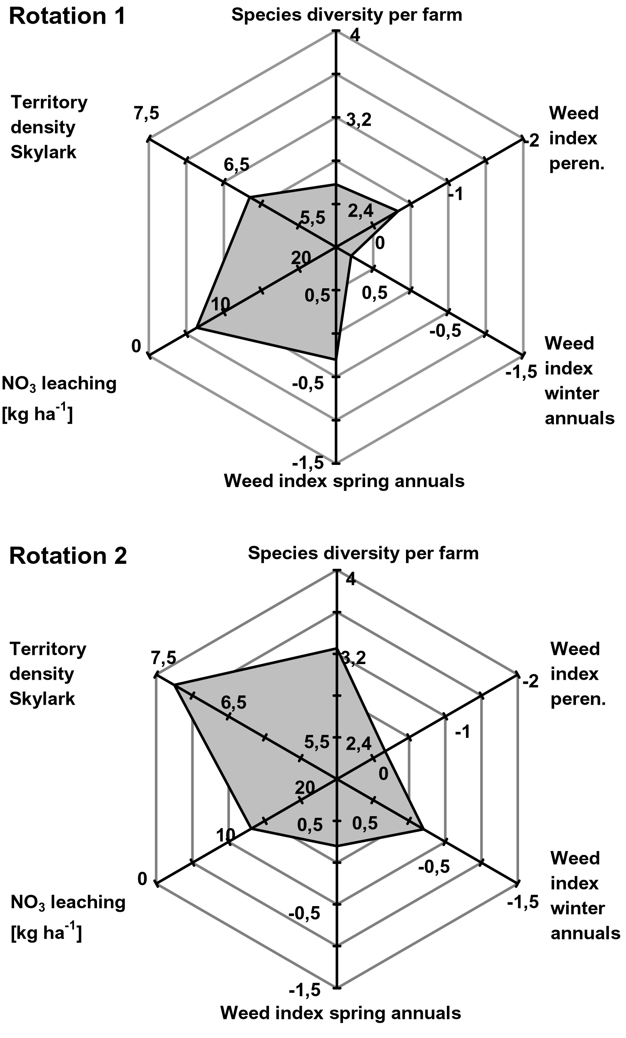
Figure 1: Assessment results of two crop rotations (positive: outer values, peren= perennial weeds)

Conclusions
ROTOR can provide the generation and multi-goal evaluation of crop rotations. For optimising the reproductive performance of farmland birds the individual breeding success of each species will have to be added as a third parameter in the evaluation. The resulting evaluations of generated rotations will serve as an input to a multi-goal linear optimisation model for the whole farm.

Acknowledgement
We thank the German Federal Agency for Nature Conservation (BfN) for the basic funding.

References
Bachinger, J., Zander, P. (2006): ROTOR, a tool for generating and evaluating crop rotations for organic farming systems, submitted.

Hole, D.G., Perkins, A.J., Wilson, J.D. Alexander, I.H. Grice, P.V. and Evans, A.D. (2005). Does organic farming benefit biodiversity? Elsevier, Biological Conservation 122, 113-130.

Stein-Bachinger, K., Zander, P., Schobert, H. and Frielinghaus, H. (2005). ISOFAR Proc. of the Conference ‘Researching Sustainable Systems, Adelaide, 468-471.

J. Bachinger, ZALF e.V. , Institute of Land Use Systems and Landscape Ecology, Eberswalder Str. 84, 15374 Müncheberg, Germany (jbachinger@zalf.de). K. Stein-Bachinger, Nature Conservation Farm Brodowin, c/o ZALF e.V. , Eberswalder Str. 84, D-15374 Müncheberg, Germany (kstein@zalf.de). S. Fuchs, Nature Conservation Farm Brodowin, Pehlitz 3, D-16320 Brodowin, Germany (fuchs@naturschutzhof.de)

