Relevance of hot water treatments for decay control

François Warlop¹ and Gilbert Bompeix²
¹Groupe de Recherche en Agriculture Biologique, warlop.grab@tiscali.fr
²Université de Jussieu, gilles.bompeix@wanadoo.fr

SUMMARY

In France, postharvest decay can lead to important losses in the case of stone fruits, as for pome fruits. Many farm-research trials with natural fungicides (vegetal extracts, mineral compounds) gave no satisfying results yet, and conventional growers also face difficulties to manage diseases with resistance appearance, and inputs reduction strategy to fit consumers expectations. Postharvest treatments seem to have an interest to decrease development of decay (Monilia sp., Rhizopus sp., Penicillium sp.,...) in storage rooms. Hot water treatment offers many advantages (compared to active compounds used after harvest) that will be presented hereafter. Its use in packing houses however remains tough, since cultivar susceptibility to heat injury may vary, professional needs and constraints are often different, and because industrial offer is still limited.

Keywords : thermotherapy, peach, apple, economics, postharvest

INTRODUCTION

Postharvest decay is responsible for significant losses on stone fruits (peach, nectarine), and also pippen fruits (apple, pear). The susceptibility of freshly harvested produce to postharvest diseases increases during a prolonged storage, as a result of physiological changes that enable pathogens to develop in the fruits (Eckert and Ogawa, 1988). Organic fruits are mainly concerned, but conventional ones look more and more exposed, since some fungicides are not efficient on some fungi strains due to resistance appearance. Also, short persistence of these synthetic compounds applied in orchards can lead to higher damages if the ecological niche is afterward free for wound parasites such as Penicillium sp, Rhizopus sp., …
Control strategies to decrease Monilia sp. infestation in orchards have not been very successful at this stage. Prophylaxis and preventive means keep being the most efficient way to limit losses : cultivar selection, type of cutting in fall season but also in summertime, removal of infected fruits and mummies, type of fertilisation and irrigation…Many of these techniques are expensive in time and money, but are worth when comparing with the final results.

Postharvest intervention is a stopgap solution, but can help in increasing fruit shelf-life, thus reducing commercial losses for packaging houses. Regulation is very severe, thus registered products used in postharvest are very limited. Then, prestorage heat treatments provides a non-damaging physical treatment, and a relevant strategy, that fits both consumers and growers expectations (Couey, 1989 ; Lurie, 1998).
In trials started in 1999, and additionally to hot water used alone, we assessed the efficacy of different natural compounds mixed with hot water on stone fruit decay. Promising results have been obtained with different essential oils (eugenol, carvacrol) mixed with soy lecithin, or lime sulphur, regularly reaching 90% efficacy on several peach varieties.
But sanitary aspects (residues) combined with regulation ones led us to abandon additional active ingredients, and to focus on hot water only.

1. MATERIAL AND METHODS

Our results will focus on trials carried out under professional conditions, in fruit houses, with several peaches & nectarines varieties.

  - Hot water machinery

Two different plants have been tried between 2001 and 2004.

- 2001 / 2002 : a drenching plant from Xeda International (F) firstly designed for citrus widely concerned by decay in Turkey or Greece. The heating system was first made of electric elements directly dipped in the 800L water tank. In the second year, it has been completed with a steam generator, to get a higher efficacy, and reach the required temperature under a shorter time.

- 2004 : a dipping plant conceived by Burg Machinefabriek (NL), designed for apples. The heating system was made of a powerful fuel boiler, keeping a separate water circuit at a temperature of 80°C. Water could reach the expected temperature (around 50°C) under 45 minutes.

  - Fruit sampling

Trials have been carried out in the fruit station of GAEC Fauriel, located in Loriol, France. Their orchards were organically managed in the 90’s, but Fauriel brothers decided to switch back to conventional because of their decay losses.
Fruits then came from non organic orchards, but the grower was asked not to spray after march, in order to avoid interactions between fungicides and trials.
About 10 commercial varieties were chosen for trials each year, with harvest dates going from end of July to the beginning of September.
Depending on trials, samples were constituted either of whole boxes coming from orchards, or individual fruits laid on platters after dipping.

  - Treatment methodology

Treatments have been done :
- on fruits coming directly from the orchard, circuit # 1 on figure 1 (full line) ;
- on fruits after cold storage, and before the packaging, circuit # 2 on figure 1 (dotted line).

Both strategies do have advantages or disadvantages, as shown on figure 1.
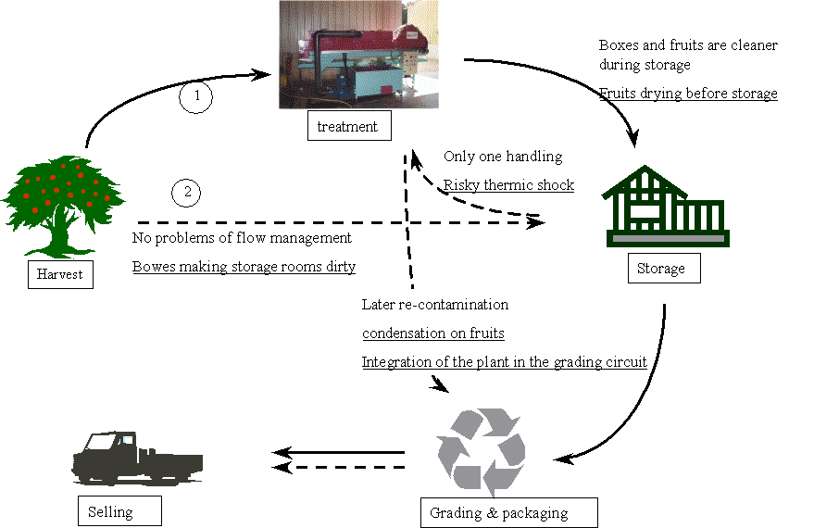
Figure1 : two possible circuits for treating stone fruits with hot water after harvest.
Disadvantages are underlined.

The decision to treat fruits before or after the storage room should be taken by the grower, and according to several parameters :
- labour availability during harvest, which is a very busy period ; indeed, one people is required to dip boxes in the tank, and store them in rooms after rinsing out. It may be more comfortable to treat several varieties in one time, after harvest period.
- market demand ; if it is low, fruits need to be kept in storage rooms, and can be treated later on.
- sanitary state of the packaging line.

After treatment, fruits were kept at ambient temperature, to assess decay evolution. Fruit conservation in storage rooms would not enable fungi to develop and to discriminate the treatments.

- RESULTS

Many trials have been done on stone fruits during 3 years.
They have been carried out with :
- different peach and nectarine varieties,
- different temperatures, with a range from 43 to 53°C,
- different treatment length, from 40 seconds to 3 minutes

We then will present below some of the most significant results obtained.

2.1. Effect of the temperature

This figure shows the slowing down of decay on fruits treated at 50°C for 3 minutes. Efficacy after 13 days is evaluated to 64%.

Figure 2 : development speed of decay for fruits treated with 50°C water
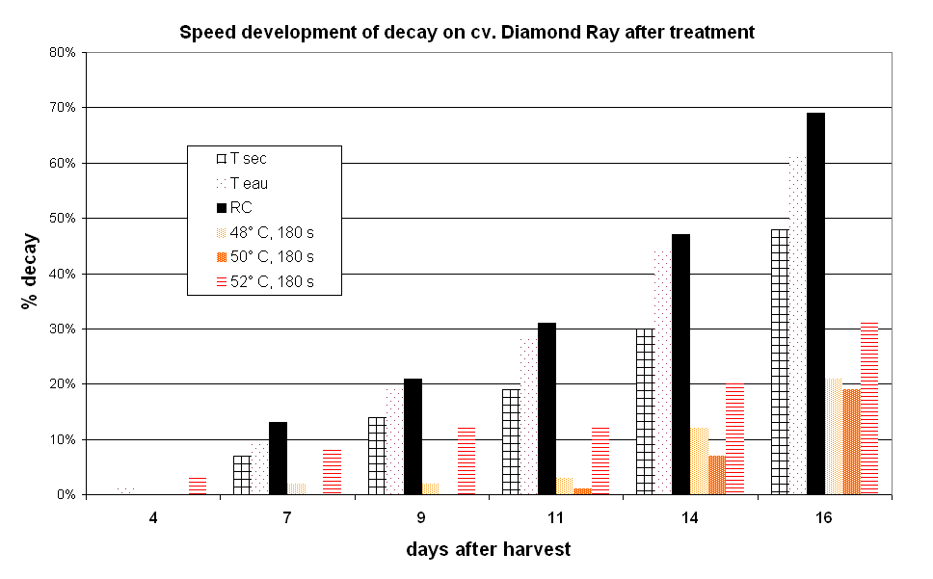

Figure 3 : development speed of decay for fruits treated with 50°C water

Figure 3 shows the evolution of decay after harvest, with different treatments :
- “Tsec” : fruits coming from untreated orchards, without postharvest treatment
- “Teau” : fruits coming from untreated orchards, with a cold water treatment
- “RC” : fruits coming from treated orchards, with no postharvest treatment
- “48°C, 180 s” : fruits coming from untreated orchards, with a hot water treatment of 180 seconds, at 48°C
- “50°C, 180 s” : fruits coming from untreated orchards, with a hot water treatment of 180 seconds, at 50°C
- “52°C, 180 s” : fruits coming from untreated orchards, with a hot water treatment of 180 seconds, at 52°C

Results clearly show that a hot water treatment has a strong effect on decay development speed ; efficacy after 11 days reaches in this case 85%, in comparison with “Tsec”.
One can also notice in that case (with cv. Diamond Ray), that a high temperature (52°C) can affect the fruit skin and create wounds favourable to pathogens. We may then be very careful with the maximum temperature to be recommended, in case of stone fruits : 50°C may be a good compromise, adapted for most of varieties.
Other results suggest that a low temperature (inferior to 47°C) may be favourable to mycelium growth, by increasing hygrometry with hot water, instead of destroying germs. This presupposes that accuracy of the machinery should be good enough, to avoid important temperature fluctuations when dipping fruits coming from the orchard (ie 30°C) and above all from the cold room (ie 3-4°C).

2.2. Effect of the duration of treatment

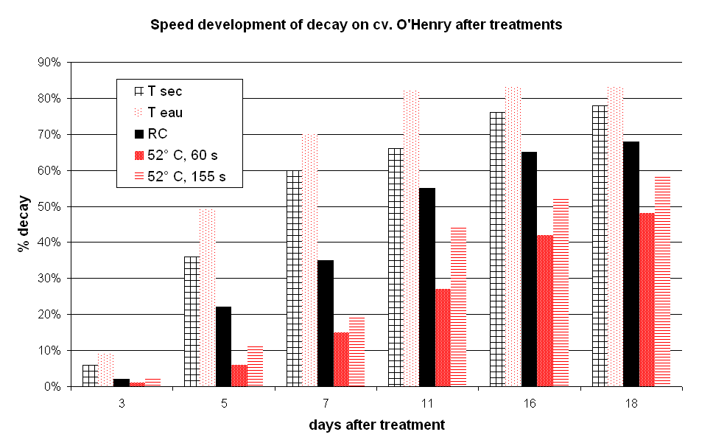
Trials focusing on duration of treatment show that best results are obtained between 2 and 3 minutes. The precise duration should not affect treatment quality, as long as temperature is not too high or too low.

Figure 4 : development speed of decay for fruits treated for different durations

Figure 4 shows that 52°C is an interesting temperature for this cultivar ; however, dipping fruits for a long time (ie 2 minutes and 30 seconds) creates micro-wounds and leads to more fungi development.

2.3. Effect of the positioning of treatment

As mentioned earlier, the positioning of treatment, in the case of stone fruits, can be thought just after harvest, or between storage and grading.

The graph below indicates the decay development speed in both cases.
Treatments are :
- “49°C, 100s, harvest” : fruits treated after harvest, for 100 seconds at 49°C
- “49°C, 100s, storage” : fruits treated after storage, for 100 seconds at 49°C
- “49°C, 180s, harvest” : fruits treated after harvest, for 180 seconds at 49°C
- “49°C, 180s, harvest” : fruits treated after storage, for180 seconds at 49°C

Figure 5 : development speed of decay for fruits treated after harvest and after storage

Results show that difference is not significant, and that (in the case of stone fruits) positioning may not have a primary importance.

Storage of apples or pears is much longer, and this may have an influence on treatment positioning. If the storage room is clean and regularly disinfected (especially just before harvest), it may be recommended to treat before storage, in order to keep fungi from making the room dirty. If the cold room is not very clean, it should be more interesting to stock fruits directly, and to dip them as late as possible, before grading. Indeed, the later re-contamination occur, the less damages the grower will get on packaged fruits.

2.3. Economics of the heat treatment

This calculation has been done on the basis of a German study led by Jork station (Maxin, Klopp, 2004), for a medium fruit station with different disease levels.

Cost simulation has been made by considering :
- a « hot water treatment » efficacy of 85%,
- an annual amount of 250 tons of fruits treated in one packaging house,
- labour of about 200 hours, spread on 10 weeks (15th of July until end of September),
- different post-harvest decay rates, from 10 to 50%.

 | euros
Plant cost | 58000

Usury (10%) | Use of the plant for 10 years | 5800
Interest rate (4% of half of cost) |  | 1160
Annual cost of the investment |  | 6960

Maintenance fees (5%) |  | 2900
consumables  (fuel, electricity) | 12 litters * 200 hours * 0,3 euros | 720
Total of variable costs |  | 3620
Labour cost | 200 annual hours * 10 euros | 2000

ANNUAL COST |  | 12580
Cost per ton | For 250 tons treated | 50

Profit calculation | Decay rate | 10% | 20% | 30% | 40% | 50%
Fruit loss per ton |  | 100 kg | 200 kg | 300 kg | 400 kg | 500 kg
Fruit loss after treatment (85% efficacy) |  | 15 kg | 30 kg | 45 kg | 60 kg | 75 kg
Fruit gain after treatment |  | 85 kg | 170 kg | 255 kg | 340 kg | 425 kg
Gross saving per ton (1,2 €/kg) |  | 102 | 204 | 306 | 408 | 510
Treatment cost per ton (€) |  | 50
Net saving per ton (€) |  | 52 | 154 | 256 | 358 | 460
Total profit (250 tonnes, €) |  | 12920 | 38420 | 63920 | 89420 | 114920

Return on investment | Decay rate | 10% | 20% | 30% | 40% | 50%
 | Initial investment (€) | -58000
 | 1 year | -45080 | -19580 | 5920 | 31420 | 56920
 | 2 years | -32160 | 18840 | 69840 | 120840 | 171840
 | 3 years | -19240 | 57260 | 133760 | 210260 | 286760
 | 4 years | -6320 | 95680 | 197680 | 299680 | 401680
 | 5 years | 6600 | 134100 | 261600 | 389100 | 516600

The medium cost of the hot water treatment, including plant investment, is about 50 € per ton of fruits treated, for a medium fruit station selling about 250 tons of fruits. It would be reduced to 20 € for houses packaging 600 tons or more.
The cases in grey represent the profit made thanks to the plant use. Return on Investment can then theoretically be reached after two years if one consider an average loss of 20%, and after one year only if decay are more significant.
Profit may also be increased if the plant is used for different fruit species (apples for example, against glœosporiosis, Bompeix, 2004), or even vegetables when considering diseases appearing on gourds for example.

Those figures may however need to be adapted to each situation, taking into account its characteristics and specificity.

- DISCUSSION

Hot water treatment (also called thermotherapy) has shown good results for years, but is more and more relevant in organics or conventional agriculture, because of consumers expectations. The need for safe fresh fruits requires to target new sustainable production techniques. Beside resistance appearance to fungicides, the residues are now less and less acceptable by many standards like EUREPGAP.

Fruit qualities (firmness, weigh, colour, taste) are not affected by heat. Basic trials did not reveal any differences between dipped fruits and control. This concern may also need to be further developed with accurate means, for example to assess the temperature increasing inside the flesh.

Hot water seems to be part of the answer to decrease importance of decay, and stimulate professional towards integrated or organic cultivation. Nevertheless, the industrial offer remains limited, and consequently, investment remains high, unaffordable for smallest organisations.

We then are planning to evaluate the possibility in 2005 of renting or leasing mobile plants, which could be used in different houses in the same year. However, this system would probably force growers to store fruits before dipping them, because they will use the plant for a reduced period, and treating all boxes in the same time.

Acknowledgements

We want to thank all growers involved in those trials, by lending their material, by being available during harvest season for our concerns, and industrials for their participation in experimentation.

LITERATURE CITED

- Bompeix G., 2004. Alternative to chemical post-harvest control ; efficacy of thermotherapy and essential oils, the case of pome fruits and potatoes. 5th International Postharvest Symposium, Verona, Italy.
- Couey H.M., 1989. Heat treatment for control of postharvest diseases and insect pests of fruits. HortScience, 24, 198-202.
- Eckert J.W., Ogawa J.M., 1998. the chemical control of postharvest diseases : deciduous fruits, berries, vegetables and root/tuber crops. Ann. Rev. Phytopathol. 26, 433-469.
- Lurie S., 1998. Postharvest heat treatments. Review. Postharvest Biology and Technology, vol. 14, pp. 257-269.
- Maxin P., K. Klopp, 2004. Economics of hot water dipping. Proceedings of the 11th International Conference on Cultivation Technique and Phytopathological Problems in Organic Fruit-Growing, pp. 75-78

