Reprinted from Biological Agriculture and Horticulture, 2000, Vol. 18, pp. 141-159. 0144-8765/00 $10 © A B Academic Publishers, Printed in Great Britain.
Reproduced with permission of editor, Prof. PJC (Phil) Harris, see: http://www.bahjournal.btinternet.co.uk/
[As also presented in 1996 at XII International Colloquium on Soil Zoology, Dublin, although formal publication rejected by regional organizer, viz.:
Blakemore, R.J. (1996c). The ecology of earthworms in agricultural fields under different fertilizer regimes. In: Curry, J.P., Bolger, T., Kaye, B. and Purvis, G. (eds.). XII International Colloquium on Soil Zoology, UC, Dublin. Abstracts. Pp. 190].

Ecology of Earthworms under the ‘Haughley Experiment’ of Organic and Conventional Management Regimes
R. J. Blakemore *
PO Box 414, Kippax, ACT 2615, Australia
* Corresponding author - robblakemore "at mark" bigpond.com

ABSTRACT
Significant differences in earthworm populations and soil properties were found in three sections of a farm at Haughley in Suffolk that, since 1939, had either an organic, a mixed conventional, or a stockless intensive arable regime. Compared with the mean earthworm population of a 1,000 year old permanent pasture of 424.0 m⁻²; an organic field had 178.6 m⁻²; a mixed field 97.5 m⁻²; and a stockless field 100.0 m⁻². Species recorded were: Allolobophora chlorotica, accounting for most of the increase in the organic section; Aporrectodea caliginosa, dominant in the stockless section; Aporrectodea icterica; Ap. longa; Ap. nocturna; Ap. rosea; and Lumbricus terrestris.
Soil analyses showed the organic soil had higher moisture, organic C, and mineral N, P, K, and S compared with soil from the stockless field. The organic soil also had lower bulk density and good crumb structure whereas the stockless soil was cloddy and subject to puddling. The properties of the mixed field soil were intermediate to the others. Winter wheat (Triticum aestivum) in the organic field had significantly longer shoots (by 11.3% and 13.9%) and roots (by 5.4% and 10.8%) compared with the mixed and stockless fields, respectively.
Choice chambers offering the three field soils, with and without organic amendments, showed an earthworm preference for the organic soil (total 96 headcounts) compared to the mixed and stockless soils (75 and 73 headcounts). Adding organic matter tended to override this trend and indicated that food supply was an important determinant in earthworm distributions in the laboratory.

INTRODUCTION
There is increasing concern about the deterioration of soil quality under agricultural production, and more sustainable management practices, such as organic farming, are gaining in importance (Hodges, 1978, USDA, 1980; Greenland; 1981; Reganold et al., 1987; Mollison, 1991; Springett, 1991). It is timely therefore to revisit some earlier studies that have investigated components of such ‘holistic’ agroecosystems. The role of earthworms in enhancing soil fertility is well known and different farming practices have considerable effects on both earthworm abundance and species compositions (Darwin, 1881; Russell, 1973; Lee, 1985; Edwards & Bohlen, 1996). Few situations have allowed systematic comparison or quantification of effects on soil biological quality of contrasting agricultural practices, especially organic versus conventional farming, due to inter-site variability and problems of separating cause and effect (Arden-Clarke & Hodges, 1988; Reganold, 1991).
Edwards & Lofty (1982a) reported on earthworms under direct drilled and minimal cultivation cereals (practices not always compatible with organic production) at Woburn, Rothamsted, and Boxworth, U.K.. These same authors (Edwards & Lofty, 1982b) compared earthworms under long-term fertilizer and continuous cropping experiments at Rothamsted, finding that populations were higher in plots treated with organic fertilizers. A ten year survey of a field in Hokkaido recorded only low numbers of earthworms after transition to organic management (Nakamura & Fujita, 1988). In Europe, Bauchhenss (1991) studied earthworms under different agricultural systems in Bavaria, reporting higher densities in ‘alternative’ systems, while Pfiffner & Mäder (1997), comparing long-term plot trials in Switzerland commenced in 1978, found higher earthworms under ‘biological’ treatments. Hendrix et al. (1992) in the U.S.A., Marinissen (1992) in the Netherlands, and Springett (1992) in New Zealand reported on the abundance of earthworms in relation to various soil conservation managment practices, all three studies showed that lumbricid earthworm populations were reduced by cultivation.
The author is unaware of any previous study that has concurrently compared the ecology of earthworms in different arable sections of the same farm that have been subjected to long-term (in this case >40 yrs) alternatives of fertilizer and management practice. The original findings of the current study were presented by Blakemore (1981). The underlying assumption of the survey was that any differences manifest in earthworm populations and in soil properties at one point in time are a consequence of the agricultural history (i.e., management) of the study fields.

MATERIALS AND METHODS

Study site
The study was carried out on a farm at Haughley in Suffolk, East Anglia, U.K., where, since 1939, three management regimes had been maintained under the pioneering ‘Haughley Experiment’ (Balfour, 1975, 1977). This 100 ha site originally had nearly uniform alkaline clay-loam soils overlying glacial clay with flints and sand pockets on chalk beds. Prior to establishment, the use of mineral fertilizers and chemical biocides on the farm would have been minimal. Three side-by-side regimes were maintained as separate sections, each large enough to operate a full farm rotation so that the food-chains involved: soil-plant-animal and back to the soil, could be studied for their interdependencies and also for any cumulative effects. These sections were:
(O) - an Organic ley-arable section supporting stock, with 8-10 year rotations of corn, root crops and grass ley and only using organic fertilizers obtained from within the section (i.e., a near completely closed system). No chemical fertilizers nor biocides were used.
(M) - a conventional Mixed ley-arable section supporting stock and with a similar rotation, using both organic and supplementary chemical fertilizers as well as herbicides, insecticides and fungicides when necessary.
(S) - a Stockless intensive arable section dependent on agrochemical inputs with limited rotation of mostly white straw crops.
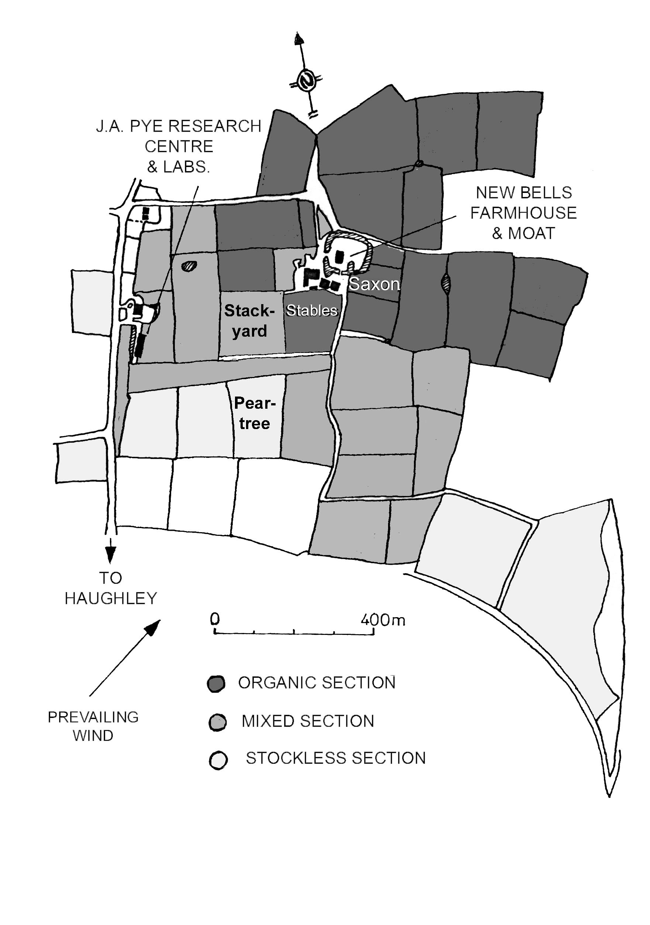
The Mixed and Organic sections both carried a dairy herd of Guernsey cattle, a flock of poultry and a small flock of sheep. All livestock was fed exclusively on the produce of its own section, replacements were home bred and cereal and pulse crops raised from home-grown seed. All wastes of crop and stock were returned only to their own sections. Only livestock products and surplus animals were sold off the farm. All crops were put though the animals.
An equivalent cultivated field from each of the three sections was available for comparison (Figure 1). These fields were growing winter wheat (Triticum aestivum L. cv. Maris Freeman) propagated in the respective sections, each sown at the same rate (225 g ha⁻¹) on the same date (26 September 1980). The seeds on the Mixed and Stockless sections were dressed with Agrosan-D mercuric fungicide, and both these fields had been fertilized the day before sowing with Fisons 10:23:23 NPK (250 kg ha⁻¹). Fields and pastures on the Organic section had been mulched annually with between 7-30 t ha⁻¹ of roughly composted animal manure and crop residues. The Mixed section field had received a similar mulch treatment in addition to the artificial fertilizer. The agricultural histories of the study fields, located in Figure 1, are shown in Table 1.

TABLE 1
Arable fields studied at Haughley farm.
Field  (Section) | Stables  (Organic) | Stackyard  (Mixed) | Peartree  (Stockless)
Size (ha) | 2.43 | 3.24 | 2.83
Ploughed | 8 August 1980 | 24 Sept 1980 | 25 July 1980
Previous crop | 3 yr ley | 3 yr ley | 3 yr ley
Previous (1976) | barley | barley | barley
Previous (1975) | beans | beans | winter wheat
General rotations | 4 yr arable/ 4 yr ley (pasture before 1940). | 4 yr arable/ 4 yr ley. | 4 yr corn and root crops, reduced ley.

There was no record of these fields having lime treatments in the previous 10 years. Herbicides were applied to Peartree and Stackyard after 19 January 1981, so are not pertinent to this study (although there was the probability of pesticide residues from previous treatments).
A permanent pasture on the Organic section was also sampled for comparison, this was Saxon meadow that from farm records was believed to have been under grass for 1,000 years (predating the 1086 Little Domesday Book of Suffolk).

Field study
Stratified random sampling (Southwood, 1978) was by digging and hand-sorting sample units of 0.0625 m² (i.e., 25 x 25 cm) to a depth of 20 cm corresponding to the depth of mouldboard plough, with the provisoes that the central 0.5 ha of each field was excluded due to concurrent studies, and points close to headlands, hedgerows and gates were avoided to reduce possible edge effects. This size of sample unit was stated by Edwards & Lofty (1980) to give an adequate estimate of medium sized earthworms in agricultural soils, where 80-90% by biomass occur in the top 20 cm. Edwards & Lofty (1980) also recommended between 10-16 samples per site, although Satchell (1971) reported that, due to earthworm aggregations, a sampling error of less than 10% of the mean cannot generally be obtained without excessive cost in sampling effort.
Ten samples were generally taken from each field at monthly intervals for four months (on 11 October 1980; 13-14 November 1980; 13-14 December, 1980; 17 January 1981), but only three were taken during the pilot survey (11 October 1980). For the Saxon permanent pasture, sampled to give an indication of earthworm numbers under pasture compared to cultivated soils, the dense root mat and high earthworm recovery slowed the sorting process and consequently fewer samples were obtained. Hand-sorting is laborious yet it yields the most representative results; moreover, although chemical extraction was trialled with limited success in the Stockless section, it would have been inappropriate for the Organic section of the farm.
Soil was sub-sampled for physico-chemical analysis, but the bulk was returned to each hole after sorting. Procedures were standardized throughout and the fields were alternately sampled to avoid diurnal bias. All samples and live earthworms were transported to the laboratory in London within one day and stored in a dark room at a constant temperature of 4ºC until required for analysis.

Laboratory study
Earthworms from each sample were identified (Gerard, 1964), counted and, after excess soil and moisture were damped off, their total weights recorded. Only ‘heads’ were counted although ‘bits’ were included in the total weights. Mature Lumbricus terrestris Linnaeus were weighed and considered separately as inclusion of this data would skew the results and, because this species maintains vertical burrows to a depth of 1-3 m into which it can rapidly retreat, it would have been under-represented by the sampling methods employed. Identification of immature specimens was based on their numbers of segments, pigmentation, size, characteristic body shape and behavioural responses as were observed and recorded in mature specimens. These behaviours included movement, release of coelomic fluids and other responses to handling and brief immersion in water. In order to count segments, the live worms were eased into glass tubing, but it soon became apparent that natural variability and the high numbers of damaged individuals made segmental counts an inadequate taxonomic character, so the other diagnostics assumed more importance. A few of the smaller, immature specimens remained difficult to classify, in particular Aporrectodea caliginosa (Savigny) vs. Ap. rosea (Savigny) and Ap. longa (Ude) vs. Ap. nocturna (Evans) are almost indistinguishable, in which case these were matched with the most likely mature specimens in their sample. Cocoons were not counted. Results, using taxonomic nomenclature of Sims & Gerard (1985), are presented in Appendix 1 and these data are analysed in Tables 2 through 5.
Soil analyses used standard techniques (Courtney & Trudgill, 1976; FitzPatrick, 1974; Russel, 1973; White, 1979) and are presented in Table 6. These data are descriptive and no statistical comparisons are made. Crop plants were randomly sampled during the final survey (17 January 1981) and their biometry compared in Table 7.

Choice trials
A series of choice-chamber trials were conducted to determine the preference of earthworms for particular soils and organic amendments. Wedge-shaped wire mesh chambers of 10 cm depth were constructed and lined with loose nylon netting so that each held approximately 800 cm³ of soil, while allowing free passage of earthworms, when the chambers were fitted closely into a circular plastic container, like slices of a cake. A known number of identified earthworms were placed on the centre of the circle and, at weekly intervals, the chambers were quickly removed and the soil sorted to locate the earthworms. After counting, the chambers were reassembled, the earthworms replaced on the centre, and the container returned to a darkened cabinet at room temperature. As the soils and earthworms were replaced in the same container after sorting, each observation was considered a replicate, although only total counts are analysed here. One series of trials used a combined, sieved mixture of soils from each of the three fields, a test for non-selective aggregation. A concurrent trial used the three soils either alone or with organic amendments mixed into the soil, arranged as shown in Figure 2. These amendments were 8g of freshly composted farm yard manure (FYM) obtained from the Organic section or 30g of plant residues (PR), mainly roots, sieved from the field soil samples.

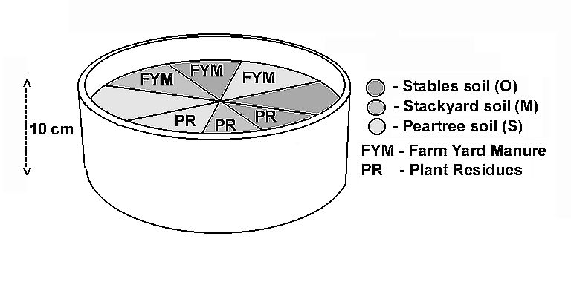

A third series of trials was set up using the same chambers but in a deeper container offering choices of the three separate field soils vertically stacked at two depths (0-10 cm and 10-20 cm). Counts were made at weekly intervals for 4 weeks, the container being maintained in two environments between observations: in a dark cabinet at room temperature for two trials and in constant temperature room at 4ºC for two trials.
Earthworms used in each series of trials were representative of those obtained from the initial field surveys, being an approximately proportional mix of six species at various life stages (actual species compositions used are given in Blakemore, 1981). Summarised results and statistical analyses are presented in Tables 8-10.

RESULTS

Field surveys
Spearman’s coefficient of rank correlation, P, (Skokal & Rohlf, 1973), used to test the association between the numbers and weights of earthworms obtained in the samples, excluding L. terrestris weights, showed a significant positive correlation (p <0.05), justifying comparison of either type of measurement and allowing discussion of relative abundances. An F-max test applied to the monthly sample counts from the arable fields (Skokal & Rohlf, 1973) showed variances were significantly heterogeneous and the data were log transformed for ANOVA. Differences between numbers of earthworms sampled from a field on successive dates, i.e., monthly means counts, were not statistically significant so only the combined data are considered. For convenience, untransformed means of the earthworm data of Appendix 1 are summarized in Table 2 [see also Figure 3].

TABLE 2
Total earthworm numbers and biomass from combined monthly field surveys. *
 | Saxon (Organic) |  | Stables (Organic) | Stackyard (Mixed) | Peartree (Stockless)
No. observations |  | 7 | 32 | 32 | 33
Mean No. (m⁻² ) |  | 424.0a | 178.6b | 97.5c | 100.0c
Mean Wt.** (g m⁻² ) |  | 117.6d | 66.2e | 35.4f | 34.7f
*Row values with different subscripts differ significantly by ANOVA after transformation (log (x+1)), at p<0.01 (except d and e, at p<0.05).
** excluding weights of L. terrestris matures.

Overall, significantly more earthworms occur in the Saxon permanent pasture and, for the arable fields, earthworms are more abundant in the Organic field, Stables, than in the other two fields which differ by non-significant amounts.
Species compositions were compared using Shannon-Wiener diversity indices (H) of the earthworm populations of each field and their equitabilities (evenness indices, E) were found (Krebs, 1972), as shown in Table 3.

TABLE 3
Diversity Indices for total counts of earthworm species from combined monthly field surveys.
 | Saxon (Organic) | Stables (Organic) | Stackyard (Mixed) | Peartree (Stockless)
Shannon-Weiner H | 1.3167 | 1.5083 | 1.5066 | 1.3561
Evenness Index E | 0.6766 | 0.9372 | 0.9361 | 0.8426

The diversity indices indicate that all fields were similar with respect to species diversity, as would be expected with only seven species. However, Saxon showed a slightly lower apparent diversity and less even distribution for species, probably due to its fewer samples, whereas Stables and Stackyard had the highest values.
Coefficients of species similarity between the fields, calculated using modified Sorensen’s (S) method (Waites, 1981 from Wratton & Fry, 1980), are given in Table 4.

TABLE 4
Sorensen’s species similarity (S) between samples from combined monthly field surveys.
 | Saxon (Organic) | Stables (Organic) | Stackyard (Mixed) | Peartree (Stockless)
Saxon | - | 0.583 | 0.627* | 0.305
Stables |  | - | 0.751* | 0.697*
Stackyard |  |  | - | 0.722*
Peartree |  |  |  | -
* Values of S approaching 1 signify similarity.

The only fields to show marked dissimilarity were Saxon and Peartree, all other comparisons were similar with respect to (low) species diversity. Saxon had Ap. rosea and A. longa, high numbers of Al. chlorotica and low numbers of Ap. caliginosa (three specimens) while Peartree had higher counts of Ap. caliginosa and very low counts of Al. chlorotica (three specimens) when compared with the other fields.
Berger Parker dominance indices (d), expressed as the proportion of the total sample numbers due to the most dominant species’ abundance (Southwood, 1978), are presented in Table 5.

TABLE 5
Species dominance indices (d) for total earthworm samples from combined monthly field surveys.
 | Saxon (Organic) | Stables (Organic) | Stackyard (Mixed) | Peartree (Stockless)
Dominant Species | Al. chlorotica | Al. chlorotica | Al. chlorotica | Ap. caliginosa
Dominance Index (d) | 0.559 | 0.374 | 0.346 | 0.419

The indices show no exclusive domination by any one species, although the trend again reflected predominance of Al. chlorotica in the Saxon permanent pasture and Ap. caliginosa in the Stockless Peartree field.
Soil analyses and crop biometry at the time of sampling are presented in Tables 6 and 7.

TABLE 6
Soil assessment and chemical analyses (mean values ± S.E.) of fields. (N/A - not available).
 | Saxon Pasture (Organic) | Stables (Organic) | Stackyard (Mixed) | Peartree (Stockless)
Nov. Temp. at 10 cm depth (°C) | N/A | 10 | 10 | 10
Jan. Temp . at 10 cm depth (°C) | N/A | 2.5 | 1.5 | 0.5
Colour (Munsell) | Black 10YR 2/1 | Dark 10YR 2/2 | Brown 10YR 5/3, mottled | Brown 10YR 4/2
Texture (by hand) | Loam | silty loam | silty clay loam | silty clay loam / clay loam
Structure | Granular | crumb | medium crumb | cloddy
Stoniness | flint gravels | flint gravels | chalk gravels and flints | occasional flints
Bulk density, air-dry (g cm⁻³) | 0.91 | 0.84 | 0.81 | 1.05
Moisture, oven-dry (% dry wt.) | 42 | 31 | 24 | 22
Organic mater, ignition (% dry wt.) | 21 | 11 | 9 | 9
pH (in water) | 7.5 | 7.2 | 7.6 | 7.5
Available P (Olsen’s – ppm) | N/A | 61.6 | 29.4 | 47.4
Total inorganic N (ppm) | N/A | 19.1 (± 0.5) | 13.5 (± 0.7) | 8.4 (± 0.7)
Organic C (%) | N/A | 4.00 (± 0.03) | 2.34 (± 0.03) | 1.75 (± 0.01)
Exchangeable K (me/100g) | N/A | 0.67 (± 0.01) | 0.31 (± 0.01) | 0.51 (± 0.03)
Exchangeable Na (me/100g) | N/A | 0.39 (± 0.01) | 0.35 (± 0.03) | 0.36 (± 0.01)
Available Ca (me/100g) | N/A | 42.1 (± 0.2) | 38.7 (± 0.4) | 45.7 (± 1.6)
Exchangeable Mg (me/100g) | N/A | 1.29 (± 0.01) | 0.60 (± 0.01) | 0.36 (± 0.02)
Available S (ppm) | N/A | 82.5 (± 0) | 42.7 (± 1.4) | 42.5 (± 0.8)
C.E.C. (me/100g) | N/A | 17.9 (± 0.05) | 15.7 (± 0.01) | 13.5 (± 0.4)

TABLE 7
Biometry of winter wheat from fields sampled in January (± standard errors).
 | Stables (Organic) | Stackyard (Mixed) | Peartree (Stockless)
No. plants | 43 | 45 | 46
Mean shoot height (cm) | 19.4 (±2.7)a | 17.2 (±2.7)b | 16.7 (±2.8)b
Mean root length (cm) | 13.0 (±3.3)c | 12.2 (±3.4)cd | 11.6 (±2.9)d
Row values with different subscripts differ significantly by d-test (p<0.05).

The heights of the crop plants from Stables Organic field were significantly greater than those from the other arable fields. Whereas no significant difference was found for the root lengths between Stables and Stackyard, and Stackyard and Peartree (at p=0.05), the roots of the Stables crop were significantly longer than those of the Peartree crop.

Choice trials
The assumption of the trials was that any choice chamber would be freely and equally accessible for earthworm migration and the null hypothesis, that the earthworms would be evenly distributed in the soils, was tested by χ² for goodness of fit (Tables 8-10).

TABLE 8
Choice chambers – counts of earthworms from chambers of same soil mix, combined for three weekly trials.
Chamber No. | 1 | 2 | 3 | 4 | 5 | 6 | 7 | 8 | TOTAL
Total counts | 27 | 31 | 23 | 12 | 21 | 22 | 28 | 31 | 195

Expected total count per chamber was 24.4 (i.e., 195 ÷ 8). Test of association χ² = 11.48, not significant (7 degrees of freedom, p >0.05), i.e., the earthworms do not aggregate. It was therefore implied that any differences obtained for the choice chambers proper may be considered to relate to the soil types offered.

TABLE 9
Choice chambers – counts of earthworms from soil chambers, combined for four weekly trials: ST – Stables field soil; SY – Stackyard field soil; PT – Peartree field soil; FYM – farm yard manure; PR – plant residues (roots).
Chamber | 1 | 2 | 3 | 4 | 5 | 6 | 7 | 8
Field soil | ST | PT | ST | ST | SY | PT | PT | SY
Amendment | FYM | FYM | Nil | PR | PR | PR | Nil | FYM
Total counts | 29 | 54 | 41 | 37 | 58 | 51 | 28 | 52

Expected total count per chamber was 43.75 (p <0.05), therefore the earthworms preferentially selected Peartree and Stackyard soil amended with either FYM or plant residues and avoided unamended soils and Stables soil with amendments.

TABLE 10
Choice chambers – counts of earthworms in equally accessible chambers of different soils at two depths, combined for four weekly trials.
 | Stables  (Organic) | Stackyard  (Mixed) | Peartree  (Stockless) | TOTAL
Upper (0-10 cm) | 56 | 44 | 46 | 146
Lower (10-20 cm) | 40 | 31 | 27 | 98
TOTALS | 96 | 75 | 73 | 244

Expected total count per chamber was 40.7 (p <0.05), i.e., the earthworms tended to prefer the upper Stables choice and avoid the lower Peartree choice, with an overall selection of the Organic soil. [See (Figure 4)].

DISCUSSION
Earthworms appear to be useful indicators of the balance, stability and fertility of the agricultural management regime. The permanent pasture had the greatest earthworm diversity and abundance, ca. 2.4 times higher than the organic field and 4 times that of the others. The organic field, which received annual applications of organic matter, no chemical treatments, and was subject to ley-rotations, had significantly higher numbers again than either the mixed or stockless fields. The mixed and stockless fields yielded equivalent counts, despite the former having a similar agricultural history to the organic field, except that it received agrochemical supplements and, initially, had slightly less time to recover from the plough. These results compare with several previous reports (eg. Tischler, 1955; Barley, 1961; Atlavinyte, 1975; Anderson, 1979; Curry et al., 1995) which have generally found that cropping without the addition of organic manure decreases earthworm populations. Conflicting results were reported by Edwards & Lofty (1975; 1982a; 1982b) from long-term trials in the clay soils of Rothampstead where earthworm populations decreased in inverse proportion to the rates of mineral nitrogen applied, and increased numbers of earthworms resulting from long-term application of organic manure were smaller under grassland than under continuous cereals - the opposite order to those found in the present study. However, the soil at Rothamstead is clayey whereas most agricultural soils in Britain are loams (Russell, 1973). Moreover, the possible recolonization of earthworms from adjacent areas needs to be taken into consideration in small plot trials such as those conducted at Rothhamstead (Howard, 1943), as various species can migrate at least 20 m overnight (Blakemore, 1999).
Using the earthworm counts obtained from the current study, an estimate of number of samples required to give a standard error of 10% of the means (Southwood, 1978) showed that the minimum was six samples per site (cf. Springett, 1992 who had a minimum of ten samples per paddock). The method employed is therefore assumed to have given a reasonably reliable estimate of populations at Haughley.
Species compositions differed at Haughley. While Aporrectodea caliginosa (Savigny) was relatively rare in the permanent pasture (three specimens from seven samples), this species, especially its immatures, was common in all arable fields. Conversely, Ap. rosea (Savigny) and Ap. nocturna (Evans) were found only under permanent pasture. Large, deep-burrowing Lumbricus terrestris was most abundant in the Organic section and, although it was probably under-represented by the depth of sampling, it made such a contribution to total biomass that the weights of the mature specimens, if not excluded from the analyses, would have shown the Organic section to have a substantially greater earthworm advantage. Most of the increased numbers in the Organic section could be accounted for by a single species, Allolobophora chlorotica (Savigny), which is reported (eg. by Sims & Gerard, 1985) to be often numerically co-dominant with Ap. caliginosa in cultivated soils and pastures. Aporrectodea longa (Ude) was fairly evenly distributed between the fields, only slightly more numerous in the Organic section. This is another deep burrowing species (40-60 cm depth) that may have been under-represented in the samples. Some authors report obligatory diapause for Ap. longa and it is believed to be responsible along with Ap. nocturna, from which it is difficult to distinguish, for nearly all of the surface casting in England about which Darwin (1881) wrote. The seventh species reported here was Aporrectodea icterica (Savigny) that occurred infrequently and in low numbers in all fields. It has been previously reported only once from Suffolk, at Brandon (Sims & Gerard, 1985). Two species that might have been expected but were not found in the samples were the small, pigmented Lumbricus castaneus (Savigny) and L. rubellus Hoffmeister, although both species have been reported as totally absent from sandy soils (Tischler, 1955).
All three arable fields had higher ratios of immature to mature specimens at each monthly survey, except for the January sample from Stables which had a high count of mature Al. chlorotica. This result is similar to the survey at Rothamstead by Evans & Guild (1948). The Saxon pasture had a consistently higher proportion of mature specimens, perhaps reflecting the maturity and stability of this 1,000 year old pasture ecosystem. In contrast, Peartree Stockless field tended to have much higher ratios of immatures, possibly related to the populations undergoing a period of expansion, or to differential mortality of matures, or to the reproductive capacities and ecological strategies of the particular species involved. Relating reproduction to the habitat templet extremes: high reproduction is a characteristic of r-strategists in unpredictable, uncrowded and ‘favourable’ habitats, while lower reproductive rate is found with K-strategists in more stable, competitive and ‘predictable’ habitats (Southwood, 1977; Satchell, 1980; Lee, 1985). Ap. caliginosa in the Stockless field could be considered an example of the former situation, while the deep burrowing sub-soil species from the permanent pasture exemplify the latter strategy.
The key characteristic of a fertile soil is good soil structure which is greatly influenced by the activity of earthworms. Known benefits to the soil accruing from earthworm activity are the mixing of the mineral and organic components of the soil and ejection of water-stable, microbially and nutrient enriched cast material below ground and on the surface; and the formation of ramifying burrow systems that aerate and drain the soil, increase water-holding capacity, and provide habitats for other components of the soil ecosystem (Lee, 1985).
Marked differences were detected in the soil analyses, largely corresponding to the amounts of organic matter supplied and, as was reported by Hendrix et al. (1992), this positively correlates with earthworm abundance. The soil from the Organic field had a better structure and higher moisture, organic C and exchangeable cation capacity than the Stockless field; the Mixed field had values somewhat intermediate. Available macronutrient measurements (also expressed in differences in crop growth) were consistently higher in the Organic field, despite the other two fields receiving inorganic fertilizers. Balfour (1977) stated that one of the most important, and previously unexpected, findings from Haughley was that when the plant available nutrients in the soil were analysed at monthly intervals for 10 years, it was revealed that in all three sections these fluctuated according to the season, maximum levels coinciding with the time of maximum plant demand. These fluctuations were far more marked on the Organic section than on the other two, where, moreover, they could be partly related to fertilizer application. Crop yields in terms of both plant growth and nutrient status from the Organic section remained consistently as high as those of the others, although the chemically grown fodder usually had higher water content. She states:
“It was clear, from the fact of the closed cycle, that this seasonal release of minerals could only have been brought about by biological agencies, and it appears to be a natural action-pattern of a biologically active soil.”

The extent to which the various earthworm communities, with their various functions for maintaining soil structure and recycling of nutrients, contributed to the differences observed between the quality of the field soils was unquantifiable and inseparable from the effect the fertility of the soil has in determining earthworm abundance.
In an attempt to empirically relate soil analyses with earthworm abundances, a series of choice trials were run. Such choice trials can be extended to readily determine earthworm preferences for a range of soils and amendments (Blakemore, 1994). Earthworms showed a preference when offered a choice for soil from the Organic section, selecting Stables soil and avoiding Stackyard and Peartree soil. Additional trials using the three field soils alone, or with organic amendments, determined that, at least under the conditions imposed in the laboratory, adding food supply can override the importance of soil type. If such findings could be extrapolated to the field situation, then it would offer a potential remedy to the depleted soil fauna in some situations.
Several other inter-related physical, chemical, and biotic factors may have influenced the field results. Consistent with its organic history, Stables field soil was darker, less compacted, had higher organic matter and more plant cover of both crop and weed, all of which may account for its higher sub-surface temperature in winter - this, in turn, may have increased its earthworm activity (Hopp, 1947; Hopp & Hopkins, 1946). Similar factors may explain why flocks of birds, especially lapwings (Vanellus sp.), were observed to favour the Stockless field where the earthworms, being more exposed and contrasting less against the lighter colour of the soil, were perhaps easier prey. Bird predation can have a negative (eg. Bengston et al., 1976), negligible (eg. Cuendet, 1977) or a stimulatory (Judas, 1989) effect on earthworm populations. Both the Mixed and the Stockless study fields were treated with herbicides and other pesticides, the residues of which may have also affected the earthworms (Lee, 1985) and this may have a deleterious effect on the birds and other predators (Carson, 1972). Mole (Talpa sp.) activity was noted in all fields, especially close to hedgerows, but was not quantified.
Perhaps the most significant finding from the current study is the extent to which an intensive arable regime can degrade the soil and reduce soil fauna. Soils in the respective fields are assumed to have been nearly uniform when the Haughley Experiment was commenced in 1939 (Balfour, 1975), yet at the time of this study there were clearly manifest differences in the arable soils that matched the boundaries of the respective sections of the farm. A particularly striking observation, when sampling in rain, was that the Organic field maintained its well-drained, crumb structure while the Stockless field became so waterlogged and muddy that it could only be walked on or worked with difficulty. This is consistent with findings by Reganold et al. (1987) that organic farming was more effective than conventional farming in reducing soil erosion. Whether is it possible to halt or reverse the degradation of non-organic fields within a similar timeframe by changing the management practices is another question. Unfortunately Lady Balfour’s farm at Haughley no longer exists, during the early/mid 1980’s the Soil Association that managed the farm transferred their activities to Bristol.
The economics, energy requirements and sustainability of the different methods of agricultural production were not compared in this study, neither was an estimate made of the cost of restoring a degraded soil. Yet this report is timely as there is an increasing consumer demand for organic produce and increasing public concern about our environment (Springett, 1991; Wynen, 1997). The Haughley Experiment set out to investigate the effects of organic farming on the health to the farm and to extend this to the effects of diet on human health (see also Fukuoka, 1978). Although the experiment was terminated before this final crucial link was made, the hidden costs of conventional agriculture in terms of chemical residues in the food chains of humans and other organisms are an intractable problem.

CONCLUSION
Earthworms appear to be effective indicators of soil quality at a point in time under contrasting agricultural management. An organic regime was found to have a positive influence on earthworms and on soil structure and fertility, albeit these three are synonymous, when compared with an intensive arable regime that had both a depauperate earthworm fauna and a more degraded soil. A mixed regime combination of organic and conventional farming practices, was found to be almost as deleterious as the intensive arable regime, suggesting that this is not a complementary compromise. Severe penalties were detected, in terms of earthworm population, soil structure and plant growth, under long-term intensive farming practices that contravene natural processes and rely on synthetic fertilizers and pesticides rather than rotation and the return of organic matter to the soil. The results of this study support findings by Reganold (1989, 1991) that organic farming was more effective in maintaining soil productivity, and also the conclusion by Edwards (1983) that if soil organic matter is preserved and the use of harmful chemicals is avoided, then higher earthworms populations are attainable. It is important to stress that the complexities of natural systems do not lend themselves to fragmentary investigation. An attempt needs always be made to relate the earthworm component to the interplay of various other physical, chemical and biotic factors operating within the soil-earthworm-microbe-plant ecosystem. However, as an organic system matures, the earthworm populations, as well as contributing to the stability and fertility of the soil, may provide a useful monitor for assay and certification.

ACKNOWLEDGMENTS
The J.A. Pye Research Laboratories, who managed the Haughley farm under the auspices of the Soil Association, were generous in allowing access to the site and to farm diaries and for supplying the soil chemical analyses. Laboratory and other facilities were made available by the authorities and staff at PCL, London where Drs Martin Collins, Ann Rumpus and Mike Rees are especially thanked. Dr. Stephanie Greshon gave assistance in the field during a cold and wet January. Accommodation was very kindly provided by my grandmother Mrs. D. Pallett of Eye, Suffolk. This work was undertaken as part of a B.Sc. Honours thesis at PCL (Westminster University), and as a tribute to mark the centenary of Darwin’s publication, funded by a grant from Suffolk County Council.

REFERENCES
Anderson, C. (1979). The influences of farmyard manure and slurry on the earthworm population (Lumbricidae) in arable soil. In Soil Biology as Related to Land Use Practices (D.L. Dindal, ed.), Proceedings of the VII International Colloquium of Soil Zoology, E.P.A., Washington, D.C., pp. 326-335.
Arden-Clarke, C. & Hodges, R.D. (1988). The environmental effects of conventional and organic/biological farming systems. II Soil ecology, soil fertility and nutrient cycling. Biological Agriculture & Husbandry, 5, 223-287.
Atlavinyte, O. (1975). Ecology of Earthworms and their Effect on the Fertility of Soils in the Lithuanian SSR; Mokslas Publishers, Vilnius, Lithuania.
Balfour, E.B. (1975). The Living Soil and the Haughley Experiment, (2nd edn.). Faber & Faber; London, U.K.
Balfour, E.B. (1977). Towards a Sustainable Agriculture – The Living Soil. Address to an International Federation of Organic Agricultural Movements (IFOAM) conference in Switzerland, 1977; http://www.netspeed.com.au/cogs/cogbal.htm.
Barley, K.P. (1961). The abundance of earthworms in agricultural land and their possible significance in agriculture. Advances in Agronomy, 13, 249-268.
Bauchhenss, J. (1991). Comparative study of earthworm taxocenoses in five alternative and five conventional farming systems. Bayer Landwirschafts Jahrbuch, 68, 430-443. (In German).
Bengston, S.-A., Nilsson, A., Nordström, S. & Rundgren, S. (1976). Effects of bird predation on lumbricid populations. Oikos, 27, 9-12.
Blakemore, R.J. (1981). A Study of the Ecology of Earthworms under Different Fertilizer Regimes in Agriculture. BSc Honours thesis (801/1/22) at PCL (Westminster University), London, U.K.
Blakemore, R.J. (1994). Earthworms of South-east Queensland and their Agronomic Potential in Brigalow Soils. PhD thesis, University of Queensland, St Lucia, Australia.
Blakemore, R.J. (1999). Diversity of exotic earthworms in Australia – a status report. In The Other 99% - The Conservation and Biodiversity of Invertebrates (Ponder, W. & Lunney, D. eds), Transactions of the Royal Society New South Wales; Mosman, NSW 2088, Australia, pp. 182-187.
Carson, R. (1972). Silent Spring. Penguin Books, New York, U.S.A.
Courtney, F.M. & Trudgill, S.T. (1976). The Soil: An Introduction to Soil Study in Britain. Arnold; London, U.K.
Cuendet, G. (1977). Etude du comportement alimentaire des Mouettes rieuses (Larus ridibundus) et de leur influence sur les populations de vers de terre, Ornithol. Beob., 2, 87-88.
Curry, J.P., Byrne, D. & Boyle, K.E. (1995). The earthworm population of a winter cereal field and its effects on soil and nitrogen turnover, Biology & Fertility of Soils, 19, 166-172.
Darwin, C.R. (1881). The Formation of Vegetable Mould Through the Action of Worms with Observations of Their Habits, (4th Impression, 1966). Murray; London, U.K.
Edwards, C.A. (1983). Earthworm ecology in cultivated soils. In Earthworm Ecology: From Darwin to vermiculture (J.E. Satchell, ed.), Chapman & Hall, London, U.K., pp 123-137.
Edwards, C.A. & Bohlen, P.J. (1996). Biology and Ecology of Earthworms, (3rd edn.), Chapman & Hall, London, U.K.
Edwards, C.A. & Lofty, J.R. (1975). The invertebrate fauna of the Park Grass plots. Report of Rothamsted Experimental Station for 1974, Pt. 2, pp. 133-154.
Edwards, C.A. & Lofty, J.R. (1980). Biology of Earthworms, (2nd edn.), Chapman & Hall; London. U.K.
Edwards, C.A. & Lofty, J.R. (1982a). Effects of direct drilling and minimal cultivation on earthworm populations. Journal of Applied Ecology, 19, 723-734.
Edwards, C.A. & Lofty, J.R. (1982b). Nitrogenous fertilizers and earthworm populations in agricultural soils. Soil Biology & Biochemistry, 14, 515-521.
Evans, A.C. & Guild, W.J. (1948). Studies on the relationship between earthworms and soil fertility. V. Field populations. Annals of Applied Biology, 35, 485-493.
FitzPatrick, E.A. (1974). An Introduction to Soil Science. Oliver & Boyd; Edinburgh, Scotland.
Fukuoka, M. (1978). The One Straw Revolution. A translation, with additions, of the author’s Shizen noho wara ippon no kakumei, published by Hakujusha in 1975. Rodale Press; Emmaus, U.S.A.
Gerard, B.M. (1964). Synopsis of the British Fauna (b) Lumbricidae. Linnaean Society of London, U.K.
Greenland, D.J. (1981). Soil management and soil degradation. Journal of Soil Science, 32, 301-322.
Hendrix, P.J., Mueller, B.R., Bruce, R.R., Langdale, G.W. & Parmelee, R.W. (1992). Abundance and distribution of earthworms in relation to landscape factors in the Georgia Piedmont, U.S.A. Soil Biology & Biochemistry, 24, 1357-1361.
Hodges, R.D. (1978). The Case for Biological Agriculture. The International Institute of Biological Husbandry. Review Paper, Series No. 1.
Hopp, H. (1947). The ecology of earthworms in cropland. Soil Science Society of America Proceedings, 12, 503-507.
Hopp, H. & Hopkins, H.T. (1946). The effects of cropping systems on the winter populations of earthworms. Journal of Soil Water Conservation, 1, 85-88, 98.
Howard, A. (1943). An Agricultural Testament. Oxford University Press, New York and London.
Judas, M. (1989). Predator-pressure on earthworms: field experiments in a beech-wood. Pedobiologia, 33, 339-354.
Krebs, C.J. (1972). Ecology; the Experimental Analysis of Distribution and Abundance. Harper & Row; London, U.K.
Lee, K.E. (1985). Earthworms: Their Ecology and Relationships with Soils and Land Use. Academic Press; Sydney, Australia.
Marinissen, J.C.Y. (1992). Population dynamics of earthworms in a silt loam under conventional and “integrated” arable farming during two years with different weather patterns. Soil Biology & Biochemistry, 24, 1647-1654.
Mollison, B. (1991). Introduction to Permaculture, (2nd edn.), Tagari Publications; Tyalgum, Australia.
Nakamura, Y & Fujita, M. (1988). Abundance of lumbricids and enchytraeids in an organically farmed field in northern Hokkaido, Japan. Pedobiologia, 32, 11-14.
Pfiffner, L. & Mäder, P. (1997). Effects of Biodynamic, Organic and Converntional Production Systems on Earthworm Populations. Entomological Research in Organic Agriculture, Biological Agriculture & Horticulture, 15, 3-10.
Reganold, J. (1989). Farming’s organic future. New Scientist, 1668, 31-34.
Reganold, J. (1991). Organic vs. conventional farming - what’s the difference? Acres Australia, 4, 30-33, 52.
Reganold, J., Elliott, L.F. & Unger, Y.L. (1987). Long-term effects of organic and conventional farming on soil erosion. Nature, 330, 370-372.
Russell, E.W. (1973). Soil Conditions and Plant Growth, (10th edn.), Longman’s; London, U.K.
Satchell, J.E. (1971). Earthworms. In Methods of Study in Quantitative Soil Ecology (J. Phillipson ed.), IBP Handbook No. 18, Blackwell Scientific, Oxford, U.K.
Satchell, J.E. (1980). r worms and K worms: A basis for classifying lumbricid earthworm strategies. In Soil Biology as Related to Land Use Practices (D.L. Dindal, ed), Procedings 7th International Colloquium of Soil Zoology, Syracuse, 1979. Enviromental Protection Agency; Washington, D.C., U.S.A., pp 848-854.
Sims, R.W. & Gerard, B.M. (1985). Earthworms: synopses of the British fauna. (Pub. E.J. Brill; Leiden). Natural History Museum; London, 31, 1-171.
Skokal, R.R. & Rohlf, F.J. (1973). Introduction to Biostatistics. Freeman; London, U.K.
Southwood, T.R.E. (1977). Habitat, the templet for ecological strategies? Journal of Animal Ecology, 46, 337-365.
Southwood, T.R.E. (1978). Ecological Methods, (2nd edn.), Chapman & Hall, London, U.K.
Springett, J.A. (1991). Organic farming - learning not to panic. Search, 22, 83-84.
Springett, J.A. (1992). Distribution of lumbricid earthworms in New Zealand. Soil Biology & Biochemistry, 24, 1377-1381.
Tischler, W. (1955). Effects of agricultural practice on the soil fauna. In Soil Zoology (M.D.McE. Kevan, ed.), Butterworths; London, U.K., pp 125-137.
USDA (1980). Report and Recommendations on Organic Farming. U.S. Department of Agriculture; Washington, D.C., U.S.A.
Waites, S. (1981). Useful indices of species structures in communities, PCL (unpublished); from: Wratton, S.A. & Fry, G.L.A. (1980), Field and Laboratory Exercises in Ecology, Arnold, London, U.K.
White, R.E. (1979). An Introduction to the Principles and Practices of Soil Science, Blackwell Scientific; London, U.K.
Wynen, E. (1997). Impact on Australian Broadacre Agriculture on Widespread Adoption of Organic Farming. Centre for Resource and Environmental Studies, Resource and Environmental Studies No. 14, Australian National University; Canberra, Australia.

(Received 1 January 2000; accepted 26 June 2000)
Appendix 1. Numbers and biomass of earthworm species sampled from fields of farm sections on different dates in 1980/1 with means transformed to m⁻². (No. - number, wt. - weight, mat. - matures, im. - immatures).
 | Saxon Pasture (Organic) |  |  |  | Stables (Organic) |  |  |  | Stackyard (Mixed) |  |  |  | Peartree (Stockless)
 | Oct. | Nov. | Dec. | Jan. | Oct. | Nov. | Dec. | Jan. | Oct. | Nov. | Dec. | Jan. | Oct. | Nov. | Dec. | Jan.
No. samples | 1 | 3 | 1 | 2 | 3 | 10 | 9 | 10 | 3 | 10 | 9 | 10 | 3 | 10 | 10 | 10
Al. chlorotica - mat. | 7 | 25 | 1 | 24 | 5 | 24 | 19 | 46 | 1 | 16 | 17 | 14 | 0 | 0 | 2 | 0
Al. chlorotica – im. | 7 | 27 | 3 | 11 | 10 | 15 | 8 | 8 | 3 | 9 | 2 | 10 | 0 | 0 | 1 | 0
Ap. caliginosa – mat. | 0 | 1 | 0 | 0 | 2 | 14 | 9 | 7 | 0 | 6 | 7 | 8 | 3 | 9 | 10 | 5
Ap. caliginosa - im. | 2 | 0 | 0 | 0 | 6 | 21 | 12 | 5 | 1 | 19 | 5 | 9 | 8 | 12 | 19 | 16
Ap. longa/ nocturna – mat. | 3 | 4 | 1 | 5* | 0 | 4 | 3 | 1 | 1 | 3 | 15 | 5 | 0 | 0 | 1 | 2
Ap. longa – im. | 3 | 10 | 2 | 7 | 4 | 13 | 21 | 9 | 2 | 11 | 0 | 9 | 8 | 20 | 14 | 3
L. terrestris – mat. | 0 | 1 | 0 | 0 | 0 | 9 | 4 | 5 | 0 | 1 | 2 | 1 | 0 | 1 | 2 | 1
L. terrestris – im. | 2 | 4 | 2 | 3 | 5 | 12 | 11 | 14 | 1 | 10 | 3 | 5 | 4 | 10 | 7 | 4
Ap. icterica – mat. | 0 | 2 | 0 | 1 | 0 | 6 | 2 | 1 | 0 | 1 | 0 | 1 | 0 | 1 | 1 | 1
Ap. icterica – im. | 0 | 0 | 1 | 3 | 0 | 5 | 9 | 12 | 0 | 8 | 1 | 10 | 1 | 10 | 4 | 14
Ap. rosea – mat. | 1 | 6 | 8 | 1 | 0 | 0 | 0 | 0 | 0 | 0 | 0 | 0 | 0 | 0 | 0 | 0
Ap. rosea – im. | 3 | 1 | 5 | 1 | 0 | 0 | 0 | 0 | 0 | 0 | 0 | 0 | 0 | 0 | 0 | 0
Mean No. (m⁻²) | 448.0 | 432.0 | 368.0 | 448.0 | 170.7 | 196.8 | 174.2 | 172.8 | 48.0 | 134.4 | 92.4 | 115.2 | 128.0 | 100.8 | 97.6 | 73.6
Mean Wt.** (g m⁻²) | 132.0 | 95.3 | 87.2 | 156.0 | 87.6 | 51.0 | 65.1 | 61.2 | 27.9 | 35.8 | 29.0 | 49.0 | 38.9 | 35.8 | 39.9 | 24.2
L. terrestris-mt. (g m⁻²) | 0 | 16.5 | 0 | 0 | 0 | 40.3 | 30.2 | 23.7 | 0 | 6.2 | 13.5 | 6.1 | 0 | 5.2 | 10.8 | 4.4
* Two identified as Ap. nocturna mat. ** Excluding L. terrestris mat. which are tabulated separately with mean wt. standardized to gm⁻².

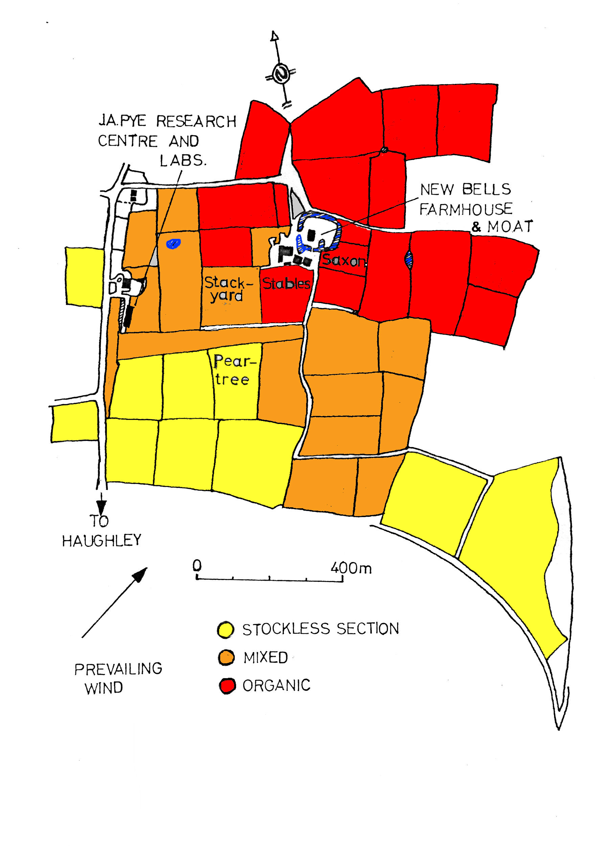
FIGURE 1. Plan of Haughley Farm.

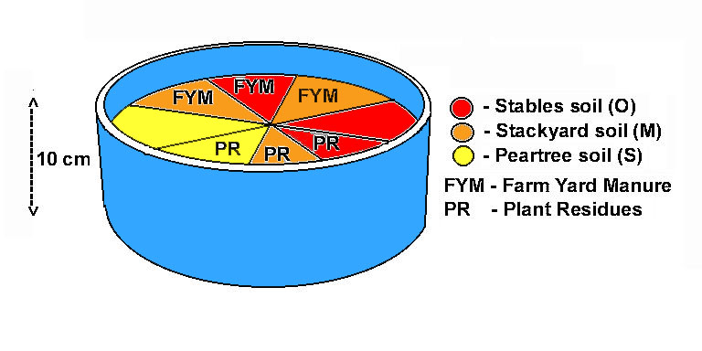FIGURE 2. Choice trial arrangement.

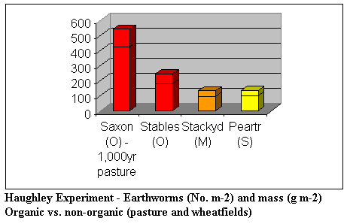
[FIGURE 3 Summary of field survey results (TABLE 2)]
[FIGURE 4 Choice trial overall results (TABLE 10)]

Additional Information added May, 2005

Lady Eve Balfour (1977): "Towards a Sustainable Agriculture--The Living Soil"

See also:

Balfour, E.B. (1943) "The Living Soil and the Haughley Experiment" Faber & Faber, London.
http://www.soilandhealth.org/01aglibrary/01aglibwelcome.html

Link to Soil Association website about Lady Eve Balfour and her "Haughley Experiment" - http://homepages.tesco.net/~Haughley/soilass.htm

Biography of Lady Eve from Organic (Ltd.) website - http://organic.com.au/people/EveBalfour/

Another online Biography (May, 2005) - http://lady-eve-balfour.biography.ms/

Sir Albert Howard's (1943) "An Agricultural Testament"
http://www.soilandhealth.org/01aglibrary/01aglibwelcome.html
http://www.soilandhealth.org/01aglibrary/010105.ag.test/010104.toc.html

