Farmer’s perception and experiences in dairy production under organic farming systems in central Uganda

S Nalubwama¹, F Kabi² , M Vaarst³, M Kiggundu ²

¹Department of Livestock and Industrial Resources, Makerere University, P.O. Box 7062, Kampala, drnalubwama@gmail.com.
²Department of Agricultural Production, Makerere University P.O. Box 7062, Kampala
³Department of Animal Science, Aarhus University, P.O. Box 50, DK-8830 Tjele, Denmark.

Abstract
In Uganda, certified organic livestock production is almost non-existent yet livestock is an integral part of many organic farms. With the increasing global market for organic foods, farmers cannot afford to overlook the emerging opportunity for organic livestock production. A survey to understand farmers’ perceptions and experiences in dairy production was undertaken on 30 certified organic pineapple farms with dairy cattle using a semi-structured questionnaire. Results indicated that average age of respondents was 48 years with majority (53.3%) having attained the minimum primary education. Land tenure system was majorly customary (96.7%). Farms had 0.4-2.6 acres of land for livestock production and 1-2 dairy cows. Tethering/free-range grazing (74.4%). was the commonest dairy management system. Milk yield and robustness were the main criteria for breed selection. Weather was rated highly as the risk factor to yields. Knowledge and market information were perceived as main considerations for adopting organic dairying. Disease was the main constraint to dairy production. Future development of organic dairy production will require providing farmers with knowledge on organic animal husbandry and market information on prospective organic animal products.

Key Words
Organic, perception, dairy, Uganda
Introduction
The global market for organic food and drinks has been increasing (Sahota, 2013). Uganda has an estimated 188,625 certified organic producer (FiBL & IFOAM, 2013) mainly in crop production whereas organic livestock production is almost non-existent. Majority of smallholder organic farmers have livestock as part of their farming system, hence cannot overlook the emerging opportunity of organic livestock production. In general organic production is knowledge and management intensive requiring good understanding of organic standards, principles and practices (Chander et al. 2011). Currently there is little documented information on farmers’ perception and experiences in dairy production under organic systems so as to understand future development prospects. This paper presents these based on data from a survey among organic pineapple producers with dairy cows in Luwero and Kayunga districts, central Uganda collected for one year.

Materials and Methods
A total of 30 organic farms were purposively selected based on the dairy management system in Kayunga and Luwero districts. Using a semi-structured questionnaire, data was collected on demographics, farm and herd size, management system plus farmer perceptions and experiences in dairying with major areas of inquiry as; risk sources and effects on yields and prices, dairy production constraints and aspects for introduction of organic husbandry. Data was analyzed for descriptive statistics; Farmer perceptions were analyzed using Likert-sample-rating. Data was analyzed using SPSS statistical package (SPSS Inc., Chicago, Illinois, USA). Indices were calculated to obtain rankings for current production constraints to dairy production.

Results
Respondent and Farm characteristics
Most respondents were males (86.7%) with average age of 48 years. Majority (53.3%) had attained primary education. Customary land ‘Kibanja’ was the commonest (96.7%) land tenure system. Family labor (67%) was used most for farm activities. Majority of the farmers (74.4%) managed their animals using tethering and free- range grazing systems while 26.7% used zero grazing. Farmers allocated an average of 3-6 acres of land to crops (approximately 60% of their total land) and 0.4 - 2.6 acres of land to livestock. Farmers owned 1-2 dairy cows. All farms (100%) were diversified having cattle and various crops mainly pineapples and coffee as the cash crops. Food crops included bananas, beans, sweet potatoes and cassava.

How farmers integrate crops and livestock

Majority of farmers (60%) reported integrating bananas, pineapples and livestock enterprises on their farms citing the use of pineapple, banana peels and other crop residues (15%) as animal feeds and manure as fertilizer to improve soil fertility. Also, 32% of farmers reported that; part of the revenue from pineapples is used in buying inputs for cows. Meanwhile, majority thought there was no contribution from pineapples to livestock (53%).
Criteria for breed selection

Farmers reported high milk yield and robustness as main criteria used in selecting dairy breeds (Figure 1).

Figure 1: Rating farmers’ perception on importance of particular criterion for breed selection

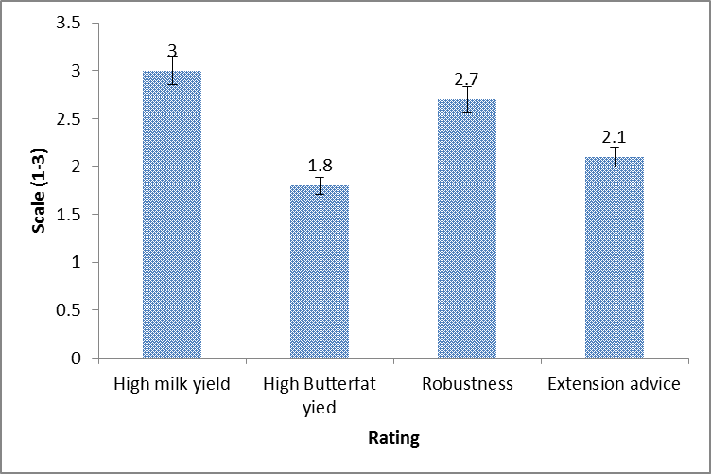

Note: Rating was done on scale 1-3 (1= unimportant, 2=important, 3=very important)

Farmers perception on farm risk factors and perceived effects on farm yield and prices

Weather was rated the highest risk factor to yields. whereas policy was rated as having least effect. (Figure 2). Knowledge and market information were rated as factors having higher effects on prices.

Figure 2: Farmers perception on effect of different risks on yields and prices

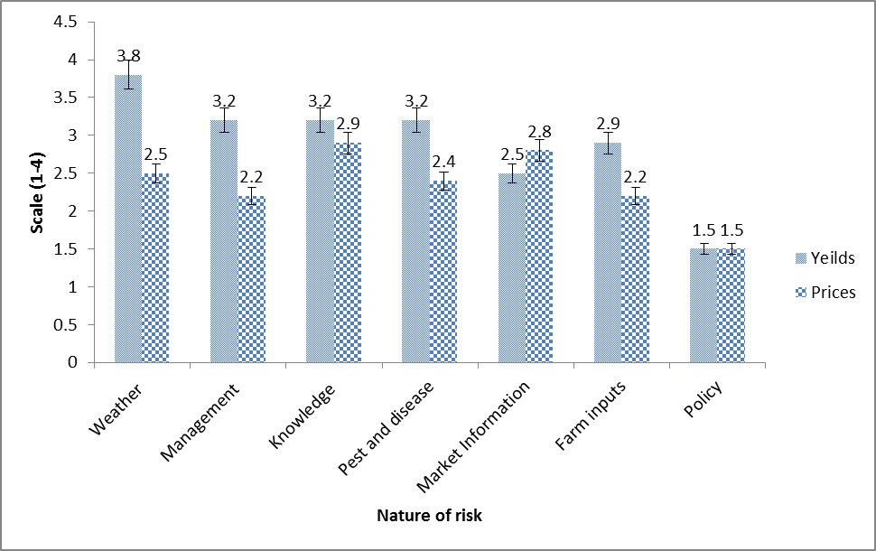

Note: Rating was done on scale: 1-4 (1- very low; 2-low; 3-high; 4- very high)

Aspects important for adopting organic dairy production

Farmers were asked to rate the different aspects important for adopting organic animal husbandry at a scale of 1-3 (1- unimportant, 2- important, 3- very important) . Information/Knowledge was rated highest (scale-2.7). whereas the error bars indicated no significant difference in importance of the other aspects (capital, inputs, market information and years of conversion) rated at scale 2.5.
Constraints faced by the dairy farmers
Farmers reported diseases as the major constraint in dairy production as indicated in Table 1.
Table1: Major constraints in dairy production as perceived by organic farmers
 | Rank (no. of responses)
Constraint |  | 1st | 2nd | 3rd |  | Index*
Diseases and pests |  | 7 | 5 | 0 |  | 0.313131
Labor |  | 3 | 3 | 2 |  | 0.171717
Expensive inputs (feeds, drugs) |  | 3 | 1 | 0 |  | 0.111111
Markets for products |  | 2 | 1 | 2 |  | 0.101010
lack of feeds/ water in dry season |  | 2 | 0 | 0 |  | 0.060606
Limited Land |  | 1 | 1 | 1 |  | 0.060606
limited herbal remedies for livestock diseases |  | 1 | 0 | 1 |  | 0.040404
land insecurity |  | 1 | 0 | 0 |  | 0.030303
Weather changes |  | 1 | 0 | 0 |  | 0.030303
Limited veterinary services |  | 1 | 0 | 0 |  | 0.030303
Poor milk prices |  | 1 | 0 | 0 |  | 0.030303
thieves |  | 0 | 0 | 1 |  | 0.010101
transport to ferry pasture |  | 0 | 0 | 1 |  | 0.010101
 |  | 23 | 11 | 8 |  | 1
* Index = (3 × Number of responses for 1 rank + 2 × Number of responses for 2 rank + 1 × Number of responses for 3 rank) ÷ (3 × Total responses for 1st rank + 2 × Total responses for2 rank + 1 × Total responses for3rd rank)

Discussion
Household and farm characteristics
Organic farming being knowledge and management intensive (Chandler, 2010) requires farmers’ learning ability which farmers seem to have based on their literacy level. Earlier studies (Umoh, 2006; Lukas and Cahn, 2008) reported that literacy among farmers improves the level of adoption of new technology and ability to utilize market information and market opportunities. (Lubungu et al., 2012). The land tenure system being customary does not offer formal security to land ownership. This may therefore deter farmers from investing in long term and expensive ventures like dairy production. As also earlier reported (Kiggundu et al., 2014), farmers allocate less land to livestock production probably due to limited land and competing farm enterprises. This therefore makes land a critical factor for future conversion to organic dairy production.
Farmers perceived their farms as well integrated citing nutrient recycling. However, majority of the farmers practiced tethering or free-range grazing. This implies that substantial amounts of manure are deposited in the grazed fields and are unavailable leaving only access to manure deposited in kraals overnight. To ensure availability of substantial quantities of manure would also mean confinement of cattle thereby limiting their free outdoor movement, a practice discouraged in organic farming. As such, there is a need for management strategies integrating free animal movements and the ability to access and utilize all the manure so as to solve the current dilemma smallholder farmers have regarding nutrient recycling, an aspect important in organic management.

Criteria for breed selection
In a bid to increase milk production, technologies like cross-breeding have been promoted in Uganda. However, the decision to upgrade local breeds also comes with consequences, since upgrading also reduces animal’s robustness and increase susceptibility to vectors and vector borne diseases which are endemic in tropical regions (Vaarst et al., 2006; Nalubwama et al., 2011; 2014). This is qualified in this study when farmers ranked disease as the major constraint to dairy production. This is even a greater challenge for organic farmers whose use of synthetic chemicals is limited by the organic standards. As such, when farmers adopt crossbreeding, they have to focus on strict management practices without which, they risk losing their animals. In order to balance the need for robustness and milk yield in organic systems, it may be necessary to focus on vigorous selection within well adapted indigenous breeds rather than only focusing on high milking exotic breeds.

On farm risk factors and aspects for adoption of organic dairy farming
Weather was perceived as a major risk factor to improved yields probably because farming is mainly rain fed. Livestock faces feed shortages during dry season since they mostly rely on natural pastures. Therefore farmers need to adopt technologies to conserve feeds for the dry seasons. Access to knowledge/information was seen as an important requirement for adoption of organic dairying. Currently farmers are using conventional methods in dairy production despite farms being certified for crop production due to limited knowledge on alternatives. Therefore provision of training in organic husbandry practices is important for these farmers. This study has also demonstrated that adoption of a new venture requires access to market information in the farmers view.

Conclusions
Land availability and tenure system were found to be critical factors in developing organic dairy production in study area. Farmers considered milk yield and robustness as criteria for breed selection. Weather was the major on-farm risk factor for improved yields. Knowledge, diseases and market information were other factors considered important. Knowledge was considered as the most important aspect for adoption of organic dairy production. Therefore future development of organic dairy production will require providing farmers with knowledge on organic animal husbandry and market information on prospective organic animal products.

References

- Chander, M., Subrahmanyeswari, B., Mukherjee, R., Kumar, S., 2011. Organic livestock production: an emerging opportunity with new challenges for producers in tropical countries. Rev.sci. tech. Off.int. Epiz. 30, 969-983.
- Kiggundu. M, Kabi.F, Vaarst. M, Nalubwama.S, and Odhongo. C. 2014. Management and use of dairy cattle feed resources on smallholder certified organic pineapple farms in Central Uganda. Journal of Agriculture and Environment for International Development-JAEID, 108 (2): 207-225
- Lubungu M., Chapoto A. and Tembo G., 2012. Smallholder Farmers Participation in Lukas M. and Cahn M., 2008. Organic agriculture and rural livelihoods in Karnataka, India. In: IFOAM Organic World Congress, Modena, Italy
- Nalubwama S M, Mugisha A and Vaarst M 2011 Organic livestock production in Uganda: Potentials, Challenges and Prospects. Tropical Animal Health and Production 4, 749
- Nalubwama S., Vaarst M., Kabi F., Kiggundu M., Bagamba F., Odhong C., Mugisha A. and Halberg N., 2014. Challenges and prospects of integrating livestock into smallholder organic pineapple production in Uganda. Livestock Research fo Rural Development 26.
- Sahota, Amarjit (2013): The Global Market for Organic Food and Drink. In: FiBL& IFOAM (2013): The World of Organic Agriculture. Statistics and EmergingTrends. Frick and Bonn
- Umoh G. S., 2006. Resource use efficiency in urban farming: An application of stochastic frontier production function. International Journal of Agriculture and Biology 8: 38-44.
- Vaarst M, Roderick S, Byarugaba D K, Kobayash I S, Rubaire-Akiiki C and Karreman H J 2006 Sustainable veterinary medical practices in organic farming: A global perspective. In: Halberg N, Alrøe HF, Knudsen MT, Kristensen E S (Eds.), Global Development of Organic Agriculture, Challenges and Prospects. CABI Publishing, pp. 241-276
- Willer, H and Kilcher, ed (2012). “The World of Organic agriculture- Statistics and Emerging Trends 2012”. Research Institute of Organic Agriculture (FiBL), Frick and International Federation of Organic Agriculture Movements (IFOAM), Bon

Tethering system: Here an animal is tired with a rope either on the front or hind leg or around the horns to a tree or pole so that it grazes in a specific radius. It’s changed to new pastures from time to time.

