Food Soybean Varieties in Low-Input Conditions
Archived at http://orgprints.org/28177/

Grain Yield and Quality from Three NE Italy Environments

Fabiano Miceli ¹, Michael Centa¹, Riccardo De Infanti¹, Marco Signor²

¹University of Udine, DISA, Udine, Italy, www.uniud.it/dipartimenti/disa, fabiano.miceli@uniud.it
²Friuli Venezia Giulia Region, ERSA, Pozzuolo del Friuli, Italy, www.ersa.fvg.it, marco.signor@ersa.fvg.it

Key words: soybean, food grade, low input, seed quality

Summary: Soybean has been diffusely grown in northern Italy since early 1980s. Indeed, at present the organic area (less than 3 % of the total) and the practical absence of certified non-GM productions are key issues for farmers and food processors. In 2013, four food-grade varieties were tested under organic or low-input conditions in three environments of Friuli, NE Italy. Environments had a large impact on grain yields, genotypes on grain composition. Late planting resulted in lower yields and high-protein seeds. Seed protein levels were associated to visual seed quality.

Background

With approximately 40% of the EU-27 acreage, Italy ranks at the 15th place among producing countries for soybean production (Rüdelsheim and Smets 2012). The eastern part of the Po valley accounts for approximately 75% of the italian area (Miceli 2012). Indeed, organic farming is still of minor importance, reaching 4.5 % of the acreage in the EU and only 2.3% in Italy. Crushing plants are largely dependent upon imported (i.e. > 90% GM) seeds to sustain the feed industry huge requirements. Taking into account the non-GM issue, soyfood processors and selected feed industries are considering alternative, certified non-GM, seed sources. Knowledge on new soybean varieties adaptation to low-input and/or organic agriculture should facilitate farmers to enter into those production systems.

Main chapter

In 2013 a small set of soybean varieties, tentatively suited for food production (large seeds, pale hilum and high seed protein) were tested in three locations of the Friuli Venezia Giulia region, within a latitude range within 45°43’25.60” N (Fossalon) and 46°02’16.23” N (Udine). Three varieties belonging to Maturity Group (MG) I (Luna, Brillante and Prana) and one MG 0 (Energy) variety were included in the test. Planting dates varied with locations, spanning from full-season crop (early May, at Fossalon) to double crop (early July, at Udine). Regimes, locations and planting dates were united as three distinct environments; additional data are presented in table 1. The experiment was arranged in blocks, with six reps for each environment.

Locations | Soil type | Agricultural  system | Previous crop | Planting dates | Weed control | Irrigation
Fossalon | silty loam | organic | zucchini | May 9 | mechanical | No
Fiume V. | loam | low input | alfalfa | June 6 | mechanical | Yes, 7 app.
Udine | sandy loam | low input | winter wheat | July 6 | mechanical | Yes, 3 app.

Table 1. Locations, soil types and management information about the 2013 field experiment.

The environment per se caused large and significant impacts on most traits. On average, grain yields reached 2.78 t DM ha⁻¹ after 16 weeks (VE-R8, Fehr & Caviness phenological scale). Poor yields were obtained at Udine (1.45 t ha⁻¹) compared with the other environments. Possible drivers for such yields
were the late planting, a lower crop density (17.5 plants m⁻² at harvest at Udine, 33.2 and 20.2 plants m⁻² respectively at Fossalon and Fiume Veneto), which in turn could be related to a higher weed density (data not present). No significant differences were observed among varieties for grain yields, thousand seed weight and other yield components. Indeed, seed composition was significantly influenced by both the environment and the genotype. Energy and Prana had a higher seed protein concentration (441 g/kg), compared to the other two genotypes (411 g/kg); the opposite was true for oil content. A visual inspection for seed quality pointed out that sound seeds, i.e. those with no sign of deterioration or discoloration, as percentage dropped in double-crop conditions (54 percent at Udine vs. 98 and 89 percent, respectively at Fossalon and Fiume Veneto).
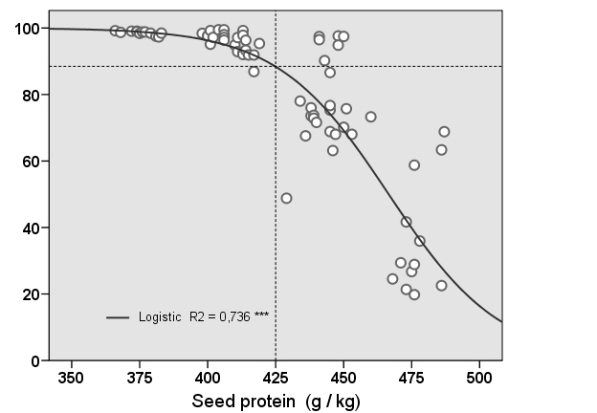
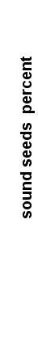

Figure 1. Relationship between seed protein content and seed quality from four soybean varieties grown in three environments of Friuli Venezia Giulia (NE Italy).

The increase of seed proteins, a known effect of late planting (Benati et al., 1988; Vollmann et al., 2000), was associated to seed quality degradation (figure 1). From the logistic regression model, a protein concentration above 425 g/kg was associated to a steep decline in seed quality. Additional work to validate these observations on a broader scale may be relevant for both breeders and farmers interested in food-grade soybean production.

References

Benati R., F. Danuso, M. Amaducci, G. Venturi 1988. Effetti dell’epoca di semina della soia sul contenuto proteico e lipidico del seme di soia (Glycine max (L.) Merr.). Rivista di Agronomia, 22, 4, 279-287.
Miceli F. 2012. Una piattaforma danubiana per la soia italiana non-GM? Bioagricoltura, 135-136, 40-41.
Rüdelsheim P. L. J., G. Smets 2012. Baseline information on agricultural practices in the EU Soybean (Glycine max (L.) Merr.). Available at: http://www.europabio.org/baseline-information-agricultural-practices-eu-soybean-glycine-max-l-merr [Accessed 8 May 2014].
Vollmann J., C. Fritz, H. Wagentristi H., P. Ruckenbauer 2000. Environmental and genetic variation of soybean seed protein content under Central European growing conditions. Journal of the Science of Food and Agriculture, 80: 1300-1306.

