The Future of Australian Organics in a Changing Marketplace

Dr Andrew Monk
CEO
Biological Farmers of Australia Co-op Ltd

Archived at http://orgprints.org/00002547
Introduction

Organic as a “category” is a multi sector industry with international regulations, national, bi and multi governmental agreements. Organic is regulated in various countries and markets by both non government organisation guidelines (International Federation of Organic Agriculture Movements, IFOAM), as well as the government recognised processes of the Codex Alimentarius Commission, and in turn national regulations in selected countries.

The leading standards emerging around the world are in the US via USDA NOP (US Department of Agriculture National Organic Program) covering over 40% of the world market, and the EU (regulation EEC 2092/91 and amendments), representing some 30%. These standards, which are the regulations pertaining to what producers and marketers of organic products may and may not do in the production process, have a common backbone of prohibition of use of most synthetic agrichemicals, GMOs, food irradiation, and most food additives bar a very restricted “necessary” list.

This multiple “package” of requirements for those who enter the organic market is the hallmark of the organic industry and arguably has led to both challenges to growing the industry, given the difficulties for some sectors in developing highly productive and growing supply bases, while at the same time has been its beacon of strength in a marketplace awash with ambit single issue claims on labels and marketing material.

The world market for organic products (food, drink and fibres) is valued somewhere between US$22 to US$30 Billion as at the start of 2004. Australia currently shares a tiny proportion of this global market (<0.05% of exports) while having an infantile domestic market demand (estimated between A$200 and A$250 Million in 2003).

In Australia this market has begun growing over the past three years in selected sectors and more importantly is tipped to grow, by some, at up to 30% into the foreseeable future. The question is, in this emerging and changing market, what trends do Australian agriculture and food industry players need to take heed of in interpreting whether to enter or engage with this market. In this paper I will outline some of these and allude to where I believe the future lies for producers and marketers of organic products.

I will not here go into details of the industry regulatory and market structures of different countries and regions as well as international trade arrangements. The annexes detail these in graphs and diagrams which I refer you to. They do however play a critical role in how the industry is evolving and more importantly are an essential “must read” for anyone considering entering the choppy international waters of organic exporting and organic marketing generally.

The nature of the organic industry

The organic industry is a niche industry in Australia and without external drivers such as food scares which have driven overseas markets, the industry has been “cold extracted” arguably more on its own merits rather than perhaps the demerits of other production systems. While this has frustrated some Australian advocates of the organic “movement”, in some senses this reality check for the industry in Australia has meant that it has evolved without the hype of a “one issue ticket” and this bodes well for a future based more on merit and abilities to sustainably supply than on mere hype.

Of course the events of overseas markets, the EU, most particularly Germany and UK, the US and Japan which are “leader” markets of relevance to Australian exporters, have been boosted by some of these scares.

The industry in Australia is some 15 years old in terms of formal standards and regulation, with the national standard administered by the Australian Quarantine Inspection Service, AQIS being introduced to industry in the early 1990s. The industry in the US and EU established earlier with movements through the 1960s culminating in standards being established in the 1970s. Government regulation however did not come into place until the early 1990s in the EU and indeed not until 2002 did the US establish the federally uniform USDA NOP which will have significant gravity pull on future standards setting across the world.

Australia is of course without domestic regulation. The AQIS regulated national standard, albeit oriented toward the export market, has by default become the organic standard used as a baseline in Australia, with the endorsement of the supermarket chains and the majority of industry. Certification results from auditing/inspecting which verifies that a given operation complies with the organic standard. Certification is the third party process of regulating legislated organic production and marketing rules across the world and is generally carried out by private/industry organisations on a bedrock of government legislation and international industry regulatory guidelines.

While it is often claimed otherwise, the Australian organic industry has been relatively uniform in regulation. There are a number of certification service providers in Australia, 7 indeed regulated under the AQIS system. The vast majority of product and producers however are certified by two main organisations: Australian Certified Organic Pty Ltd (ACO), the subsidiary of BFA Co-op Ltd, and National Association for Sustainable Agriculture Australia Ltd (NASAA). It is no co-incidence that these two service providers also carry accreditations with the other main international regulations, the USDA and IFOAM which can be seen in the annexes, and this enables their clients to be relatively buffered by the diversity of requirements across the world for organic certification.

Future rationalisation within the service providers for certification is both inevitable and welcome from an industry development perspective. Smaller and less viable certifiers are a risk rather than a benefit to the development of the industry for the longer term. The growth in size of the industry has culminated today in professional certification processes which enable independent and transparent regulation, something which will place the industry in good stead for the longer term.

The industry varies in its manifestation in the market place across countries. In the UK, most likely to be the model which Australia emulates, there is a background of government regulation with one main “private label” logo dominant (being the UK Soil Association). In the US there is a clear single government logo, while in Japan while there is a single government logo, a multitude of private labels are evident with it on labelling. In Europe there is generally one or two dominant label/s (again almost invariably private or industry rather than government) recognised for each EU member state even while the EU now has an organic EU logo (see annexes). Importantly also is the presence of private label supermarket brands – in Australia most evident so far by the entrance of Coles, again emulating the Tesco and Sainsbury models in the UK.

Statistics

Industry statistics have been difficult to establish due both to lack of public reporting from some sectors of industry and also past lack of total data collection. The Organic Food and Farming Report Australia 2003 (OFFRA 03) is a new style annual publication publishing known figures on the industry. The 2004 edition will build upon this and will have back up from a national study currently being conducted by independent research supported by DAFF which the industry is duly grateful for. Obtaining exact domestic data will however remain a challenge as no official collection nor centralised system exists and with the multi-sector nature and both mainstream and local variants of supply and sale, it is unlikely that exact data will be easily obtained. Clear indications from the major supermarket chains however suggest strong and clear growth over the past 2 years particularly with no sign at this point of abating and indeed with the biggest challenge being to feed this market growth.

Suffice to say, export figures by volume are exact, as are numbers of certified operators (farmers, value adders, etc) and area of land under certification programs and being operated “organically”. Australia indeed has the largest area of land certified in the world – indeed now more than the rest of the world combined. Of course once we take out the rangelands we are left with a more sobering figure of an estimated 0.5 million Ha of both horticultural areas as well as irrigated and flooding cropping land. Organic farmers make up 1-1.5% of farmers in Australia and are growing in both proportionate and absolute terms. Suffice to say the capacity of Australian production is growing to fill the needs of this emerging industry and clearly Australia has some competitive advantages here.

What is of note is the low volume of export versus the opportunity for Australia. One only has to compare with New Zealand, where current estimates are that exports are close to A$50 Million, and Australia’s may be as low as A$30 - 40 Million over the past year, albeit affected by drought. The OFFRA 03 predicted that in the coming 3 years Australia will overtake NZ and this will be led by beef, grains and oil seeds, and smaller sectors such as wine. The drought has continued to affect export over the past year, however the domestic market, based on all information available, has grown significantly once again through this period – from an estimated 15-30% depending on the sector.

A caveat to all this however is also to look at more maturing markets. The UK has seen a stabilising of the acceleration of this growth over the past two years. Also these figures highlight that there are two types of consumers – those who will increase the range of products where available and will pay a significant premium (clearly a more static subgroup) and those who will buy where a price is reasonable and the value is clearly defined.

The two cultures

Within all these figures and statistics two issues get lost. One is the detail of particular companies or enterprises and their successes and failures. Secondly there are two cultures or segments, which I refer to as mainstream and cottage, which comprise this industry. Both have commercial application and implication. The latter though is often more specialised in local consumption of production, gourmet niches or self sufficiency in the extreme. This sector is growing with the rise of farmers’ markets, gourmet foods and regional cuisine and tourism. I will be mostly ignoring this segment for the rest of this talk today, but I in no way view this segment as irrelevant, indeed it is a bedrock that the rest of the industry ignores at its peril.

The segment of most significant potential growth is the mainstream segment. This segment covers export, supermarkets and higher volume value adding. It may be found in baby foods produced for the UK market, private brand packaged carrots for the supermarkets, or dairy products trucked across Australia and the region.

Both these segments are complimentary, comply with the same basic Organic Standard, and indeed will symbiotically reinforce the organic message through time at both the local level as well as the mainstream level.

There is a view from some quarters that the mainstream industry of organics poses a threat by undermining the Organic Standard. This is a constant balancing act, but at the end of the day it is the bearers of the mainstream segment who have most interest in ensuring rigour and high standards are maintained, to protect their investment. Further, at the end of the day the strength of the Organic Standard lies in its black and white nature of regulation and most involved with this industry understand this fundamental fact.

Case examples

Statistics on the industry paint one story. It is far more effective however to look in detail to get the real story and for people to judge for themselves whether this industry harbours viable commercial options for food industry players.

The Cottage Industry Segment is best portrayed for me by an operation in the hinterland of the Byron Bay region. Some 100 acres are owned by a leader in organic agronomy David Forrest, whose produce bears his name. Macadamia and chocolate butter, Davidson plum jams, the unique Byron region Arabica coffee, sold into Sydney gourmet shops and to passers by. David’s wife and one of his daughters happen to be food technologists as part of the team. Very commercially successful whilst being based upon some of the best examples of organic pest and weed management practices, fertility management and organic processing. David doubles his very busy time as a TAFE teacher in organic production techniques, being an invaluable source of information and technical know-how for the growth of this industry.

The Mainstream Industry Segment is best portrayed by examples across a number of sectors, as this may dispel some myths that organic is limited in its application. In grain there will be 10,000 tonnes of grain milled this year through the dedicated Kialla Greenmount mill on the Darling Downs. Meanwhile companies such as Weston Milling has 5 operations across 4 states certified to mill wheat with growing intensity for supermarkets as well as export. An ongoing and upward demand for this as well as for feedstock for dairy and chicken producers means there are significant opportunities for grain as well as oil seed producers.

Relying upon some of these broadacre inputs are dairy farmers, which since deregulation in the remaining states have been led to alternatives, organic being one of the more promising. The Organic Dairy farmers of Gippsland in Victoria look set to reap a long term investment by gearing up to supply food ingredients from milk powder through to cheese. Meanwhile the more established Paris Creek dairy south of Adelaide has, through a gravity field based on market success, been drawing new supplier farmers into their distribution network which now spreads out across Australia, while being winners in the Australian Grand Dairy Awards for 2004.

Beef. Many have heard of OBE, the channel country group in SW Queensland. Now meet their big brothers Nippon Meat Packers Aust. and Australian Country Choice which source from across Australia. Nippon is heading containers into Europe and the US and is clearly in for the long term. The graph on export of organic beef growth over the past three years owes much to them. Organic beef exports will be one of the success stories of the Australian industry, and we have only just begun. While the graph looks impressive for growth, the volume is still some 0.1% of total beef exports, albeit we are a considerable beef exporter. The key is to watch this space in the coming years with the drought now breaking and with key drivers such as BSE in markets from the US to EU. Most particularly the organic alternative for meat exporters is that restrictive quota systems (which Australia spends inordinate amounts of effort on raising, often futilely) may achieve greater returns by selling higher value added products such as organic into those restricted markets.

Horticulture has some 75% of all organic farmers in the country and has powered through the drought season of the past three years. I think the success has best been summed up by certain successful growers being the ones with the new tractors and buying out their neighbours’ properties, perhaps a sign of the times.

Challenges and Threats

I can’t emphasise enough however that all is not rosy, and there remain significant challenges for some sectors and or operations. Some of these are related to standard issues for any emerging market – ie jerky and lumpy supply and demand, which is the bane of any farmer who desires consistent demand for product and by any value adder who desires consistent quality supply. This is being circumvented by supply chain alliances, no surprises there.

The threats are just as equal to the market promise: beef from Argentina and Brazil, grains from the US, horticultural products from the US, Africa, Chile. So some of these threats are no different to conventional industry threats however in an age of increasing concern in regard quarantine and biosecurity and the consequent BSE, FMD, NFS (next food scare) etc concerns, combined with consumers and buyers as well as governments taking steps to protect themselves against such scenarios, Australia has a classic competitive advantage that Michael Porter could write about. And we ignore this advantage at our peril as what it represents is only the tip of the ice berg in terms of food industry high level value adding.

At a technical level there are other challenges and I appeal here to both the R&D community as well as the private sector to engage with these challenges, as the application of the solutions will have broad application to the future sustainability of farming generally in Australia. Namely the increasing sophistication needed for biological or soft option pest and fungal management, greater understanding and the build up of tacit knowledge within the farming community of the mechanisms of bio fertilisers, as well as specific challenges such as making sufficient available phosphorus in high pH soils. Within all of this is the challenge of delivering “holistic” scientific and technical outcomes, which does pose challenges in terms of private investment.

Australia to date has had a relatively poor level of investment in organic style R&D though we have made a start. There is a RIRDC organic program but it is now the organic industry which will have to drive the private industry raising of funds. The culture of this is only just now emerging. While there is an argument that organic is part of “greater public good” and therefore should receive direct government funding, there is an equal argument that if the industry is to become truly successful it must stand on its own merits. Clearly a balance in between will need to be struck.

Myths and resistance to the organic industry

Getting any emerging industry seriously flying ideally relies upon bureaucratic support, as has been the case for the organic industry in the US, EU and Japan. The industry is keenly aware of the reticence to recognise the potential if not the existing successes of the organic industry in some circles. I am less concerned about the commercial response, as the marketplace will and is sorting that out. Governments and bureaucracies, which form a critical part of any significant success for an emerging organic industry, are perhaps mixed in their response. There are legitimate concerns of the industry being anti scientific and that certain elements of the “movement” will detract from our ability to bring in new technologies such as GE biotechnology into agriculture and the food industry. I trust that I have portrayed the mainstream component of industry as pro agribusiness and indeed pro biotechnology in various forms. Its constituency across the world has expressed a clear view about not desiring GE versions of biotechnology in organic production.

Irrespective of the debates in these quarters, we have a collective interest in Australia of ensuring we build markets based not just on commodities but on highly value added agricultural products, in their various forms. Organic offers a perfect case of high value adding, consumer driven product. It is up to governments and bureaucrats to listen and act on the component of the organic industry which is practically oriented and reactive to these market needs, rather than being supportive and reactive to philosophically or politically (ie non commercially) driven elements from within the industry.

Biological Farming Inputs and Agribusiness

The other main (bogus) concern is that the nature of organic does not lend itself to agribusiness and therefore is a threat to the establishment. I noted above there are two cultures or components to the organic industry. The mainstream component is not only growing now at a considerable pace but represents a clear and present opportunity (not threat!) for the agribusiness sector to capitalise on. The Biological Farmers of Australia maintains a program of registration of biological input products which conform to the Organic Standard. This is one of its most successful and growing business units. The list of companies now on board include the likes of SME organisations such as Organic Crop Protectants which specialise in highly scientific and technical approaches to fungal and pest management, to Dow Agro Sciences and NutriSmart. And in fertilisers the list includes Yates, as one may expect, as well as a variety of novel emerging enterprises such as Vermitech, transforming green wastes into highly effective fertilisers.

The growth of this “bio inputs” sector is critical to the type of organic agriculture that is evolving in Australia. Whereas in Europe (where the first organic standards evolved) they have concerns regarding nutrient excess, in most parts of Australia it is about ensuring enough nutrients are available. And whereas in Europe there is political desire to limit farm size and production, in Australia is it about economies of scale and increased productivity. The Australian mainstream organic industry is mirroring these Australian trends.

Hence the great opportunity in this area. I would direct you to the website of the BFA – www.bfa.com.au to see a list of these bio input companies. The BFA, with the name that it has, sees itself playing a critical role in progressing this sector not just for the benefit of the organic industry but also to play a commercially practical role in speeding the process of agriculture in Australia toward a more biological orientation.

There is no doubt that there is an element of the organic industry, or perhaps “movement” which would not have this happen. The emergence of the two clearly defined cultures in the industry, combined with the progression to professionalism and commercialism, within a stringent and steady Organic Standard, will see this resolved.

The Future

In terms of regulation, there is a need to resource the AQIS program and the Department of Agriculture, Fisheries and Forestry, DAFF, in terms of standards management and enhanced international market access, as this is currently suboptimal. At a service provision level (certification), there will most possibly be a further rationalisation in the marketplace. Some certifiers are well below critical mass to enable effective national service provision, while others are currently struggling with the regulatory transition within the industry. This belies the small and fragile nature of the industry as well as its progress from voluntary and amateur to professional regulation.

The notion that the industry is fragmented is contestable. The industry is a liquorice all sorts and always will be. When you divide the industry into cottage and mainstream however it looks very different. Further, regulatory differences are the nature of international trade and Australia has greater uniformity than most areas in the world. The majority of the industry is uniformly administered under the dual standards of IFOAM and the AQIS national standard and hopefully future progress in this realm will strategically position Australia for the longer term. Industry welcomes a leadership role from government is assisting this rather than fuelling further dissent and diversity within the industry (See Table 5).

The market is a niche market and will remain so, however it is tipped to continue to grow above the rate of food industry growth. Where this stops no one knows. What is clear that it is a tip of the iceberg of consumer demand for traceable and clean and green food products with a “story”. With the evident languishing to date of many other eco label schemes in the market place perhaps the organic category will cover a greater share of the market place than even it ever dreamed of. But I will leave that to the market place to carve out, rather than speculate on the impossible. One thing is clear. The Australian organic industry is now both well positioned to capitalise on the projected growth here in Australia (both regional and mainstream markets) whilst finally tapping in (albeit belatedly) to the competitive advantage we do and will enjoy into specific well developed markets of the US, EU and Japan.

References

Biological Farmers of Australia (2003) Organic Standard Version 6 Toowoomba. See www.bfa.com.au

Biological Farmers of Australia (2003) Organic Food and Farming Report Australia 2003 Toowoomba see www.bfa.com.au

Burch, D, Lyons, K and Monk, A (2002) Standards Setting and Regulatory Equivalence for Organic Foods within APEC - Final Report Griffith University, Brisbane. Based upon research funded by the Department of Industry, Science and Resources - APEC Market Integration Program – Standards and Conformance Sub-Program.

Codex Alimentarius (1999) Organic Production Specifications, Rome.

European Union (1991), On Organic Production, Council Regulation 2092/91 Brussels.

Hassall and Associates (1990), The Market for Australian Produced Organic Food, Rural Industries Research and Development Corporation Canberra.

Hassall and Associates (1995), The Domestic Market for Australian Organic Produce - An Update, Rural Industries Research and Development Corporation, Canberra.

International Federation of Organic Agricultural Movements (IFOAM) (2002), Basic Standards for Organic Production and Processing, Tholey-Theley Germany.

Lampkin, N. and Padel, S. (eds.) (1994), The Economics of Organic Farming: An International Perspective, CAB International, Wallingford, UK.

Lockie, S., Lyons, K., Lawrence, G. and Mummery, K. (2002) ‘Eating ‘Green’: Motivations Behind Organic Food Consumption in Australia, Sociologia Ruralis, 42, 1. pp.23-40.

Lyons, K., Lockie, S., and Lawrence, G. (2001) ‘Organic: What Do Consumers Really
Think?’, paper presented at the Third National Public Health Association of Australia Food
and Nutrition Conference – Eating Well into the Future, 15 – 17 July, Melbourne.

Macarthur Agribusiness (1999), Organic Industry Growth Projections, Brisbane.

United States Department of Agriculture, (2002), National Organic Program, Washington, D.C.

Annexes

Table 1: Organic Industry Development in Australia

Year | 1990 | 1995 | 2000 | 2004 (est)**
Number of Producers | 491 | 862 | 1800 | 2200
Farming Area Certified | 150 000 ha | 335 000 ha | 7.6 million ha* | 11 million ha*
$ value of retail (domestic) | $28 million | $80.5 million | $200 million** | $280 million**

(Source: Hassall and Associates 1995; BFA 2004).
* note most is additions from semi arid areas
** estimates

Table 2: UK market growth for organic foods
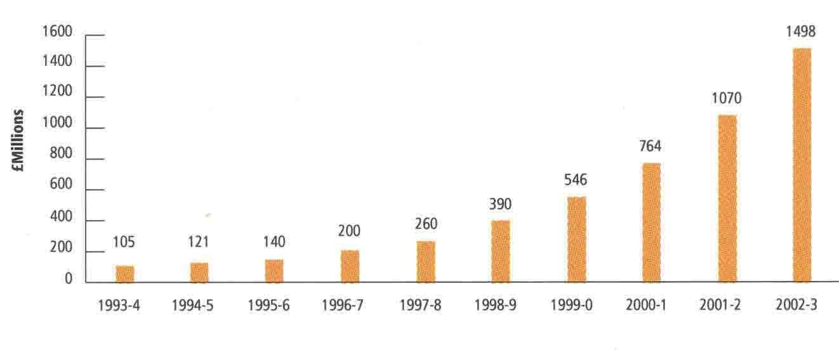

Table 3: Structure of Australian Organic Industry 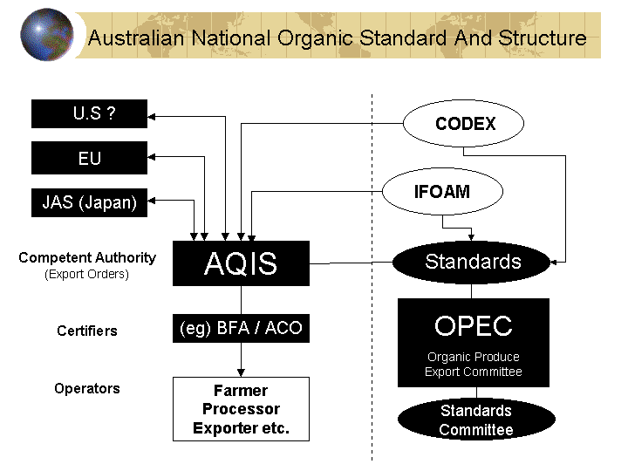
Source: Burch, D, Lyons, K and Monk, A (2002). Note that OPEC has recently changed its name to OIECC: the Organic Industry Export Consultative Committee.
Table 4: Requirements for importation into U.S 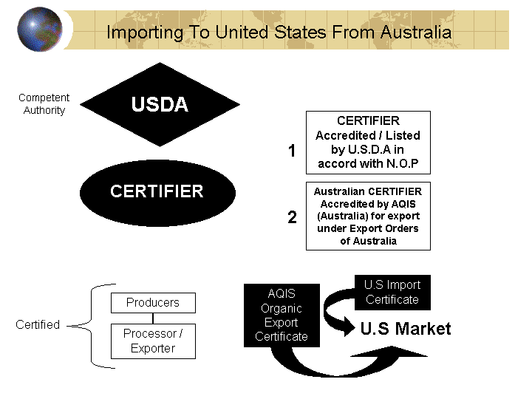
Source: Burch, D, Lyons, K and Monk, A (2002)

Table 5: % of exports regulated or linked by both the AQIS export requirements as well as via the IFOAM (and indirectly USDA certifier programs) by kgs of export for 2003. The trend increasingly is towards both regulations in Australia, leading to greater harmonisation and unification of operators within the industry.

Table 6: Why Australian consumers purchase organic food

Source: Lockie, et al, 2002.

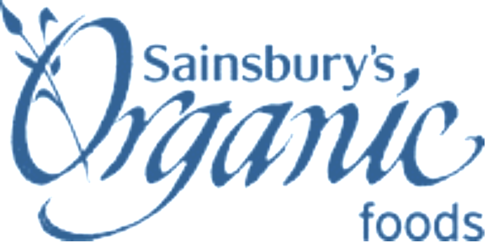

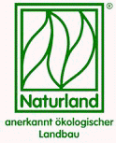
Table 7: Variety of branding and regulators in EU
UK
Germany
Other European

Footnotes

Modified paper first presented at: Australian Bureau of Agriculture and Resource Economics (ABARE) OUTLOOK CONFERENCE 2004, March 2004, Canberra, Australia.
Annex 3 and 4 of the Organic Standard (available free on www.bfa.com.au) lists the restricted number of food ingredients allowed in organic foods.
See graph in Annexes on consumer reasons for purchase of organic products.
I will refer generically to all standards pertaining to organic regulation as the Organic Standard. It is presumed that there are slight differences amongst them worldwide, however they all are based on the same basic requirements. The major difference between regions and service providers is more related to the way in which the service providers – the certification services – are regulated by accreditation agencies (eg AQIS, IFOAM, USDA etc), and it is this difference, combined with the usual challenges of international trade, which become the sticking point in cross border recognition of equivalence of regulatory systems. For a copy of the Organic Standard either visit www.bfa.com.au or order a hard copy through the offices of the BFA.
See examples of labels used in the EU – in Annexes.
The Organic Food and Farming Report is now the annual publication of the Biological Farmers of Australia and is sent to all members annually in September each year. It is available in electronic form on www.bfa.com.au . It contains a summary of the events of the year in the organic industry in Australia while publishing known and estimated data on number of operators, area of land certified and growth in the value of the market for both export and domestic (the latter can only be estimated at this point). The OFFRA 03 took a conservative stance regarding the domestic market claiming that past estimates and growth estimates may have been over exaggerated.
Prior publications have been made by Hassall and Associates – see references.
See Annexes – data on industry.
See graph on UK market development.
This has been reported and discussed over a number of editions of the Australian Organic Journal which is published by the Biological Farmers of Australia. Copies are available via subscription or membership see www.bfa.com.au
There is currently a bid process being undertaken for the next round of Co-operative Research Centre funding. The success of this is in the balance and will be directly correlated with the amount of private funding that can be garnered for this project. The RIRDC, Rural Industry Research and Development Corporation, has an organic subprogram which spends close to $300,000 PA, which limits the amount of large scale research that can occur but which is catalyzing industry self funded research and future larger projects.
To quote a publication assessing APEC country regulations and organic markets: “Governments acknowledge the need for sensitivity in organic regulation, in terms of the need to maintain market confidence and consumer support for the ‘integrity’ of the industry through effective and industry-endorsed processes of standards modification and regulation.” (Burch, Lyons, Monk 2002). The issue is that it is essential to ensure that the organic industry maintains management control of both standards setting procedures as well as regulation in a “co-regulatory” role with governments. This is still suboptimal in Australia and the closer alliance with the NGO international system of IFOAM would be highly advantageous for the Australian export market, as well as a more aggressive drive in regard to achieving recognition with other international players – most particularly the US – where Australia still does not have direct recognition.

