Research in vegetable proteins for diets for organic trout
Archived at http://orgprints.org/16118

By Alfred Jokumsen, Senior Advisory Scientist, Technical University of Denmark, National Institute of Aquatic Resources (DTU Aqua), Section for Aquaculture; The North Sea Science Park, Hirtshals. Denmark.

In few years Danish organic protein crops may be used as ingredients in feed for organic fish in partial replacement of fish meal protein. Fish meal is currently the primary protein source in feed for organic fish. Fish meal is manufactured by industrial fish caught among sustainable stocks, but even natural this protein source is not defined as organic and is as well a limited resource.
Therefore, it is necessary to replace as much as possible of the fish meal protein with competitive organic vegetable protein sources with high protein content as well as a relevant amino acid composition compared to that in fish meal. Opposite optimization of conventional fish feed the regulation does not allow addition of artificial amino acids to feed for organic fish.

Protein Concentrates
Grown plant crops generally have lower protein contents than fish meal. Due to this fact only a limited part of the fish meal can be replaced by plant protein. The degree of replacement is to a great extent determined by available technologies, which are adequate for manufacturing protein concentrates of specific crops in accordance with the current organic regulations.
During the current research we have succeeded to concentrate the protein content in organic peas, rape, lupine and horse beans to 40 – 50 %, which however, are lower than the protein content of 70 - 72 % in fish meal.

Growth and Digestibility
Feeding experiments with organic rainbow trout have been performed using 3 experimental diets (B, C and D), where fish meal was partially replaced by the protein concentrates given above and considering the best fitting amino acid profile. The control diet (A) was similar to the current commercial feed for organic trout, and with fish meal constituting about 53 % of the feed (Fig. 1).

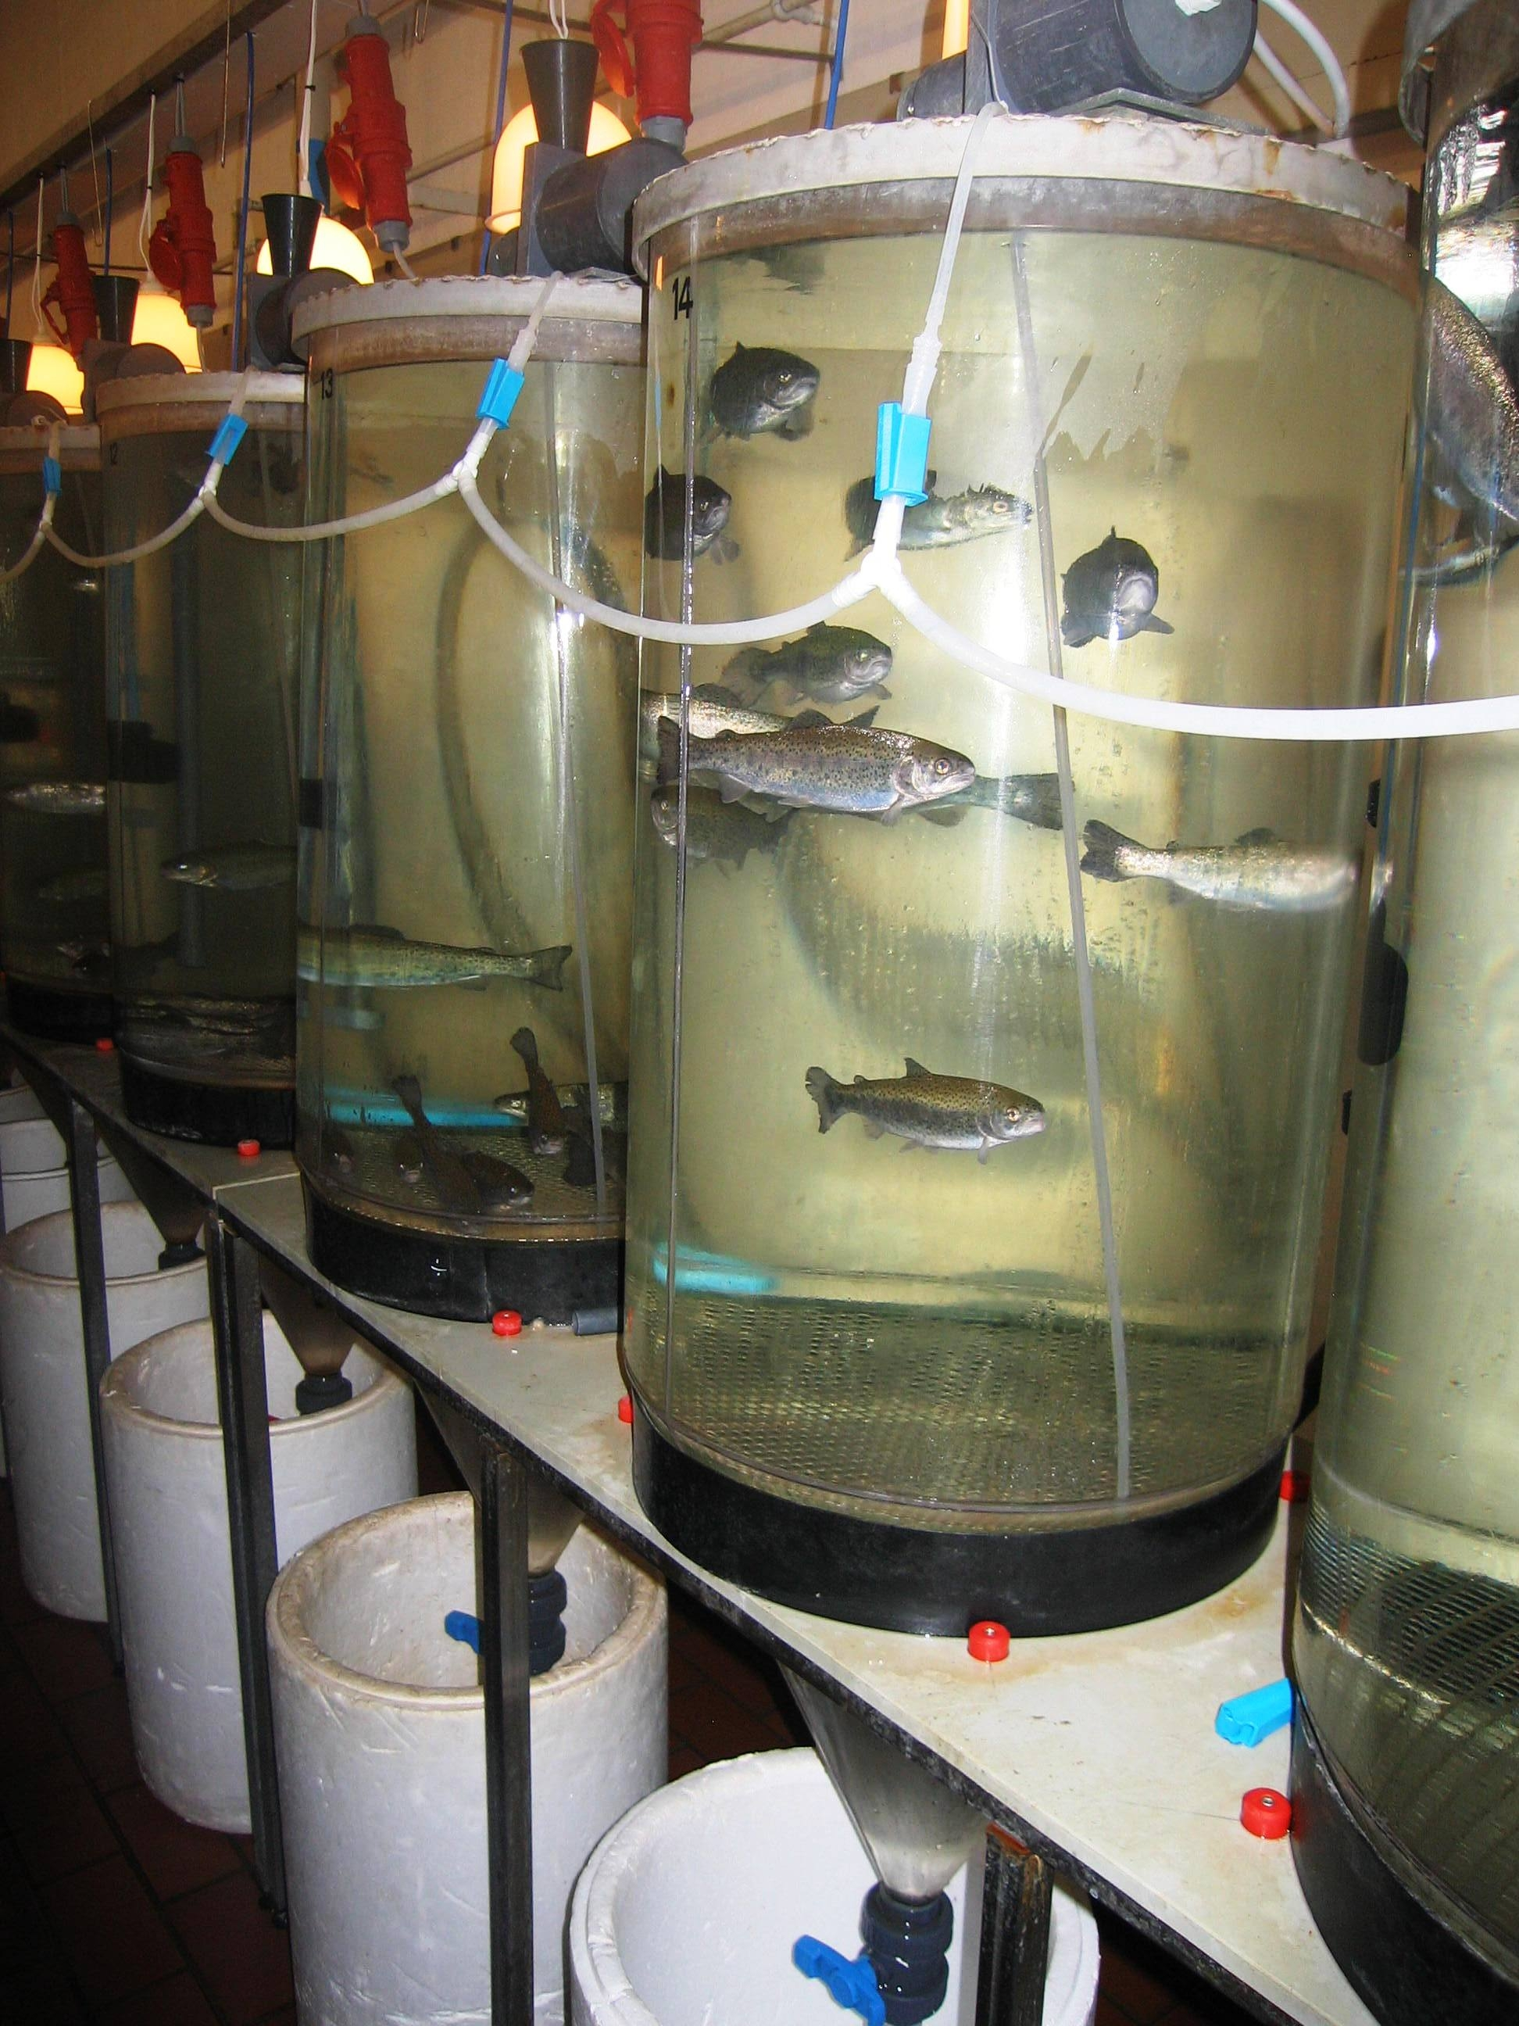
Fig. 1. Digestibility experiment with organic trouts. Foto: A. Jokumsen

The experiment investigated as well the effect of changing the protein/fat-ratio in the diet from 48/25 to 45/28 as the effect of reducing the fish meal content from 53 to 25 % of the diet and replacing this fraction by the vegetable protein concentrates.
The growth experiments indicated a positive effect of changing the protein/fat-ratio from 48/25 to 45/28, i.e. a decrease in the protein content from 48 to 45 % and an increase in the content of oil from 25 to 28 % improved the growth performance of the fish.
The digestibility study showed the significant highest protein digestibility in diet D (93,2 %), in which the inclusion of fish meal was reduced from 53 % to 25 % of the diet and replaced by vegetable protein concentrates (Fig. 2).

Fig. 2. Digestibility expressed by an approximated value, the Apparent Digestibility Coefficient, ADC as % of Protein, Oil, Carbohydrates and Phosphorus, respectively, in the 4 diets.

However, the specific growth rate was highest in the control group (A) and significantly lowest in diet D. That means, that even a diet shows a high digestibility the composition of nutrients may influence the growth performance of the fish.

Perspectives
The yearly production of organic fish in Denmark is currently about 200 metric ton, but many traditional farms are about to convert to the organic concept. (Fig. 3).

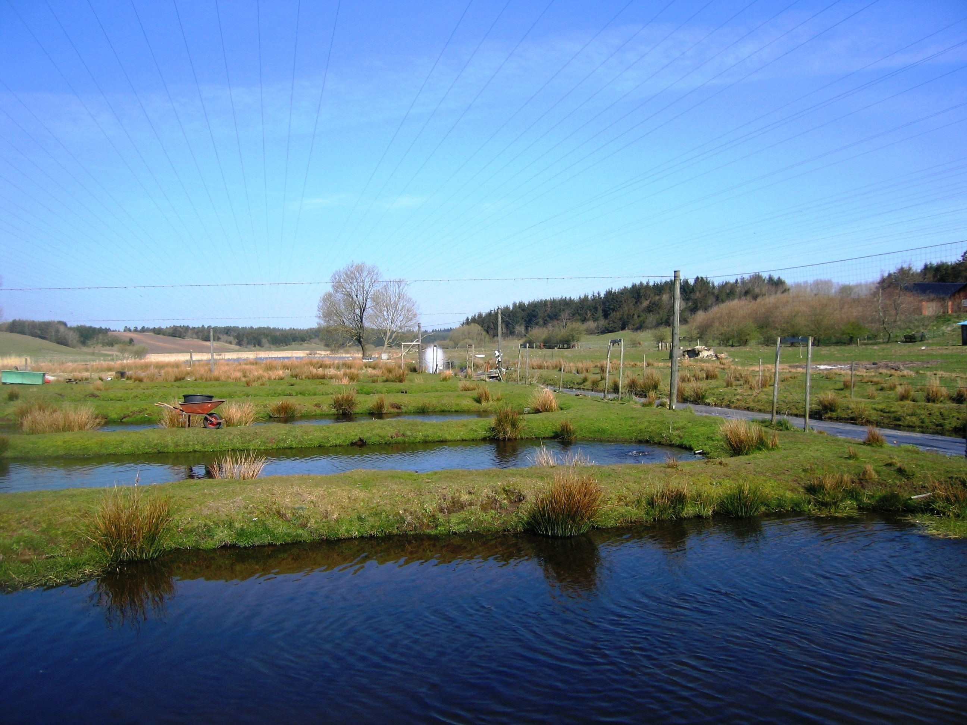
Fig. 3. The Organic Trout Farm Skravad Mølle between Viborg and Hobro, Denmark. Foto: A. Jokumsen

The research also includes case studies of existing Danish organic farm systems and management methods. In connection to the case studies selected test diets from the laboratory experiments are tested under commercial conditions.
Further information about health, prevention and treatment of disease are collected in cooperation with the veterinary inspector.
The influence of the experimental diets on the product quality of the organic fish includes objective sensory and biochemical analyses of the meat.
Thus, the research is primarily focused on the most critical areas in the chain connecting organic feed production, the organic farmers and the consumer.

