Food, Fairness & Ecology: An organic research agenda for a sustainable future

Niggli, U., Slabe, A., Schmid, O., Halberg, N. and Schlüter M.

Key words: Organic research agenda, sustainability, food security, ecosystem services

Abstract

The European Union Group of the International Federation of Organic Agriculture Movements (IFOAM EU Group) and the International Society of Organic Agriculture Research (ISOFAR) are developing a strategic research agenda focussing on ecological intensification, on sustainable rural regions, on high quality food for healthy nutrition and on ethical values of people vis-à-vis technology development in food production. The strategic research agenda (currently in its second draft, Niggli et al., 2008a) invites farmers, processors, traders, NGOs and scientists to debate on how practice and science should co-operate on future innovation. The final goal of the debate is a widely supported technology platform for organic agriculture and beyond.

Introduction

Organic food and farming is a constantly growing sector in the European Union (EU) and globally. It has a good potential to respond to the big challenges the EU and the world will face in the next decades, both in the area of environment (mitigation of and adaptation to climate change, including soil, water and biodiversity management and conservation) as well as in the area of food (sustainable productivity and high quality), rural development and animal welfare.

Innovation generated by the organic sector has considerably driven general agriculture and food production towards sustainability, high quality foods and low risk technologies in the past. Thus, strengthening research activities will have an impact far beyond the certified organic sector.

Technology platforms are permanent, industry-led schemes, involving the research community, public authorities and civil society.

General situation of the organic sector in the EU.

In 2006, the European organic market grew by more than 10 percent, and it was worth approximately 14 billion €. In many old member states, production accounted for up to 13 % of the total agricultural land; more than 6.8 million hectares were under organic management in the EU.

Until the 1980s, research was mainly carried out by private initiatives. In 1982, the first universities took organic farming on their curricula, in the 1990s, the first EU-funded projects on organic farming started, and a growing number of national state research institutes became involved in organic farming projects.

Many national action plans include special programs for organic farming research. With the ERA-Net project CORE Organic, the cooperation among funding agencies of research programmes led to a joint call of 11 countries in 2006. The total national funding for organic research in these 11 countries was 54 million Euros in 2005.

From the 5th EU research framework programme to the 6th, project funding increased from 15.4 million € to 22.1 million (without national co-funding).

Long-term observations and a shift from a multidisciplinary to an interdisciplinary research culture are characteristic for organic farming. Increasing emphasis is given to trans-disciplinarity where researchers, practitioners and stakeholders cooperate in order to address complex challenges of the society and find feasible solutions.

Strengths and weaknesses of organic agriculture and food chains

Analysing the strengths and weaknesses of organic agriculture is the first step towards identifying future research priorities. Such a critical analysis also helps to dynamically optimize the framework of organic agriculture, looking at its principles and standards, implementation rules and indicators which are used in the quality management system. For references used for assessing organic systems see Niggli et al., 2008a.

Among the ecological and environmental strengths of organic agricultural are to be found: i) reduced pollution (nitrates, pesticides), ii) improved biological and physical qualities of soils and iii) strongly increased diversity at landscape, farm, field, species and genome level. Furthermore, organic farming systems are likely to be better able to cope with climate change, as they are more resilient and have inherent techniques which reduce greenhouse gas (GHG) emissions ( Niggli et al., 2008b).

The socio-economic situation of organic agriculture is inconsistent. Therefore, state direct payments are vital for organic farms in order to compensate for the fact that, in organic farming, negative environmental and social costs are externalized to a lesser degree. Organic farming combines similar or higher incomes with the creation of higher employment, as it contributes to rural economic development through value-adding activities such as direct marketing, local processing of specialities and tourism.

Generally, consumers attribute positive characteristics to organic foods and they perceive them as healthy, tasty, authentic, local, highly diverse, fresh, minimally processed, natural, free of undesirable residues and safe. Several meta-studies confirm not all but many of these quality claims. Health claims, however, are generally only poorly substantiated by scientific research, mainly because intervention and cohort studies are very expensive.

When designing future research programs, it is, however, more interesting to know the weaknesses of organic agriculture and the organic food chain. Among these, the most pressing ones are the productivity and yield stability gaps, both caused by severe deficits in the knowledge of how agro-ecological systems work and the lack of appropriate technologies for organic systems. These gaps need to be addressed in a consequent way in order to fully exploit the positive impacts of this farming method on the environment, on biodiversity and on climate change mitigation and adaptation.

Vision for research and strategic priorities for 2025

The strategic research priorities are based on i) the principles of organic agriculture, ii) scientific innovation and iii) best integration of indigenous knowledge of farmers. The priorities focus particularly on the conflicts between economy, ecology and social cohesion/harmony inherent in most concepts for sustainable agriculture and food production, and they propose research activities and insightful learning concepts far beyond the niche that organic farming currently still represents. Each of the four research priorities (see figure 1) is underpinned with examples of possible research activities (see Niggli et al., 2008) which are not outlined here.

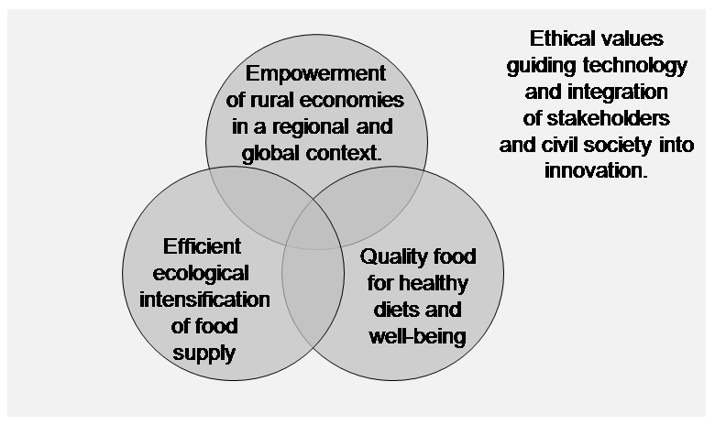
Figure 1: Vision for research and strategic priorities for organic systems.

The magnitude of challenges outlined by foresight studies (e.g. SCAR, 2007) indicate that agriculture is based upon distinctive ethical values. This is especially true for questions like rural development, decentralised food production, the quality of the landscape, the conservation of biodiversity, the sustainable use of natural resources as well as fair trade, livelihood of farm families and animal welfare.

The ethical value system of organic agriculture is described by the principles of health, ecology, fairness and care (IFOAM, 2005). It provides a unique basis for developing complex assessment and decision tools and for modelling future sustainable food and farming systems in a practical context where stakeholders along the whole food chain can participate and where civil society is strongly involved into technology development and innovation.

Locally produced raw materials with specific qualities will increase the diversity of European food in a considerable way and will keep agriculture, food production, culinary culture and tourism very competitive. Wellness, high quality food, locally processed foods from traditional recipes and geographical denomination will create jobs and wealth in rural areas and will add to their attractiveness. Organic farming has taken up very early this concept of multifunctionality. This forerunner role is very fruitful for the society and helps to adjust technology development and innovation.

In this regard, organic agriculture represents one of the best developed multifunctional strategies in agriculture so far. Therefore, it is an excellent starting point for an ecologically and environmentally sound intensification in balance with ecological goods and services, nature protection, animal welfare and social objectives.

The weakness of organic agriculture, so far, is its currently insufficient productivity and stability of the yields (especially of intensive cash crops). This may be solved by an appropriate “ecological intensification”, i.e. via a better and more efficient use of natural resources, improved nutrient recycling techniques and agro-ecological methods for the enhancement of diversity and health of soils, crops and livestock. Successful research strategies are i) the clever integration of leguminous plants into cropping, ii) the better use the nitrogen (and other nutrients), derived from livestock production, iii) reversing the separation of crop and livestock production, which has often resulted in soil degradation on croplands and in nutrient excess in livestock operations with yet unsolved environmental problems, iv) the exploitation of eco-system services via clever habitat design and v) the use of novel technologies (such as sensors, robots, information technology and smart breeding).

Individual and social well-being strongly depend on both the quantity and quality of the food we eat, the composition of the diets and how it is processed and prepared. The power to choose foods that meet the highest standards of ethics and craftsmanship, is a manifestation of every citizen’s everyday’s control of his life circumstances, the key prerequisite for a long and healthy life. Therefore, an improved quality of life is intricately linked with an increasing demand for foods of the highest standards such as organic food. Food quality research includes a whole chain approach and will address the most critical steps which influence the quality of the food from primary production to processing, transportation, packaging and consumption.

Conclusions

A sustainable approach to agriculture and food production means coping with trade-offs between ecosystem services while not reducing some of them in favour of others. The rationale behind organic agriculture is providing sufficient food and fibre while increasing regulating services (e.g. increasing the adaptive capacity of farming systems to climate change) and maintaining or restoring cultural (e.g. pleasant landscape) and supporting services (e.g. soil fertility). As human well-being depends not only on the quantity of food but also on its quality and diversity, the vision also addresses food, nutrition and health aspects. Organic farmers practise a pragmatically optimised equilibrium between the services the society expects agriculture to deliver. It is therefore an excellent starting point for truly sustainable food systems.

References

European Commission (2004): European Action Plan for Organic Food and Farming http://ec.europa.eu/agriculture/qual/organic/plan/comm_en.pdf.

IFOAM (2005): The Principles of Organic Agriculture. http://www.ifoam.org/about_ifoam/principles/index.html.

Niggli, U, Slabe, A., Schmid, O., Halberg., N and Schlüter, M. (2008a): Vision for an Organic Food and Farming Research Agenda 2025. Food, Fairness and Ecology. http://www.organic-research.org.

Niggli, U., Schmid, H. and Fliessbach, A. (2008b): Organic farming and climate change. International Trade Center (ITC), Geneva. http://www.intracen.org/Organics/documents/Organic_Farming_and_Climate_Change.pdf

SCAR (2007): Fore sighting food, rural and agrifutures. Available at http://ec.europa.eu/research/agriculture/scar/pdf/foresighting_food_rural_and_agri_futures.pdf

Research Institute of Organic Agriculture FiBL, Frick, Switzerland
Institute for Sustainable Development, Ljubljana, Slovenia,
Research Institute of Organic Agriculture FiBL, Frick, Switzerland
Danish Research Centre for Organic Farming (DARCOF), Tjele, Denmark
IFOAM EU Group, Brussels, Belgium

