Effects of red clover and maize silages on the carriage of gut pathogens in steers

Marley, C.L., Scott, M.B.1, Bakewell, E.L.1, Leemans, D.K.1, Sanderson, R1. & Davies, D.R.1

Key words: Red clover silage, maize silage, pathogens, cattle, faecal shedding

Abstract

An experiment investigated the effects of increasing proportions of red clover (RC) (Trifolium pratense) silage relative to maize (M) (Zea mays) silage in the diet of steers on the pathogenic microflora of gut digesta and faecal samples. The experiment consisted of 3 periods of 21 d. Eight Hereford x Friesian steers were used, with 4 maintained on a 90 % maize: 10 % red clover (90M:10RC) silage diet throughout and 4 receiving 90M:10RC silage in period 1 then 50M:50RC, 10M:90RC in periods 2-3, respectively. Populations of Listeria monocytogenes and E. coli were enumerated at time points in each period. L. monocytogenes data showed disparity between periods. In the latter part of period 2, L. monocytogenes populations were higher in the rumen, duodenum and faeces of steers offered 50M:50RC but in period 3, L. monocytogenes populations were lower in the faeces of steers fed the higher level of red clover silage (P < 0.05). Despite negligible E. coli levels in the diets, populations of E. coli, including E. coli 0157, were detected in the steers throughout the trial. Diet effects on E. coli levels were not apparent at any of the three sites examined. Further research is needed to elucidate the effects of red clover and dietary pathogen load on gut and faecal pathogen populations.

Introduction
In agricultural systems, the use of manure and slurry may result in the contamination of land and water courses with pathogens, such as Escherichia coli and Listeria. These pathogens may then be transferred from contaminated forage and water to livestock, animal products and, thus, to humans. Listeria monocytogenes is the agent of listeriosis, a serious infection caused by eating contaminated food. This pathogen is a main contaminant of forage which can multiply during ensiling; therefore, silage feeding is a common route of infection for farm animals. Listeriosis is being recognized as an important public health problem as, in humans, the overt form has a mortality of greater than 25%. While infected animals rarely directly cause human infections, animal-derived food products (e.g., raw milk) and raw foods of plant origin, contaminated by manure from infected animals, represent links between human and ruminant infections (Nightingale et al., 2004). Research has found that up to 50% of faecal samples collected from ruminants with no clinical symptoms of listeriosis may contain L. monocytogenes (Ho et al., 2007).
Ruminants may be described as reservoirs of verocytotoxin producing E. coli, food-borne pathogens implicated in several outbreaks of disease in humans (US FDA, 1998). The commonest E. coli responsible for human disease in Europe is E. coli 0157. Similar to L. monocytogenes infections, studies have shown that ruminants can harbour E. coli without any overt clinical signs (Kudva et al., 1996). In humans, infections can result from the consumption of contaminated beef and milk products, drinking and bathing water. In most instances, the source of contamination was faecal material (Phillips, 1999).
Studies have shown that dietary factors can influence pathogen shedding, with some evidence that red clover can reduce pathogen growth, possibily due to the action of secondary plant metabolites such as formononetin (Duncan et al., 2000). The aim of the current study was to determine the effects of increasing the proportion of red clover silage offered in the diet of steers when compared with maize silage on the subsequent shedding of L. monocytogenes and E. coli pathogens.

Materials and methods

Eight Hereford x Friesian steers (600 kg approx. weight) prepared with rumen and duodenal cannulae were offered a mix of a red clover (Trifolium pratense) silage (RC) and a maize (Zea mays) silage (M). The experiment was a continuous design consisting of 3 periods of 21 days. Four animals received 90M:10RC silage in period 1 then 50M:50RC and 10M:90RC in periods 2 and 3, respectively. The remaining four steers were maintained on the 90M:10RC diet throughout. Due to the simple nature of the diets, silages were switched with immediate effect at the end of each period, with no gradual changeover. Steers were housed individually and received their food in two equal feeds at 09.00 and 16.00. Refusals were removed before early morning feed and daily dry matter (DM) intakes were recorded. Samples of diets offered were accumulated weekly. Samples of rumen and duodenal digesta and faeces were collected prior to the morning feed on day 0, 1, 2, 4, 8, 16 and 21. All samples were incubated on agar plates following a series of dilutions to 10⁻³ in Ringers solution (Oxoid Ltd., Basingstoke, UK) and enumerated for L. monocytogenes using Listeria Isolation Medium (LAB M Limited, Bury, UK) and E. coli and E. coli O157 using Sorbitol McConkey with B.C.I.G. Agar (Oxoid Ltd., Basingstoke, UK). Data for one steer on the 90M:10RC treatment were excluded on account of antibiotic treatment in periods 2 and 3. Within period mean counts on days 16 and 21 were compared between the two groups of steers by one-way analysis of variance using levels in the preceding period as a covariate where appropriate.

Results

All diets showed L. monocytogenes counts in excess of 6.2x10⁴ colony forming units (CFU) /g DM. L. monocytogenes counts for 90M:10RC, 50M:50RC silages were similar and 10M:90RC counts tended to be lower by a factor of 10. Taking DM intake into account, this resulted in steers offered 10M:90RC silage having a lower L. monocytogenes challenge compared with steers offered a 90M:10RC silage diet in period 3. L. monocytogenes populations in the rumen and faeces are presented in Figure 1. Trends in L. monocytogenes levels in the duodenum were broadly similar to those in faeces although less pronounced. Results showed disparity between periods. L. monocytogenes populations were higher in the rumen, duodenum and faeces of steers fed the higher proportion of red clover compared with maize silage in Period 2 (P < 0.05). In Period 3, L. monocytogenes populations were lower in the duodenum and faeces (P < 0.05) of steers fed the highest level of red clover. However, faecal shedding remained in excess of 10⁵ CFU/g DM.

Silage contamination with E. coli pathogens was negligible. Only the 10M:90RC diet contained any E. coli, with counts of 2 and 4 CFU/g DM in the final two weeks of the experiment. E. coli 0157 was not detected in any of the treatment silages. Populations of E. coli pathogens, including E. coli 0157, were detected in the rumen, duodenum and faeces of steers within this experiment. However, data of E. coli populations were highly variable and no significant effects of diet were apparent.
a)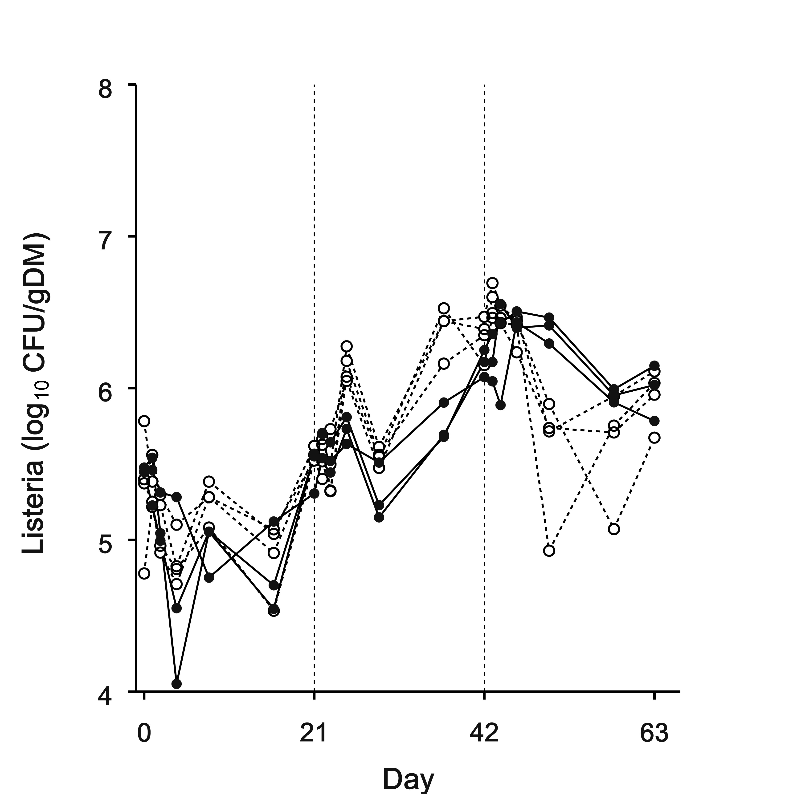 | b)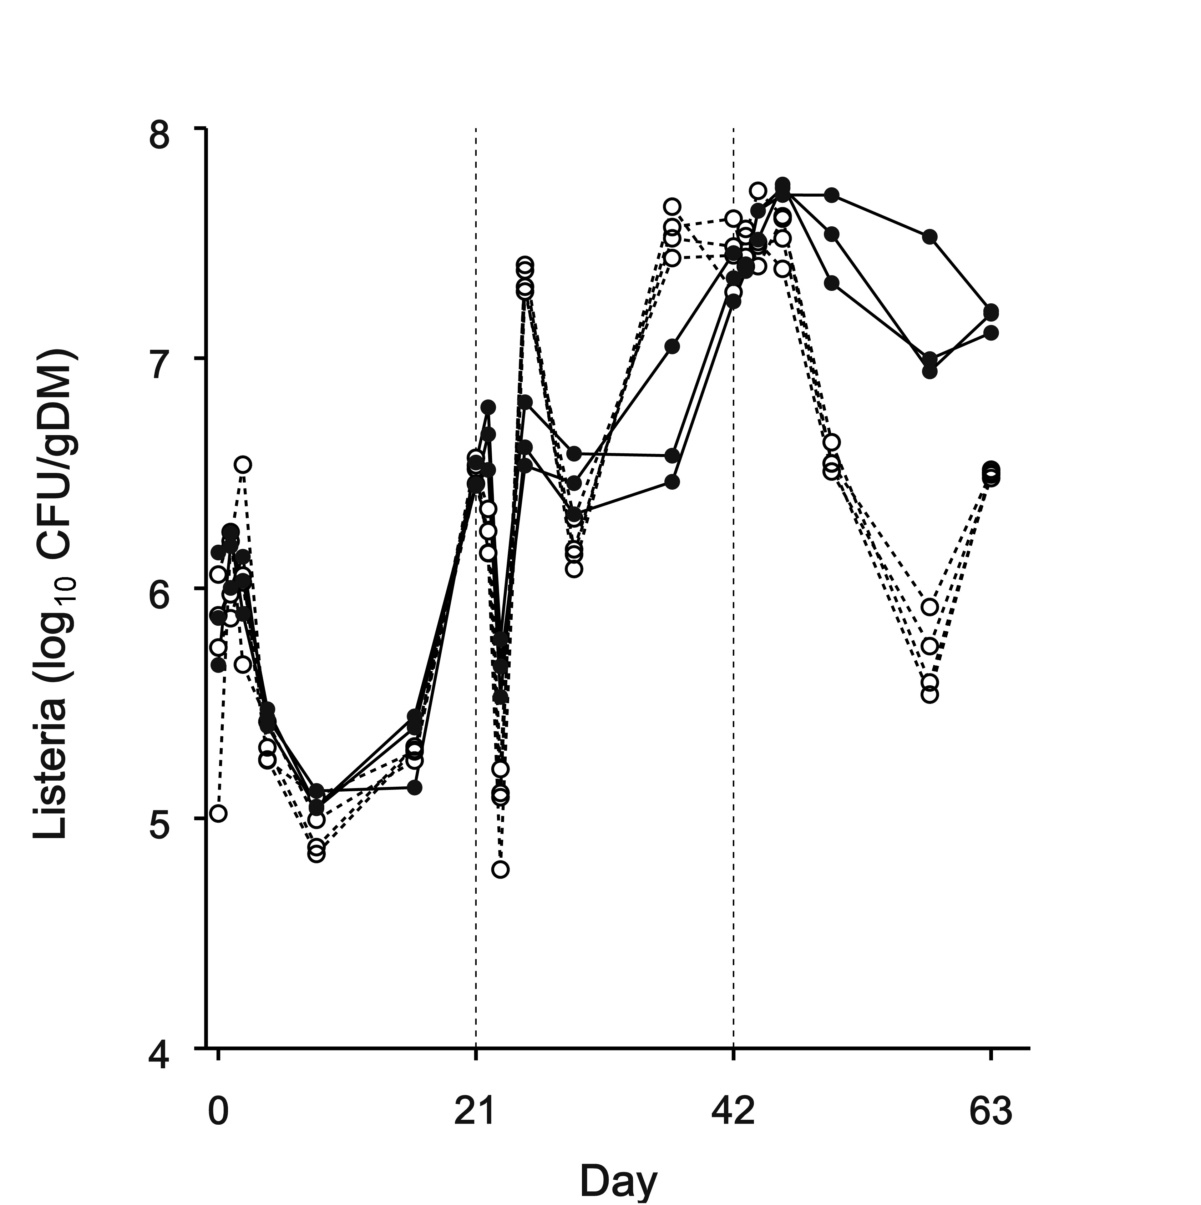
Figure 1: Populations of Listeria in a) rumen digesta and b) faeces from steers fed increasing proportions of red clover silage (denoted by open circles with broken lines) compared with steers receiving 90%maize:10% red clover silage. Vertical broken lines denote transitions between periods.
a) 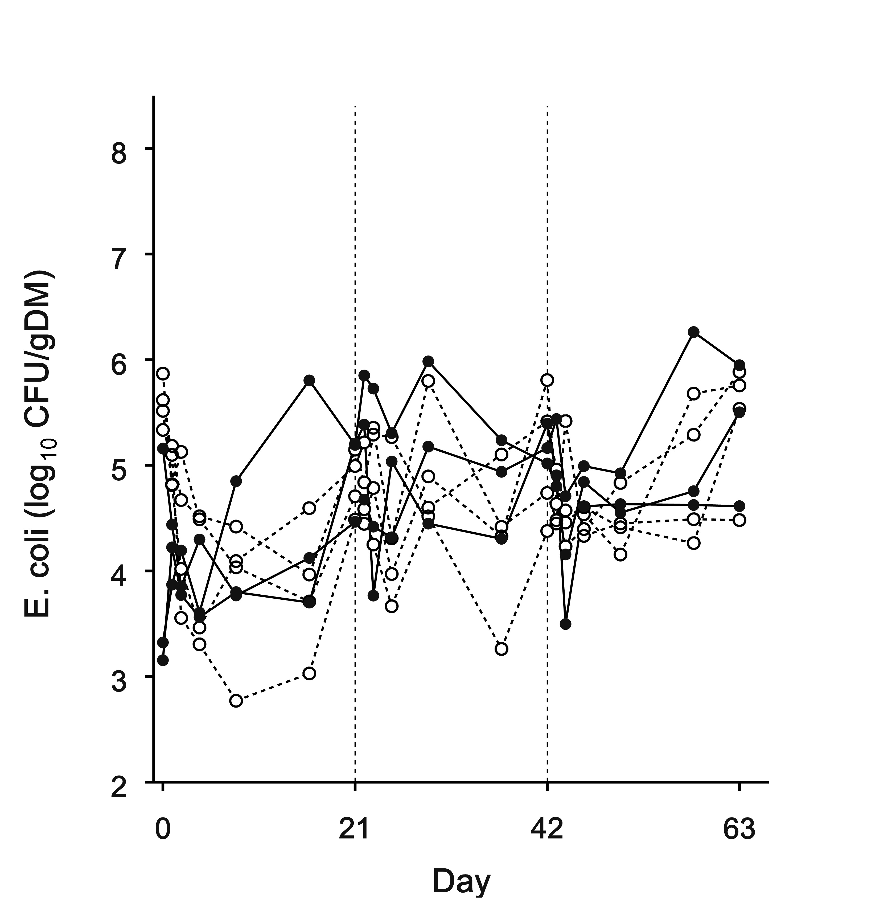 | b)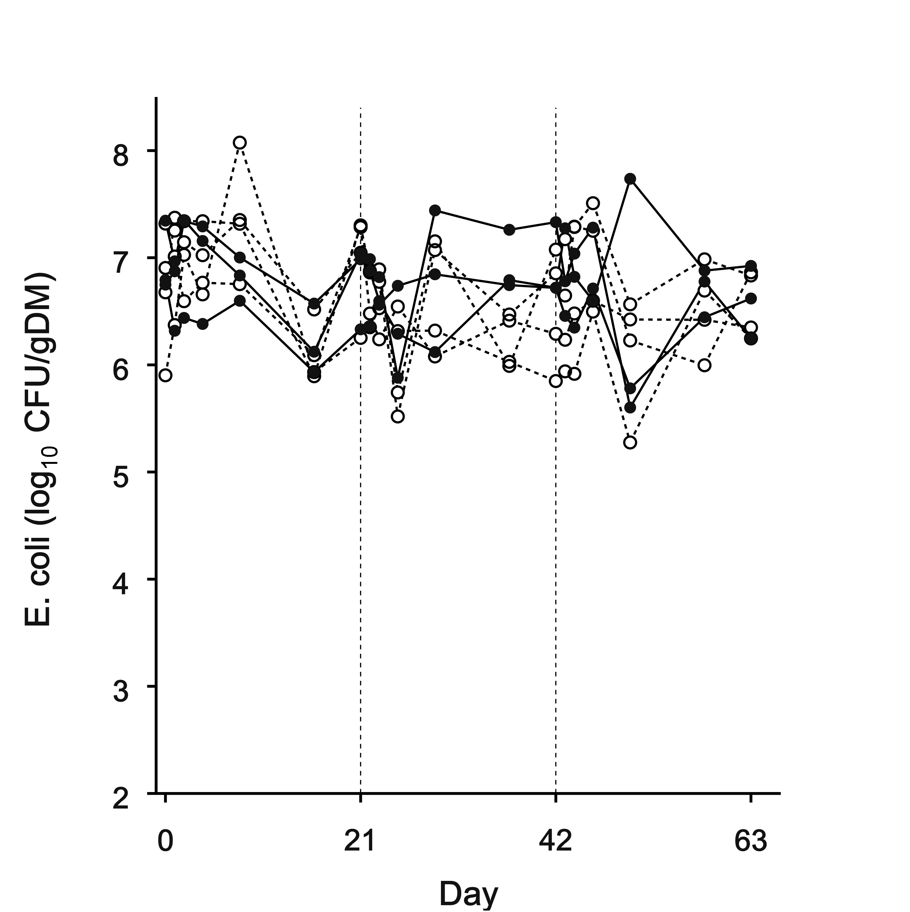
Figure 2: Populations of E. coli in a) rumen digesta and b) faeces in steers fed increasing proportions of red clover silage (denoted by open circles with broken lines) compared with steers receiving 90%maize:10% red clover silage.

Discussion

The results are in agreement with other studies showing that there are high levels of variation in the day-to-day shedding of L. monocytogenes and E. coli within the same herd (Ho et al., 2007). It appears that with respect to L. monocytogenes, the dietary pathogen load also had an impact on the shedding of this pathogen, as the low populations in the 10M:90RC silage resulted in fewer L. monocytogenes in the faeces on steers offered this diet. Overall, the transient nature of these infections may help to explain the disparity found in the results between different periods for the L. monocytogenes populations and the high variability observed for the E. coli populations with regards to the effects of diet on pathogen population numbers.

Conclusions

There are no clear indications from the findings in this study as to the dietary effects of red clover silage on the shedding of L. monocytogenes and E. coli from ruminant animals. Further studies are needed to determine the effects of red clover on L. monocytogenes and E. coli contamination during the ensiling process and to determine the dose-response effect of dietary pathogen load on pathogen shedding when different proportions of red clover are consumed.

Acknowledgments

The authors would like to thank Martin Leyland and Naomi Ellis at IGER Trawscoed for the care of the animals throughout these experiments. This work was carried out with funding from the EU framework VI QLIF project and the Department for Environment, Food and Rural Affairs, UK.

References
Duncan, S.H., Booth, I.R., Flint, H.J. and Stewart, C.S. (2000) The potential for the control of Escherichia coli 0157 in farm animals. Journal of Applied Microbiology Symposium Supplement, 88, 157S-165S.
Ho, A. J., Ivanek, R., Groehn, Y. T., Nightingale, K. K., Wiedmann, M. (2007) Listeria monocytogenes fecal shedding in dairy cattle shows high levels of day-to-day variation and includes outbreaks and sporadic cases of shedding of specific L-monocytogenes subtypes. Preventative Veterinary Medicine, 80, 287-305.
Kudva, T.I., Hatfield, P.G., Havode, C. (1996) Escherichia coli 0157:H7 in microflora of sheep. Journal of Clinical Microbiology, 31, 431-433.
Nightingale, K.K., Schukken, Y.H., Nightingale, C.R., Fortes, E.D., Ho, A.J. Her, Z., Grohn, Y.T., McDonough, P.L. Wiedmann, M. (2004). Ecology and transmission of Listeria monocytogenes infecting ruminants and in the farm environment. Applied and Environmental Microbiology 70, 4458-4467.
Phillips, C.A. (1999). The epidemiology, detection and control of Escherichia coli O157 [Review]. Journal of the Science of Food and Agriculture 79, 1367-1381.
US Food and Drug Administration, Center for Food Safety and Applied Nutrition. Pathogenic Microorganisms and Natural Toxins Handbook. Updated 1998.

Institute of Grassland and Environmental Research, Plas Gogerddan, Aberystwyth SY23 3EB UK, E-Mail david.davies@bbsrc.ac.uk, Internet www.iger.bbsrc.ac.uk

