Indicators for the Evaluation of Soil Organic Matter and their Application in Organic and Conventional Farming Systems

Hoyer, U., Reents, H.-J. 1, Hülsbergen, K.-J.1

Key words: soil organic matter, indicator, farming system, humus balancing

Abstract

In view of the problems caused by soil degradation, it becomes ever more important to estimate the influence of different management systems on soil organic matter (SOM). In the past, a number of indicators characterizing SOM have been elaborated, which, however, do not allow to draw conclusions on separate management measures or even future development tendencies. A promising approach might be humus balancing, which quantifies and evaluates the humus supply of soils on the basis of crop rotation and fertilization. Comparative studies on adjacent arable sites under both organic and conventional management in different climatic regions of Germany have revealed that the indicator soil organic carbon (SOC) depends mainly on the site conditions, whereas indicators characterizing active SOM like hot water soluble C (C_{hws}), C in microbial biomass (C_{mic}) and the enzyme activities of β-glucosidase and catalase are stronger related to management methods. It became evident that humus balancing is a good indicator of the active SOM pool and thus also a qualified tool for demonstrating management effects.

Introduction

Soil degradation caused by erosion, compaction and humus depletion is a severe problem all over the world. In order to assess the effects of agricultural landuse under different site conditions, various indicators of soil conservation have been developed. They include principally the parameters soil organic carbon (SOC), soil organic nitrogen (SON) microbial biomass and active SOM (Gregorich et al. 1994, Arshad & Martin 2002). These measurements help estimate the current quality of a soil; however, they do not allow to make statements on how a soil will respond to management influences in the future (Herrick 2000). Evaluating management effects requires to consider crop rotations, fertilizer input and tillage, in order to describe the relationships between soil properties and management. State indicators like SOC provide information on the current situation of the environment, while pressure indicators are related to the type of management and offer an indirect assessment. As methodical approach to the estimation of management effects on SOM, humus balancing was developed (Leithold et al. 2007). The necessary input data can be collected easily; humus balancing permits to assess SOM depletion and accumulation depending on the quantity and quality of C input. Adverse to C- and N-simulation models, no sophisticated processes or different pools are described, but rather the summed up net effect on SOM is calculated (Leithold et al. 2007, Körschens et al. 2005).

The following paper is to elucidate the relationships existing between different indicators for SOM and humus balancing. On the basis of comparisons between organically and conventionally run farms the question is pursued whether common state indicators can reflect system-related differences in management sufficiently and whether humus balancing may be a reliable indicator for the evaluation of sustainable land use.

Materials and Methods

In various agricultural regions of Germany, long-term test plots were established on adjacent arable sites, both under organic and conventional management, but with comparable soil texture. Preferably sites under humid and cool conditions in southern Germany as well as locations in eastern German dry regions were included. Soil types range from light sandy to heavy clay soils. On five plots each per site and management system, soil samples were taken from the topsoil which were then analysed for SOC, SON, C_{hws}, C_{mic}, β-glucosidase and catalase. On each plot long-term management records were kept and entered into the calculations. Humus balance sheets were computed according to the approach by Küstermann et al. (2007). The statistical analysis was executed by use of SPSS 15.0.

Results

The biological active time (BAT = f [silt + clay, air temperature, precipitation]) as site characterizing parameter (Franko & Oelschlägel 1995) was calculated as main influence factor for all investigated indicators. This has been demonstrated in Fig. 1 on the example of SOC and C_{mic}.

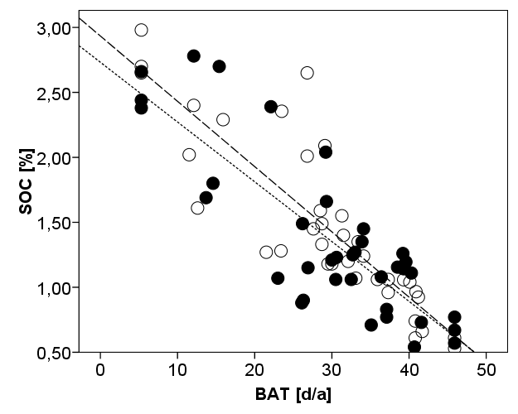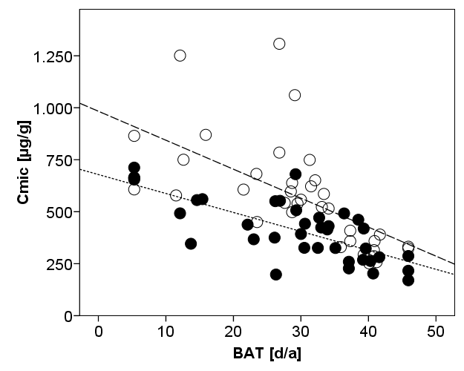

Figure 1: Relationship between biological active time (BAT) and SOC- and C_{mic}-contents; organic; conventional;

regression curves: organic; conventional

Different management factors cause different effects even when all other site conditions coincide. Table 1 shows the results of gradual linear regression for the estimation of the parameters that influence the measurable SOM indicators. Organic farming entails slightly increased SOC contents. The measured parameters C_{mic}, C_{hws}, β-glucosidase and catalase characterizing the active SOM are related to the pH value and more or less also to the different input values. C_{hws} and catalase rise with the quantity of organic fertilizer. C_{mic} is positively influenced by the share of clover grass mixture, organic fertilization and yields. β-glucosidase is enhanced by higher yields, and a slightly negative relation was found for the rates of mineral fertilizers.

Table 1: Regression and correlation coefficients for the description of influences on different SOM indicators (weight of influence factors marked with a-d, a = strongest influence)
 | Site |  |  | Management |  |  |  |  | R
 | fU | BAT | pH | System | Yield | CG | DM_OF | N_MF | R
SOC | 0.06ª | -0.02^{b} | - | 0.14^{c} | - | - | - | - | 0.91
C_{hws} | 15.58ª | - | 51.41^{b} | - | - | - | 3.04^{c} | - | 0.85
C_{mic} | - | -8.71^{c} | 82.95^{d} | - | - | 4.57ª | 5.28^{b} | - | 0.85
Gluc | - | - | 17.61ª | - | 0.6^{c} | - | - | -0.21^{b} | 0.75
Cat | 0.48ª | - | 2.98^{c} | - | - | - | 0.22^{b} | - | 0.82
fU: fine silt (%); BAT: biological active time (d a⁻¹); System: organic or conventional farming; CG: share of clover grass mixture (%); DM_OF: DM input with organic fertilizer (100 kg ha⁻¹); N_MF: mineral N input (kg ha⁻¹); Gluc: β-glucosidase; Cat: catalase

The mean value of the humus surplus quantities for all organic plots differs significantly (+246 kg C ha⁻¹ a⁻¹) from the mean of the conventional plots (only -76 kg C ha⁻¹ a⁻¹). The correlation between measured values and humus balance surpluses is differently pronounced (Table 2). A comparatively strong correlation was obtained for C_{mic} and the humus balance surpluses.

Table 2: Correlation coefficients (Pearson) between balance surpluses and measured values (organic and conventional)
 | SOC | SON | C_{hws} | C_{mic} | Gluc | Cat | pH
Humus balance surplus | 0.23 | 0.28* | 0.37** | 0.65** | 0.29* | 0.47* | 0.25*
* significant for P<0.05

** significant for P<0.01

Discussion

The results obtained in regression analyses have shown that the humus level and all measured values of active SOM were mostly influenced by the site conditions. Nevertheless, these indicators can be modified to a certain extent by management methods. Organic farming entails mostly slightly increased contents of SOC, and especially C_{mic} is clearly enhanced on organically run fields. Enzyme activities and C_{hws} respond positively to yield level and organic fertilizer input. Higher yields raise the input of organic matter, mainly by root residues and rhizodeposition, which represent a preferential substrate for the cellulose-decomposing enzyme β-glucosidase and thus the nutrition of microorganisms.

Due to low portions of field forage and low spreading of stable manure, balancing of conventional farms produced lower humus surplus levels than organic systems. There are only weak correlations between measured values and balance sheet results, except for C_{mic}. C_{mic} rises markedly with an increasing share of clover grass mixture and the input of organic fertilizer. These parameters have a strong weight in humus balancing.

Conclusions

The SOC content as a state indicator can be influenced by management measures within close brackets only; the decisive effect is exerted by the site conditions. Humus balancing depends on management data; surpluses are more evidently related to the active SOM, which is likewise dependant on management. Therefore, the pressure indicator "humus balance" turned out to be a suitable indicator for describing management effects on the active SOM pool.

Acknowledgments

The authors wish to thank the Federal Agency for Agriculture and Food BLE for financial support and the Departments of Soil Physics and Site Conditions of the Bavarian State Research Center for Agriculture LfL for the execution of soil texture as well as the University in Halle for enzyme analyses.

References

Arshad M. A., Martin S. (2002): Identifying critical limits for soil quality indicators in agro-ecosystems. Agriculture, Ecosystems and Environment 88:153-160.

Franko U., Oelschlägel B. (1995): Einfluss von Klima und Textur auf die biologische Aktivität beim Umsatz der organischen Bodensubstanz. Arch. Agron. Soil Sci. 39: 155-163.

Gregorich E.G., Carter M.R., Angers D.A., Monreal C.M. Ellert B.H. (1994): Towards a minimum data set to assess soil organic matter quality in agricultural soils. Can. J. Soil Sci. 74: 367-385.

Herrick J.E. (2000): Soil quality: an indicator of sustainable land management? Applied Soil Ecology 15: 75-83.

Körschens M., Rogasik J., Schulz E., 2005: Bilanzierung und Richtwerte organischer Bodensubstanz. Landbauforschung Völkenrode 55: 01-10.

Küstermann B., Kainz M., Hülsbergen K.-J. (2007): Modeling carbon cycles and estimation of greenhouse gas emissions from organic and conventional farming systems. Renewable Agriculture and Food Systems 23: 1-16.

Leithold G., Brock C., Hoyer U., Hülsbergen K.-J., 2007: Anpassung der Humusbilanzierung an die Bedingungen des ökologischen Landbaus. In: KTBL (ed.): Bewertung ökologischer Betriebssysteme. Bodenfruchtbarkeit, Stoffkreisläufe, Biodiversität. KTBL-Schrift 458, Darmstadt, pp. 24-50.

Technical University of Munich, Chair for Organic Agriculture, Alte Akademie 12, 85354 Freising, e-mail: uta.hoyer@wzw.tum.de

