Direct Seeding of Faba Beans in Organic Agriculture

Köpke, U. & Schulte, H.

Key words: weed control, high residue reduced tillage system, mulch, precrop oats, gross margin

Abstract

Field experiments carried out at two experimental sites over two years showed that temporary direct seeding (DS) of faba beans (FAB) is possible in Organic Agriculture (OA) when weed pressure of perennials is low. Weed density of DS treatments was significantly lower when compared with mouldboard plough (MP, control) although no clear effects on annual weeds were given by the precrop oats neither by the amount of crop residues (0, 4, 6 t ha⁻¹) nor the sowing density of autumnal sown oats (0, 600, 1200, 1800 seeds m⁻) simulating hail-shattered grains. No significant differences in grain yield but lower costs of labour and fuel were determined for DS compared with MP. Estimated DS gross margins exceeded MP gross margins when DS yield losses remained lower than 0.95 t ha⁻¹ as compared with MP yields.

Introduction

The aim of reducing tillage intensity is to prevent soil compaction and erosion, to improve top soil trafficability and to save labour and energy costs. All non-inverting tillage procedures usually show higher microbial activity or microbial biomass in the upper topsoil compared with the lower topsoil. Correspondingly, it is often suggested that tillage procedures in Organic Agriculture (OA) should avoid disturbance and mix of the different soil layers. However, the use of loose soil husbandry (LSH) which is mostly performed with the mouldboard plough (MP) and combined with secondary tillage is still common practice. Only a few organic farmers in Central Europe are using the extreme option of firm soil mulch husbandry (FSMH), i.e. direct seeding (DS), mainly due to two reasons: i. under temperate climate conditions omitting deep loosening and thorough inversion of the topsoil results in cooler and wetter soils in early spring and hence in reduced mineralization and nitrification of soil-borne nitrogen and its transformation into crop yield of non-leguminous crops. ii. tillage, and in particular ploughing, is one of the most effective tools to directly control annual and perennial weeds as well. Synthetic total herbicides that enable mainstream farmers to conduct no-till systems over years are not allowed to be used in OA, and their natural counterparts (‘bioherbicides’) that are officially certified in other regions of this globe (e.g. natural vinegar, corn gluten, pine wood extracts) are currently not considered as adequate to be used in Europe’s OA (Kühne et al. 2005).

In contrast to non-legumes, grain legumes do not depend on soil-borne nitrogen due to their ability to fix nitrogen symbiotically. Competitiveness against weeds is high for faba beans (FAB) which can satisfy their high demand for water to germinate in wetter no-tilled soil.

Mulch layers of precrops may suppress weeds. For efficient weed suppression Barberi (2002) considers homogeneous distribution of at least 4-6 t ha⁻¹ crop residues necessary. Additionally, allelopathic action of some oats genotypes has been assumed (Chou 1986). For the conditions of European temperate climate, competitiveness of yellow oats (Avena sativa L.) is considered as relatively high when compared with other cereals (Davies & Welsh 2001). Our own previous experiments have shown that yellow oats performed better, i.e. more residues and higher crop ground cover were produced when compared with black oats (Avena strigosa Schreb). Based on the experience in year 2004 when hail-shattered grains and reduced yield of yellow oats by 60%, leaving the field with a thick mulch layer of straw and shattered germinating seeds weed free, we established field trials in order to test the following hypotheses: (i.) Direct seeding of FAB into a mulch layer of precrop oats enables sufficient control of annual weeds. (ii.) Increasing density of autumnal germinating oats can further increase weed suppression. (iii.) Perennial weeds can limit FAB grain yield also in a system that omits tillage only temporarily.

Materials and methods

Two two-factorial field trials with four replicates were carried out in 2006 and 2007 at the organic research farm Wiesengut (WG) of the University of Bonn in Hennef (Germany) on a clayey-silty to sandy-silty floodplain sediment (fluvisol, 50°48´ N, 7°17´ E; 62 m a.s.l.; mean annual temperature 10.2°C; mean annual precipitation 750 mm). The experimental site was homogeneously covered with Ranunculus sardous, an endangered ‘red list’ annual weed species that could develop vigorously in autumn and overwintered with about 15 winter rosettes m⁻² . Thus, R. sardous was considered as realizing early competition comparable to perennial weeds. A further trial was conducted in 2007 under the conditions of low weed pressure on a conventional experimental farm Frankenforst (FF) on a stagnic luvisol derived from loess (50°42' N, 7°12' E; 182 m a.s.l.). Since data of 2007 are still not fully exploited predominantly results of 2006 are presented here. DS-treatments were: (a) straw residue: 0, 4, 6 t ha⁻¹, resp.; (b) autumnal seeding density of oats: 0, 600, 1200, 1800 grains m⁻², resp., hand sown broadcasted into oats stubble. MP control consisted of oil radish as winter cover crop, ploughing and seed bed preparation in early spring. FAB (45 grains m⁻²⁾ were sown in all treatments of WG-2006 trial on March 24, 2006 with a direct seeding machine (John Deere 750 A). Crop establishment was determined. Weed ground cover, weed density and weed dry matter were determined four times over the growing season in 0.5 m² subplots. Besides combine harvesting on 11 m² plot⁻¹ grain yield and yield components were determined also in weedy and manually weeded 1m² subplots Soil nitrate and ammonium were determined. ANOVA was performed by using SPSS (version 14) followed by Shapiro-Wilk’s test. In a first step factors ‘residues’ and ‘seeding density of oats’ were tested omitting the control. In a second step a pairwise comparison of each DS treatment with MP control was performed by using the Dunett’s test.

Results and brief discussion

Seeding density and crop establishment of FAB were equal in DS and MP treatments (38 plants m⁻²). According to our hypothesis, density of annuals apart from R. sardous was significantly lower in DS treatments compared with MP control (FIG 1). Pairwise comparison of weed dry matter including R. sardous resulted in some DS treatments significantly higher compared with MP control that eliminated R. sardous completely. Weed parameters did show neither a significant effect of increasing amount of straw residue nor the seeding density of oats whose seedlings were totally destroyed by frost over winter as expected. Soil nitrate in DS treatments was significantly lower compared with the MP treatment. Retarded early development of FAB in DS treatments was considered as resulting from cooler and wetter soil as well as high competitiveness of R. sardous. Significantly higher shoot d. m. production was determined in MP compared with DS until 90 DAS (FIG. 2). FAB did overgrow weeds in DS after R. sardous finished flowering. 130 DAS (harvest date) differences of shoot mass of tillage treatments no longer existed.

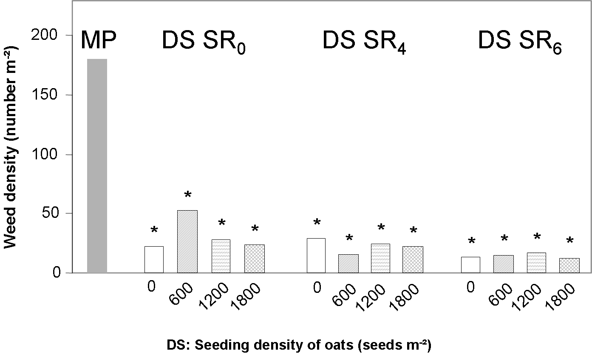
Fig 1: Weed density (R. sardous not included) in faba beans (30 DAS), as affected by tillage treatment (mouldboard plough MP, direct seeding DS), amount of straw residues (SR in DS: 0, 4 and 6 t ha⁻¹) and seeding density of oats (sown in autumn). Pairwise comparison of MP with DS treatments: Dunett’s test, * significant for P<0.05

The early competition of R. sardous in DS plots was indicated by higher pod insertion in DS plots (not shown). Competitiveness of R. sardous in DS plots resulted in significantly lower grain yield compared with the hand weeded plots. Nevertheless, retarded FAB development resulted in no significant yield losses in DS treatments. No significant yield differences were determined between MP (3.80 t ha⁻¹) and DS (3.44 t ha⁻¹) treatments which showed no tendency of lower grain yield neither influenced by the amount of straw residues nor the seeding density of oats. Costs for labour and fuel inputs were more than five-fold higher in MP (€ 275 ha⁻¹) compared with DS (€ 48 ha⁻¹) resulting in a 0.95 t ha⁻¹ lower grain yield for DS that might be accepted at least to equalize gross margin of the MP treatment when based on a FAB market price of € 240 t⁻¹. Low weed pressure and vigorous growth enabled DS FAB in the 2007-FF-trial to yield 3.83 t ha⁻¹ grain compared with 3.40 t ha⁻¹ (MP) (not significant).

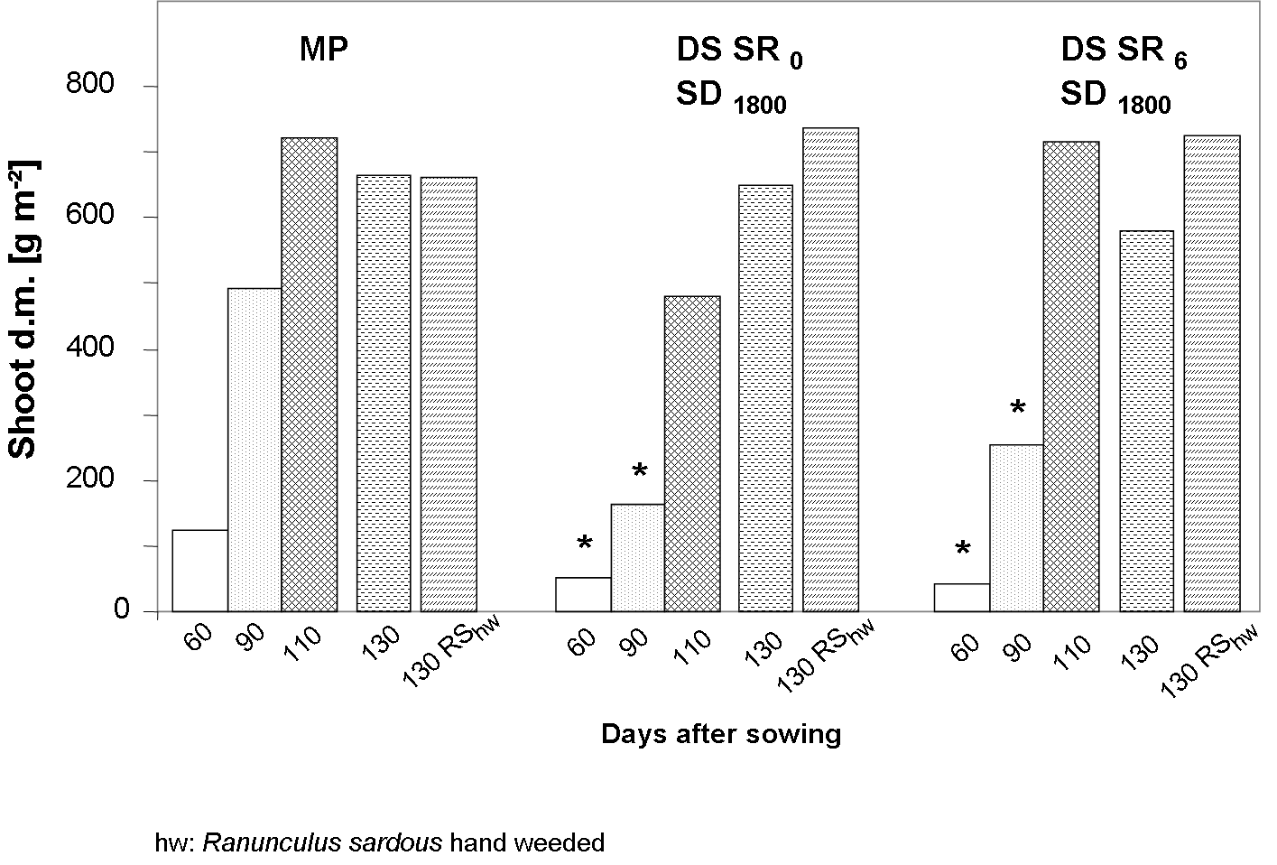
FIG 2: Shoot dry matter of faba beans as affected by tillage treatment (mould-board plough MP, direct seeding DS), amount of straw residues (SR in DS: 0, and 6 t ha⁻¹), seeding density of oats (SD: 1800 seeds m⁻² sown in autumn) and hand weeding of R. sardous and time. Pairwise comparison of MP and SR in DS treatments with Dunett’s test, * significant for P<0.05

Conclusions

Temporary use of DS of FAB is considered as a suitable approach to save labour and fuel in those cases where perennial weeds do not play an important role or can be accepted for one season due to sufficient crop competitiveness. Failure of clear effects of weed suppression assumed for the amount of oat crop residues and seeding density of oats in autumn makes further investigations necessary.

References

Barberi, P. (2002): Weed management in organic agriculture: Are we addressing the right issues? Weed Research 42, pp. 177-193.

Chou, C. H. (1986): The role of allelopathy in subtropical agroecosystems in Taiwan. In Putnam, A. R. and Tang, C. S. (eds): The Science of Allelopathy, New York, pp. 57-73.

Davies, D. H. K. and Welsh, J. P. (2001): Weed control in organic cereals and pulses. In Younie, D., Taylor, B. R., Welsh, J. P., Wilkinson, J. M. (eds.): Organic cereals and pulses: Chalcombe Publications, Lincoln, pp. 77-114.

Kühne, S, Verschwele, A., Hörsten, D. v., Jahn, M (2005): Implementation of bioherbicides and seed treatment in organic farming. In Köpke, U., Niggli, U., Neuhoff, D., Cornish, P., Lockeretz, W., Willer, H. (eds.): Researching sustainable systems. Proceedings of the First Scientific Conference of the International Society of Organic Agriculture Research (ISOFAR) 21-23 September 2005, Adelaide, South Australia, pp. 150- 153.

Institute of Organic Agriculture (IOL), University of Bonn, Katzenburgweg 3, 53115 Bonn, Germany, E-Mail: ukiol@uni-bonn.de, Internet: www.iol.uni-bonn.de

