Exploiting weed management benefits of cover crops requires pre-emption of seed rain

Gallandt, E.R., & Molloy, T.1

Key words: cropping system; green manure; weed seedbank

Abstract

To manage weeds with reduced reliance on, or without herbicides, cropping systems require intervals during which rapid and significant reductions in the germinable portion of the weed seedbank occur or, if already small, management to maintain a low density. Cover cropping systems and component studies have identified single-season cover cropping practices that will lower the density of the germinable weed seedbank, offering an effective means for managing the weed seedbank while maintaining or improving soil health. Specifically, field experiments demonstrated that soil disturbance events associated with cover cropping encouraged germination and seedling establishment thereby reducing the density of germinable seeds in the weed seedbank. Of notable importance, however, are the disturbance events that preempt weed seed rain. If weeds are permitted to reach reproductive maturity in cash or cover crops, the “debits” to the seedbank resulting from early season disturbance will likely be overwhelmed by the resulting seed rain “credits.”

Introduction

Cultivation generally kills a constant proportion of established weed seedlings (Mohler, 2001). High levels of weed control in organically-managed fields thus requires a low density of germinable seeds in the weed seedbank, and consequently a low initial density of weed seedlings. Seedbanks in agricultural systems may be managed by maintaining low densities of weeds, by enhancing the competitive advantage of the crop, by increasing seed mortality, and by manipulation of the soil environment to reduce the probability of weed establishment (Gallandt 2006. Cover cropping practices may be useful in this regard, contributing soil disturbance events that preempt weed growth and stimulate germination of additional weeds, and establishing a competitive environment that can reduce seed production of surviving weeds. Moreover, cover crops often offer flexible management opportunities that can prevent weed seed rain. They also contribute residues that reduce weed establishment in subsequent crops. A further advantage of cover cropping practices is their potential beneficial contribution to soil quality.

We compared single-season cover cropping practices, varying in intensity, for their ability to directly or indirectly reduce the density of germinable seeds in the weed seedbank. We hypothesized that the decline in the weed seedbank would be proportional to the intensity of cover cropping as reflected by the amount of time live cover crop biomass is present in a system, and the frequency of unique disturbance (tillage/mowing) events.

Materials and methods

To evaluate the contribution of cover cropping practices to the management of the weed seedbank, field experiments were established in the spring of 2004 and repeated in the spring of 2005, in a randomized complete block design with four replications. Treatments included four cover crop systems and a fallow control. We considered the intensity of cover cropping to be based on the length of time a field is kept in a living cover crop, the biomass production of the cover crop, and the number of tillage or mowing events before the next cash crop (Figure 1). Back-to-back cover cropping involves more soil disturbance and was therefore hypothesized to decrease the soil seedbank faster.

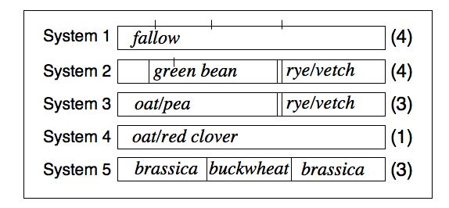
Figure 1: Cover cropping systems established in 2004 and repeated in 2005. Numbers in parentheses indicate major disturbance events that would preempt weed growth.

Synthetic seedbanks were established in the areas to be planted to the cover crop Systems. Weeds were dispersed at 2100 viable seeds m⁻² in the early spring (“frost-seeded”) prior to cover crop establishment. The synthetic seedbanks included a 2 m⁻² area seeded with an equal number of Setaria lutescens, Chenopodium album, and Abutilon theophrasti. Ceramic beads, similar in size and density to C. album, were included to evaluate the efficiency of recovery. Greenhouse germination was used to estimate the readily germinable (non-dormant) fraction of the seedbank. Direct extraction using specialized wet sieving equipment was used on sub-samples to enumerate dormant seeds and ceramic beads.

Results

Greenhouse germination. The initial germinable seedbank densities were unaffected by System (Figure 2). Poor timing of late-season disturbance resulted in considerable C. album seed production and an increase in the seedbank in the field pea/oat-rye/vetch system (Figure 2 A). Other treatments responded remarkably similar over time and species, demonstrating that systems with more soil disturbance events result in greater depletion of the seedbank over a single season (Figure 2). Notable is the consistently dramatic single-season reduction in C. album, S. lutescens and A. theophrasti in the systems that included three or more unique disturbance events (Figure 2 A-C).

Direct extraction. Thirty nine percent of the sown “surrogate” seeds (ceramic beads), averaged over years, were recovered in the spring following sowing, and 25% in the following spring. The density of S. lutescens seeds remained the greatest in the oat/red clover system (data not shown), consistent with the theory that season-long cover crops may act to preserve the preceding years seedbank compared to systems managed with more frequent disturbance events.
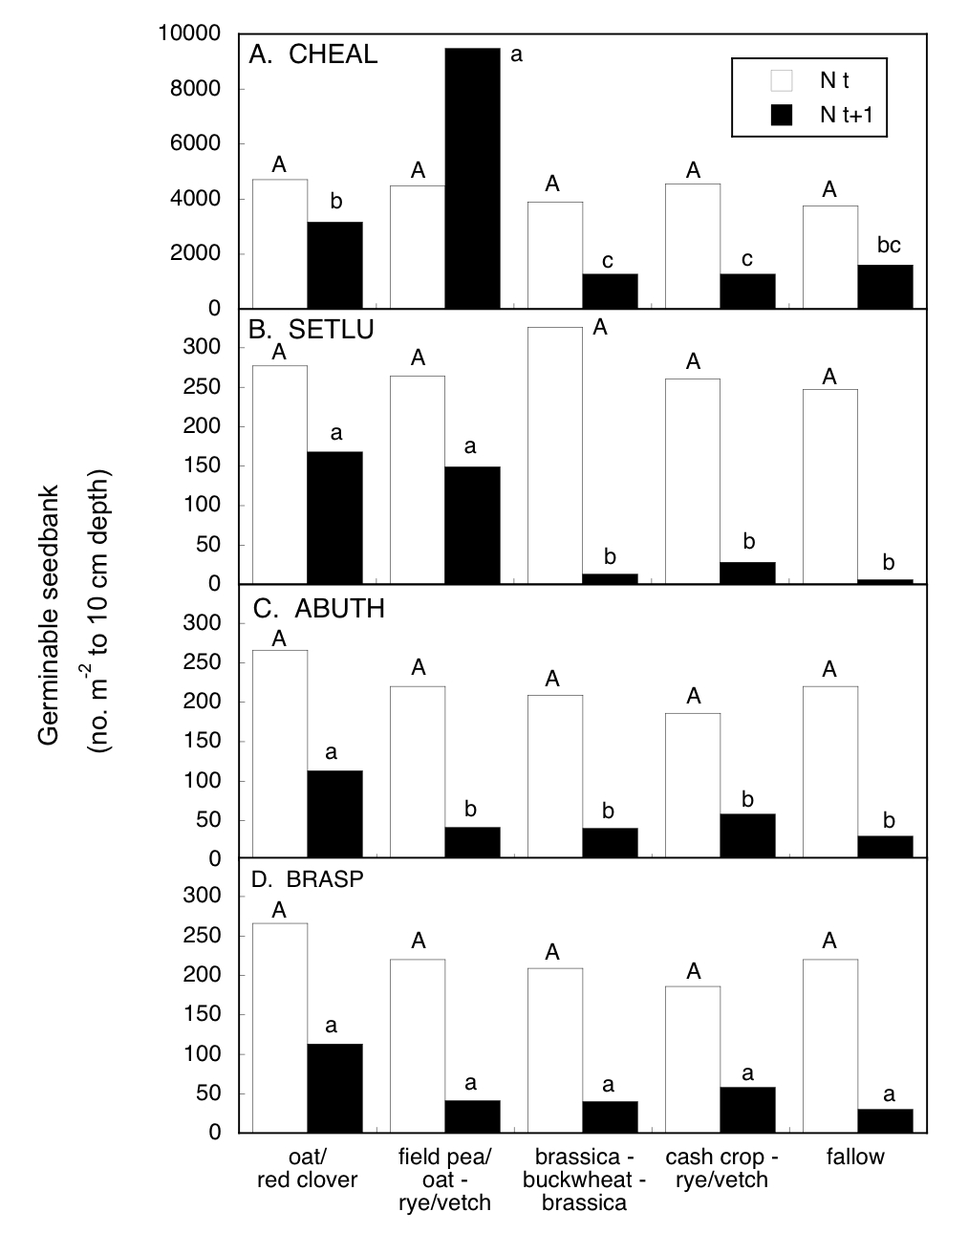
Figure 2. Density of germinable seeds sampled in the spring, prior to implementing cover cropping sytems (N t), and sampled the following spring (N t+1), in Maine, U.S.A. Oat/red clover included a single unique disturbance event whereas fallow and cash crop/rye vetch received four disturbance events; other systems included three disturbance events. Species included Chenopodium album (A), Setaria lutescens, Abutilon theophrasti (C), and several brassica species (D), primarily Sinapus arvenses, Brassica rapa, and Raphanus raphanistrum. Means labeled with common letters within year (N t or N t+1) are not significantly different (P > 0.05).

Discussion

Cover crops may contribute multiple benefits to organic farming systems that aim to function with greater biodiversity, notably linking management to improve soil quality with multiple direct and indirect stresses that may reduce weed problems (Bàrberi 2002; Gallandt 2004). While the beneficial contributions of cover crops are frequently discussed, without strategic implementation, cover cropping may actually exacerbate existing weed problems. A long period of a perennial cover crop will, for example, preserve the seedbank of relatively persistent species. If the growth of a cover crop is not terminated prior to weed reproduction, the cover crop can contribute significant seed rain. Thus, deployment of cover crops should be guided by the timing of unique disturbance events to avoid “crediting” the seed bank while maximizing opportunities for “debiting” the seedbank (Forcella 2003). For example, post-harvest management should aim to keep seeds on the soil surface to encourage predation (Westerman et al., 2006), and timing of tillage events, i.e., summer fallowing, should aim to maximize germination losses.

Conclusions

Single-season cover cropping practices including three or more unique soil disturbance events resulted in a marked reduction in the germinable weed seedbank. Despite their apparent competitive ability, and likely benefits to soil quality, full season cover crops lacking soil disturbance may result in considerable weed seed rain and therefore an increasing weed problem in subsequent years. While we do not discourage growers from considering these full-season cover crops, they must be monitored carefully so that they are terminated prior to production of viable weed seed.

Acknowledgments

This work was part of a collaborative project “Threshold-based Cover Cropping Strategies for Weed Management,” supported by the Northeast Regional Integrated Pest Management program, and conducted in collaboration with S. Mirsky, W.S. Curran, D.A. Mortensen, and M.E. Barbercheck, Penn State University.

References

Bàrberi, P. (2002). Weed management in organic agriculture: are we addressing the right issues? Weed Research 42, 177-193.

Forcella, F. (2003). Debiting the seedbank: priorities and predictions. Aspects of Applied Biology 69, 151-162.

Gallandt, E. R. (2004). Soil improving practices for ecological weed management. In "Principles and Practices in Weed Management: Weed Biology & Weed Management" (Inderjit, ed.), pp. 267-284. Kluwer academic publishers, Dordecht, The Netherlands.

Gallandt, E. R. (2006). How can we target the weed seedbank? Weed Science 54, 588-596.

Mohler, C. L. (2001). Mechanical management of weeds. In "Ecological Management of Agricultural Weeds" (M. Liebman, C. L. Mohler and C. P. Staver, eds.), pp. 139-209. Cambridge University Press, Cambridge, UK.

Westerman, P. R., Liebman, M., Heggenstaller, A. H., and Forcella, F. (2006). Integrating measurements of seed availability and removal to estimate weed seed losses due to predation. Weed Science 54, 566-574.

University of Maine Sustainable Agriculture Program,5722 Deering Hall, Orono, ME, 04469-5722. U.S.A. E-mail: gallandt@maine.edu, Internet www.umaine.edu/weedecology

