Annual clovers and medics in living mulch systems: Competition and effect on N supply and soil fertility

J. P. Baresel und H.-J. Reents¹

Key words: genetic resources, legumes, crop farming, plant nutrition, living mulch

Abstract

The potential of a large number of species of self-reseeding annual clovers and medics as continuous ground cover in living mulch systems with cereals in southern Germany and their effect on N supply and soil properties were assessed. Adapted legume species could be identified. The competition of the legumes on rye was limited but not on wheat. Positive effects on N supply and on indicators of soil fertility could be evidenced

Introduction

Living mulch systems are characterised by a continuous ground cover, in the most cases legumes, and by minimum tillage (see Hiltbrunner, 2005). They are of interest mainly for Organic Farming (OF). The potential advantages of such systems are an improved N supply (and thus, in the case of wheat, a better baking quality), less problems of erosion, an improvement of the biological soil characteristics and a reduced input of energy.

In Germany, almost exclusively white clover has been used as ground cover in LM systems. Scientific studies and practical experience from the past years show, that the competition of this relatively aggressive species with its undetermined growth cycle is too strong (Neumann, 2005). The aim of the present study was to asses the potential of annual self-reseeding species, which, due to their determined growth cycle, are potentially better adapted.

The following aspects are highlighted in the present contribution: (1) May annual self-reseeding species be found, which are potentially suitable as living mulches, adapted to German climatic conditions and which are able to re-establish from seed over consecutive years? (2) Are the competitive relationships really more favourable in annual than in perennial legume species? (4) Which contribution to N supply and soil fertility may be expected?

Materials and methods

In 2002 and 2003, a screening of 500 genotypes and 50 species (mainly Medicago and Trifolium species) was performed by spaced plant evaluation and replicated plot experiments, assessing mainly adaptation to German climate and growth characteristics (survival, persistence, biomass, canopy height, see Baresel et al. 2004). For subsequent studies Trifolium subterraneum (TS), T. campestre (TC), Medicago orbicularis (MO) and M. minima (MM) were selected, which turned out to be adapted to southern German climatic and, due to their growth characteristics, were supposed to be suitable for LM systems. With these species, from 2004 to 2006, 11 field experiments were performed; due to hailstorms and a particularly cold winter in 2005/2006, a part of them could not be fully evaluated. To enable the assessment of the effect of the legumes on N supply, in some of the experiments an N-poor position within the rotation was chosen, which explains the low yield levels in those experiments. All experiments were performed in organically managed farms in southern Bavaria (Germany) on sandy loam soils.

In the first year of each experiments, the legumes were sown together with the main crop, i.e. Winter wheat (cv. „Tiger“) of winter rye (cv. „Walet“) in the second half of August. Early planting is necessary to permit a good development of the legume swards before winter. As controls, plots with perennial legumes (T. repens and M. lupulina) and M. truncatula as well as cereals alone were planted. M. truncatula grows quickly in autumn, but is not winter hardy; the use of such frost-killed LM may be a way to reduce competition. In October of the subsequent year, winter cereals (rye and wheat) were planted into the swards of legumes, which meanwhile were re-established from seed (see over-view in Table 1). To prepare a seedbed and to reduce competition by the legumes, a partial tillage was performed combining a strip rototiller with a seed drill. Double rows of cereals were sown into the strips; the distances were 48 cm between and 8 cm within the double rows. In the control plots without legumes, a conventional soil tillage was performed and the cereals were drilled commonly with a density of 400 grains/m² and a row distance of 12,5 cm (Experiments 1-6).

Nitrogen uptake of the above-ground-biomass of legumes, cereals and weeds, soil mineral N as well as, in a part of the experiments, the particulate organic matter (POM) were assessed to valuate the effect of the living mulches on N supply.

Results and Discussion

Within the frame of this contribution, only selected results, highlighting aspects of competition and effects on N supply and soil fertility, can be reported.
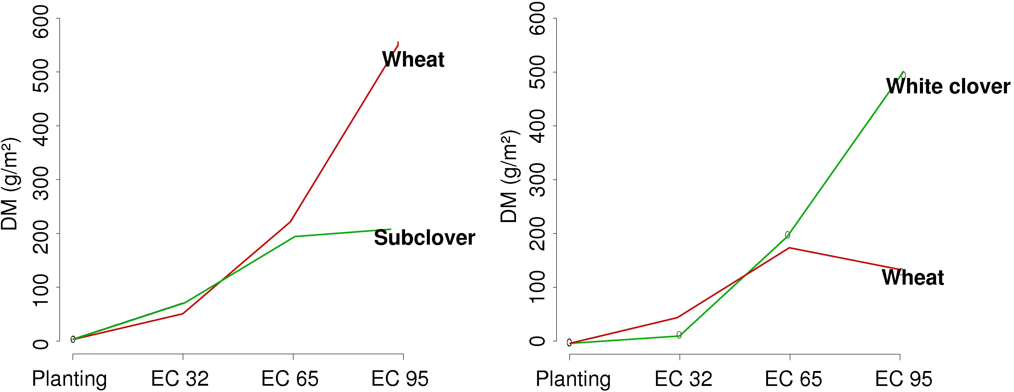
Fig. 1: Development of biomasses in living mulch systems with Wheat and subclover, resp. White clover in the year of first establishment (in 2004)

In normal winters (2002-2005), the legumes were only little damaged by frost, permit-ting a good recovery of the legume swards in spring. Only in 2005/2006, after a long period of severe frost and snow (with the formation of a layer of ice), more plants were damaged by frost than in other years. All species tested in the LM experiments (with exception of M. truncatula) were able to persist over several years by self-reseeding. In contrast to perennial species, the growth of all annual legumes finished after seed ripening. Thus, the competitive relationships were more in favour of the cereals, compared to white clover (Fig. 1). This was particularly the case, when the cereals were sown into existing swards, but also in the year of establishment. In the experiments established in 2004, with rye as main crop, white clover was suppressed already from the early development stages; this might be also due to the dry conditions during early development of the white clover.
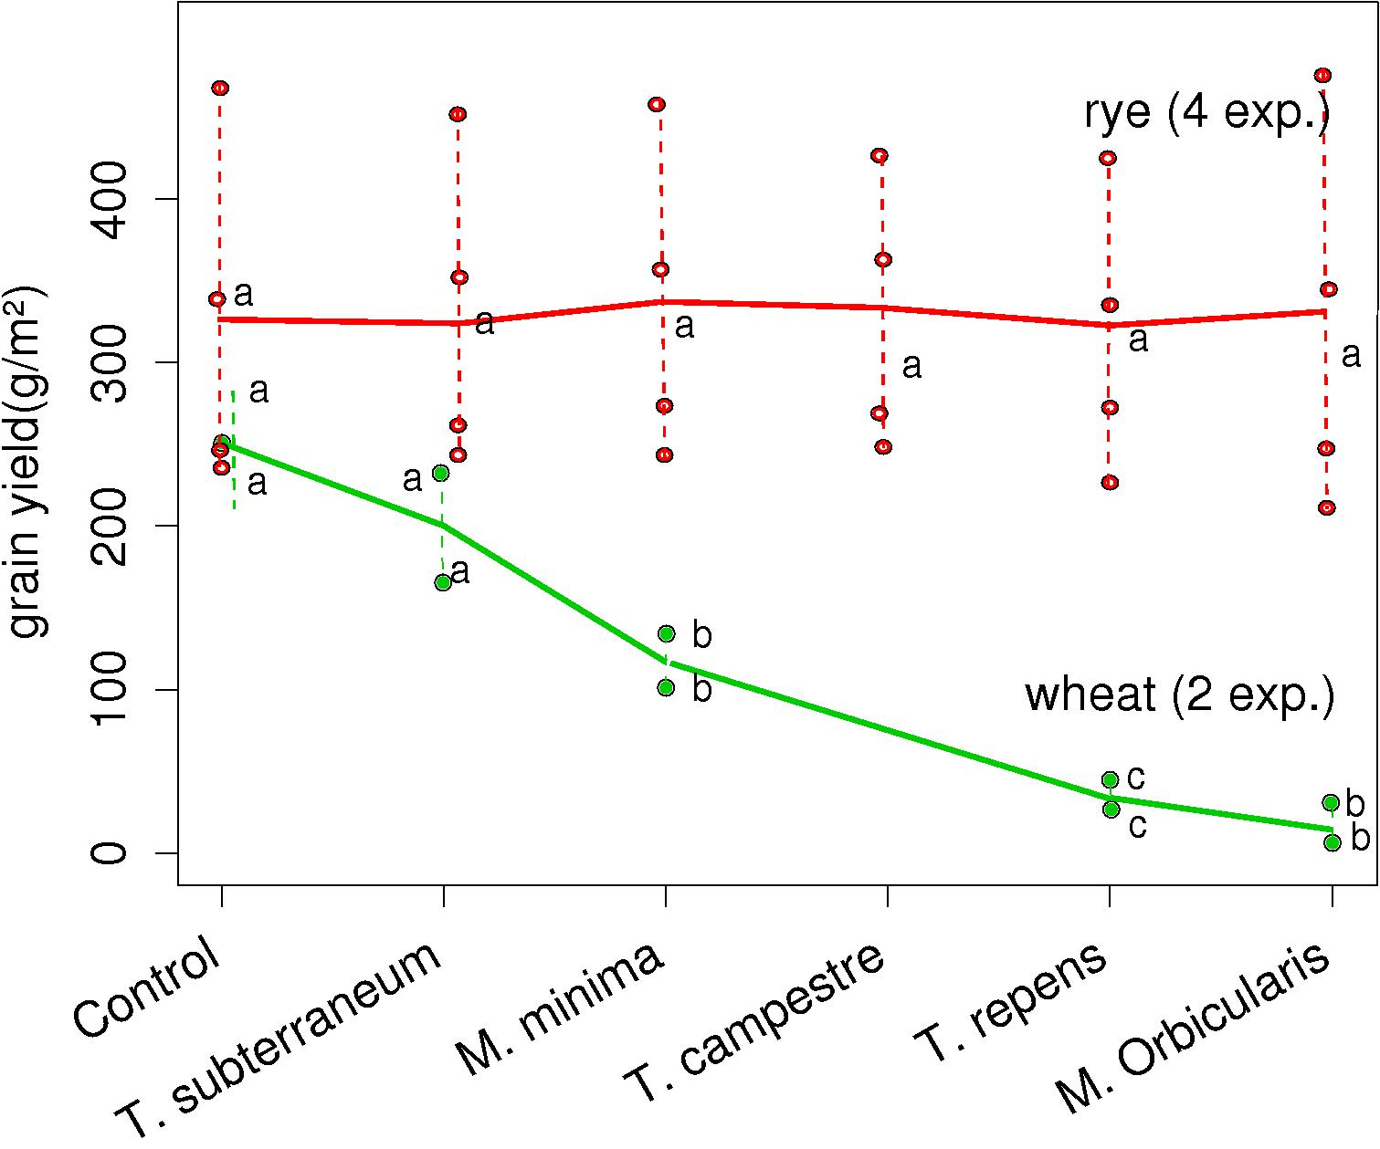
Fig. 2: Yield of Rye and Wheat in various living mulches in the year of first establishment. (t-test / Bonferroni; p<0,05).

No reduction of yield of rye due to competition by ground cover legumes could be observed (Fig. 2). For M. truncatula (which were killed by frost, leaving moderate amounts of additional organic matter in the soil), a slight yield increase could be observed. For wheat (due to the cold winter in 2005/2006) only the data of one experiment are available: according to the legume species, yield reduction ranged from 20% in T. subterraneum to 100 % in M. orbicularis, whose development was, due to a moist and relatively cool summer, particularly strong (Fig. 2). In the experiments established in 2005, where the legumes were killed by the frost, no yield reduction by subterranean clover could be observed.
Fig. 3: Comparison of cereal yields and plant densities in the year of establishment and interplanting in existing legume swards

Considerably lower yields were achieved sowing cereals in already established swards of subterranean clover (Fig. 3). This was caused by the seeding technique, which requires large distances between the double rows and leads to low plant densities. Cereal and legume biomass are negatively correlated depending on the legume and cereal species as well as on the N supply. Thus, the effect on the N supply varies widely (Fig. 4). N input and output were in an equilibrium at a yield level (for rye) of 5 t/ha. Beneficial effects on indicators of soil fertility such as soil POM content, Aggregate stability and the occurrence of AM spores (Fig. 5) could be revealed.

Conclusions: (1) Annual self-reseeding species could be identified, which were suit-able as living mulches, adapted to German climatic conditions and which are able to re-establish from seed over more consecutive years. (2) These species were less competitive with the cereals than LM systems with white clover. (3) The contribution to the N supply of the agricultural system is modest and negatively correlated with grain yield; an equilibrium may be achieved with grain yields around 5 t/ha. (4) Due to the continuous ground cover and reduced soil tillage, the soil fertility may be improved. (5) Cultivation and seeding techniques need further improvement in order to make the system practicable for farmers.

Acknowledgments
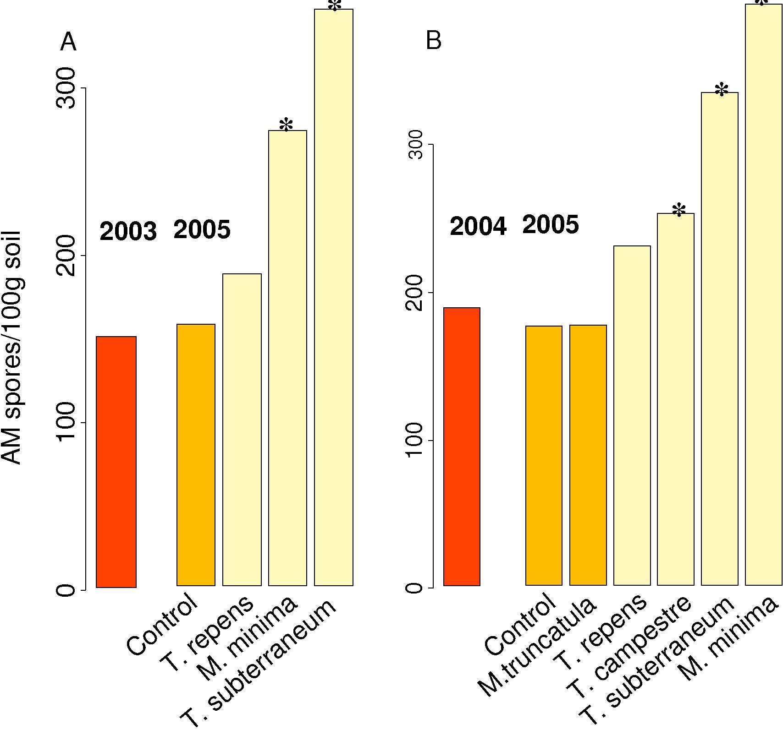
Fig. 5: Effect of various living mulches on the occurrence of AM spores compared to the spore density before the establishment of the living mulches (left bar) (*: p <0,05,t-test, / Bonferroni)
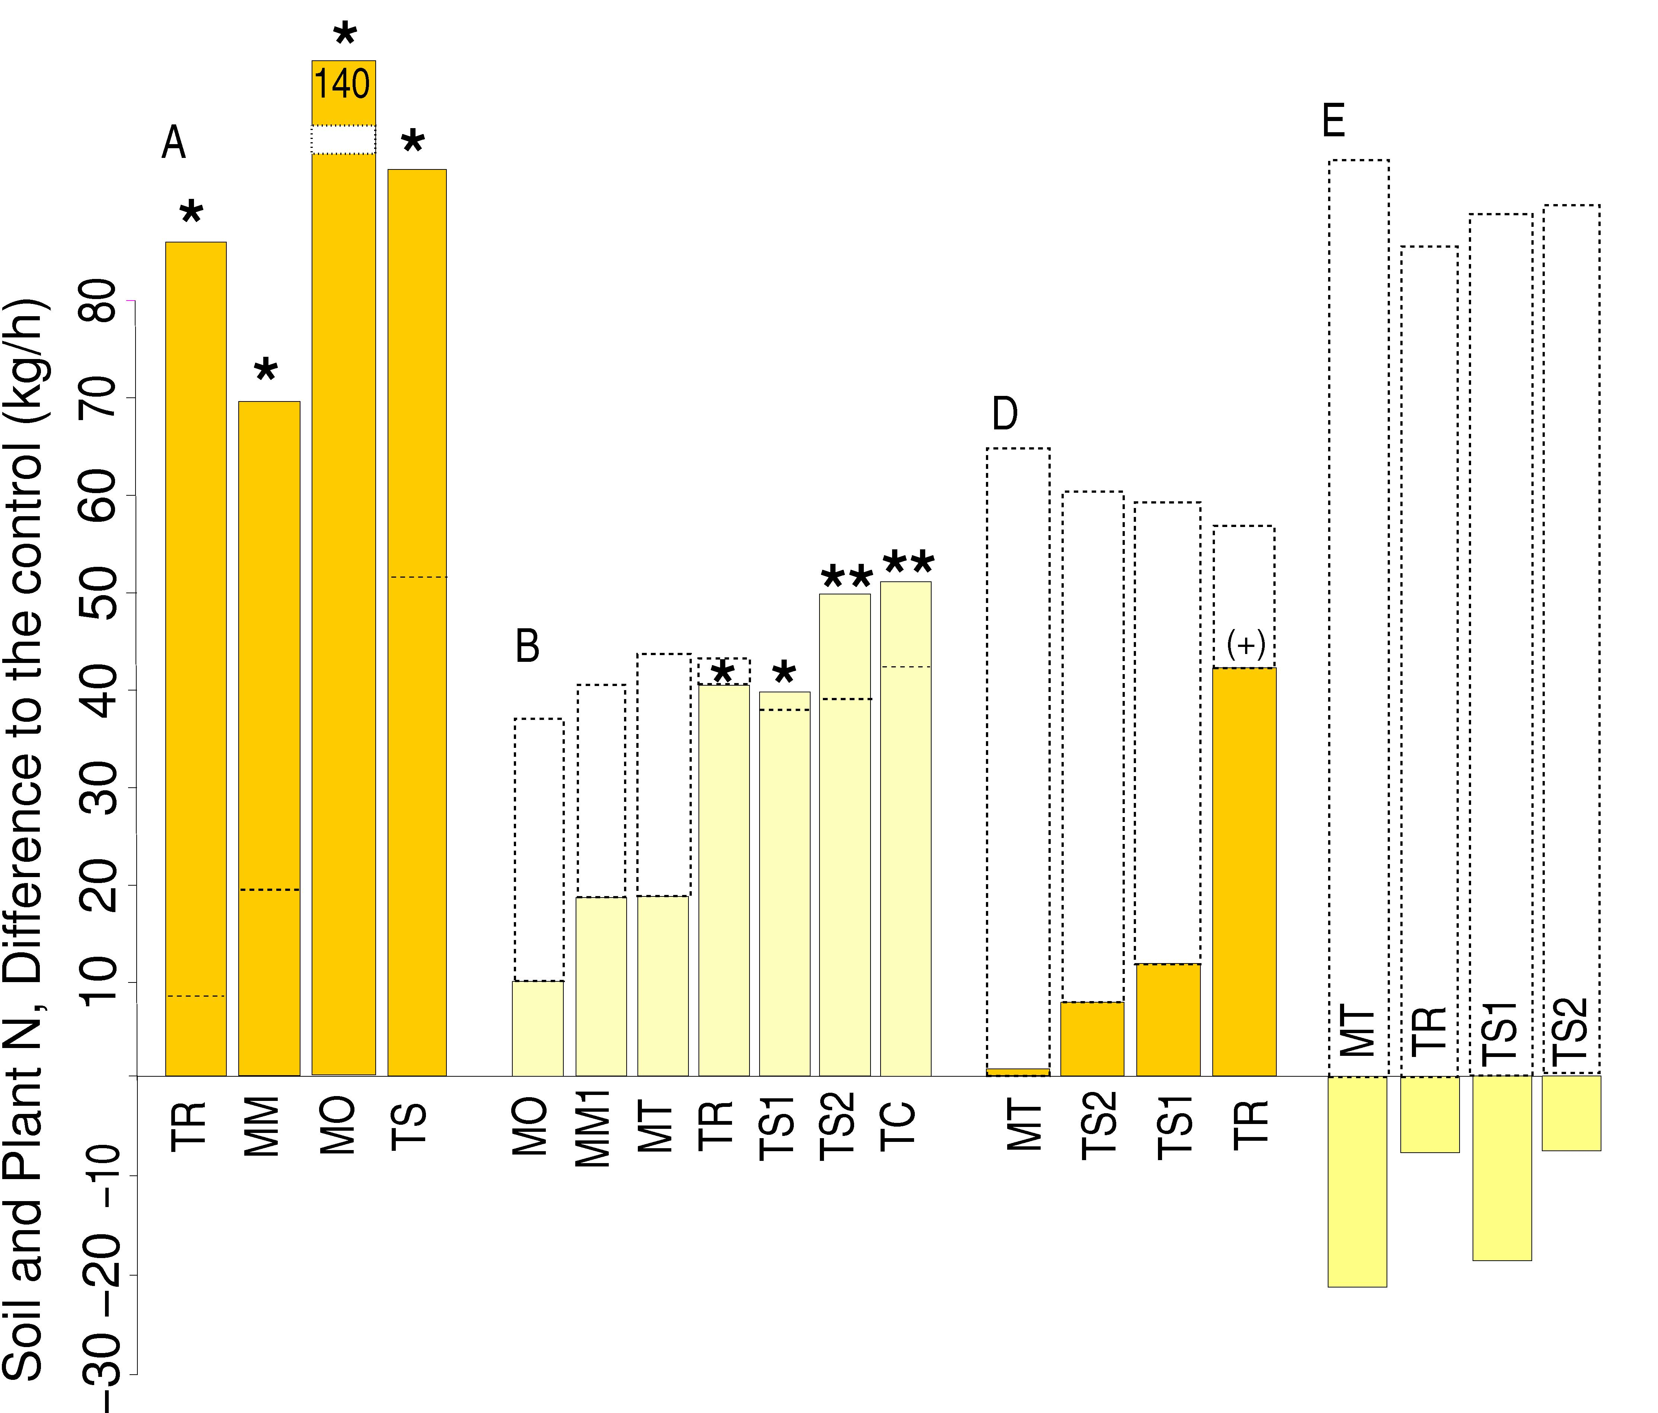
Fig. 4 Effect of different legume living mulches on total N, i.e. plant biomass N, soil mineral N and N bound in the POM fraction. (Difference to the control: **: p<0,01; *: p <0,05, (+): p < 0,1, t-test /Bonferroni)

This project was supported by Bundesprogramm Ökologischer Landbau (03OE99)

References

Neumann, H. (2005): Optimierungsstrategien für den Getreideanbau im Ökologischen Landbau: System weite Reihe und Direktsaat in ausdauernden Weißklee. Diss. Univ. Kiel.

Baresel P., Reents H.J., Schenkel W. (2004): Screening alternativer Leguminosenarten auf ihre Eignung zur Gründüngung und zum Mischanbau im Ökologischen Landbau. Organic e-prints No. 8353 (http://www.orgprints .org)

Hiltbrunner J. (2005): Legume Living Mulches for the Control of Weeds in Organic Winter Wheat (Triticum aestivum L.). Diss. ETH Zürich No. 15634

Lehrstuhl für Ökologischen Landbau, TU München, 85354 Freising, reents@wzw.tum.de

