Variety Recommended Lists of Organic Cereals in Emilia-Romagna

Piazza, C., Foutry H. , Reggiani R , Poli M., Bolognesi S.

Key words: variety trials, wheat, barley, corn.

Abstract

In order to meet the needs of Emilia-Romagna’s technicians and farmers, specific trials on cereals (soft wheat, hard wheat, barley, corn) for organic production have been carried out since 1995. These trials helped draw up specific Variety Recommended Lists.

Introduction
Variety selection plays a main role in organic production and the best varieties in traditional production are not always the best solution for organic farming. Key features of organic production must be: high yield and rusticity, weeds competition and pest and disease resistance.
Specific trials on cereals for organic production have been carried out since 1995 in Emilia-Romagna. The investigation has started with soft wheat, later on corn (1999), barley (2000) and hard wheat (2004) have been involved, too.

Material and methods

Trials were carried out on a yearly basis in 1-2 organic certified farms in Emilia-Romagna (North Italy). The experimental layout consisted of randomised blocks with 3-4 replicates. The chosen varieties were among those achieving the best results in conventional farming trials and showing good resistance/tolerance to several pathogens. On the whole 111 varieties of soft wheat, 18 of hard wheat, 43 of barley and 132 of corn were compared. The following criteria were detected: yield, disease sensitivity and environmental stress, hectolitre weight, life cycle of the plant. Protein % and hardness on soft wheat and broken plants on corn were also detected.
The draft of the Variety Recommended Lists was made according to the following standards:
- this List is valid in Emilia-Romagna; data used derive from variety comparison trials in organic farming made in Emilia-Romagna and from additional information by technicians, farmers, millers and seed companies;
- proposed varieties and hybrids of each species are divided according to the following criteria:
- soft wheat: Synthetic Quality Index - ISQ (Foca G. et al. 2007)
- corn: FAO maturity classes; flint corn fits in a separate group
- barley : ear type

- varieties and hybrids have to be tested for at least a two-year period;
- productivity must exceed at least 5% the field average yield and must not drop below the field average yield for more than one year;
- less productive varieties/hybrids can be put in the list if suitable varieties in a particular group are missing;
- varieties/hybrids must be pathogen tolerant

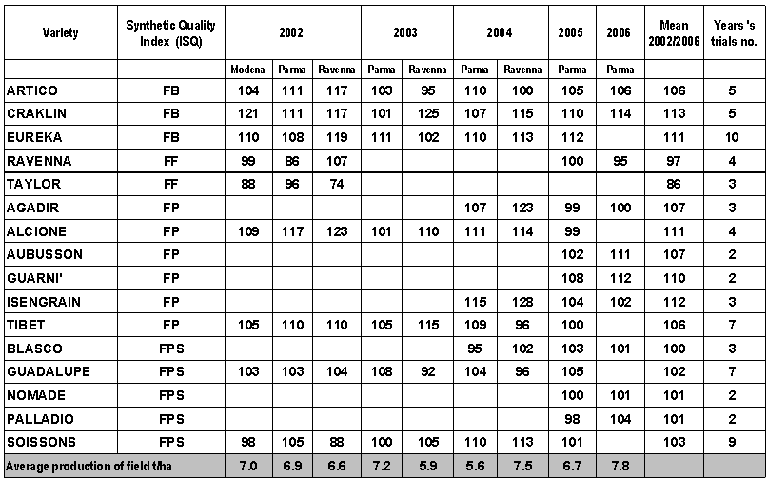
Results
Table 1. Yield index (field average yield =100) for Soft Wheat Varieties included in Recommended Lists for Organic Production in Emilia-Romagna - Year 2007. Quality categories ISQ: FB (w. for biscuits), FF (improver w.), FP (ordinary bread making w.) and FPS (superior red making quality w.).

Table 2. Yield Index (field average yield = 100) for Barley Varieties included in Recommended Lists for Organic Production in Emilia-Romagna. Year 2007. Table 3. Yield Index (field average yield = 100) for Hard Wheat Varieties included in Recommended Lists for Organic Production in Emilia-Romagna. Year 2007 Table 4. Yield Index (field average yield = 100) for Corn Hybrids included in Recommended Lists for Organic Production in Emilia-Romagna. Year 2007.

Discussion and Conclusions

Soft Wheat: on the average, yield was more than satisfactory (Table 1) and in some years it was even higher than in traditional production (6.5-7.0 t/ha). Only in 2003 and 2004 crops were affected by Brown Rust and by Septoria spp., while Fusarium spp. and Powdery Mildew were quite absent. Protein level is 1% lower if compared to conventional fields (Corbellini M. et al. 2006), its average value varying between 12.7 and 13.5; some cultivars (Taylor, Ravenna, Blasco, Palladio) have maintained their protein values close to 14% in organic farming, too. Weight per hectolitre was good (slightly less than 80 kg/hl) in 2004 and 2006, but low in 2002

Barley: in addition to hulled barley types, naked varieties, being suitable substitute for coffee and soup preparation, were added in trials, too. In several cases cultivation after meadow-grass (alfalfa) has caused widespread lodging, lowering its yield (2004). Productive differences among varieties were not as evident as in wheat (Table 2).

Hard wheat: in the last few years an interest in this species has been increasing also in Emilia-Romagna. Yields were interesting, even if affected by Brown Rust and by Septoria attacks in 2004 (Table 3).

Corn: on the average, yields are lower than in conventional farming even though they can exceed 10 t/ha in optimal conditions (Table 4). From a productive point of view the most interesting FAO classes in organic cultivation are those reaching 400-500. While DK440, PR36B08, Karen, DKC5783, Larigal and Vertice are less sensitive to stem break.
Data obtained allow to identify, for every single species, a group of varieties to be grown in organic farming. At the beginning only soft wheat was in the recommended lists (C. Piazza et al. 2001), later on other species were included as well. According to the data obtained, the lists are updated every 1-2 years, the last update was carried out in 2007 (AAVV.,2007).

Acknowledgments

Activity carried out within project co-ordinated by CRPV (Vegetal Production Research Center) in collaboration with ProBER (Organic Producers of E. R.), funded by Emilia-Romagna Region (L.R. 28/98).

References

AAVV. Agricoltura biologica- Tecnica colturale e liste varietali Agricoltura 6:116-129 (2007)

Corbellini M., Empilli S., Mazzucchi L., Boggini G. Caratteri qualitativi del tenero biologico. Informatore Agrario 37/2006, 42-43.

Foca G, Ulrici A, Corbellini M, Pagani M A, Lucisano M, Franchini G C and Tassi L. Reproducibility of the Italian ISQ method for quality classification of bread wheats: An evaluation by expert assessors Journal of the Science of Food and Agriculture J Sci Food Agric 87: 839-846 (2007).

Piazza C, Poli M, Reggiani R, Sarti A. Varietà per il frumento biologico. L’Informatore Agrario 38: 41-43 (2001)

Azienda Agraria Sperimentale Stuard, Strada Madonna dell’Aiuto, 7/A S. Pancrazio (PR), Italy
Azienda Agraria Sperimentale Stuard, Strada Madonna dell’Aiuto, 7/A S. Pancrazio (PR), Italy
Azienda Agraria Sperimentale Stuard, Strada Madonna dell’Aiuto, 7/A S. Pancrazio (PR), Italy
Azienda Agraria Sperimentale M. Marani, Via Romea Nord, 54 (RA), Italy ⁴ Azienda Agraria Sperimentale M. Marani, Via Romea Nord, 54 (RA), Italy

