Pilot scale application of ozonated water wash – effect on microbiological and sensory quality parameters of processed iceberg lettuce during shelf-life

Särkkä-Tirkkonen, M., Leskinen, M.1 & Ölmez, H.

Key words: ozone, iceberg lettuce, fresh-cut-vegetables, minimal processing

Abstract

The aim of the study was to assess the effect of ozonated water wash on the microbiological and sensory quality parameters of minimally processed iceberg lettuce in pilot scale in comparison to aqueous chlorine wash. Alternative solutions for chlorine are needed, since its use is prohibited in organic food processing. Iceberg lettuce samples were washed with three different ozone solutions and the water wash and the 100 ppm chlorine wash were used as control. Ozone generator based on corona discharge was used to produce ozone at level 7 ppm. The samples (150 g) packed in oriented polypropylene pouches were stored for 10 days at + 5ºC and the microbiological and sensory quality was analysed on days 1, 6 and 10. There was no significant difference between chlorine wash samples and the samples washed 1 min in a machine with ozonated water concerning the microbiological quality. Compared with the chlorine with lower concentrations of ozone it is possible to control the microbial load. Concerning the sensory quality all samples endured all of the treatments well except the treatment with 7 ppm ozone for 5 min. As a conclusion the bubbling gaseous ozone in water can be as effective disinfection method as chlorine wash when the following processing parameters are taken into account: concentration of ozone during the whole process, exposure time, water temperature and the amount and type of the organic material.

Introduction

The disinfection of processed vegetables is one of the critical points along the processing line and has a definitive effect on the safety, quality and shelf-life of the product. Chlorine, which is the most widely used sanitizing agent for fresh cut vegetables, is forbidden in organic food production (EU 2092/91) due to the environmental and health risks (Wei et al., 1985). There is also a need for minimizing the water consumption and wastewater discharge rates in the industry. Therefore both the organic and the conventional processing sectors are now seeking alternatives to chlorine which assure the safety of the products, maintain the quality and enable a shelf-life as long as chlorine. Ozone has many characteristics that make it attractive for use as a sanitizer in food processing. High reactivity, penetrability and spontaneous decomposition to a non-toxic product (O₂) make ozone a viable disinfectant (Kim et al. 1999). It does not remain in water or on the surface of the product for a significantly long period of time, thus its use may be considered as a processing method rather than a food additive. There is also no need for storage of toxic chemicals as ozone is produced on demand and it is possible to re-use the process water and the ozone treatment is accepted as an environmentally friendly process (Khadre et al., 2001). Many studies show that bubbling gaseous ozone in water is the most effective ozonation method for vegetables and can be effective even in lower concentrations (Kim et al., 1999; Singh et al., 2002; Beltran et al., 2005; Ölmez et. al. 2007). However higher levels of ozone might be needed for a large manufacturing plant because of the amount of organic, dissolved solids and ozone-demanding material in the water (Garcia et al., 2003). Therefore pilot trials should be always conducted before implementing ozone applications in industry.

The aim of the study was to assess the effect of ozonated water wash on the microbiological and sensory quality parameters of minimally processed iceberg lettuce in pilot scale in comparison to aqueous chlorine wash during the shelf-life of the products. Based on the laboratory scale tests and pre-tests (Ölmez et al., 2007) a pilot test was executed in order to find out the optimized ozone treatment (dose, exposure time and temperature) and in order to develop a process applicable in industrial scale.

Materials and methods
Conventional industrial iceberg lettuce heads (Lactuca sativa L.) were transported and stored under refrigerated conditions until processing day. The wrapper leaves of the lettuce head were stripped away and the lettuce head was split in four pieces. The pieces were shredded with Hällde RG-200 vegetable cutter in 3 cm pieces (10 mm blade). The shredded iceberg lettuces were washed with five different solutions: 1) 7 ppm of ozone for 1 min. in Meiko GK60 washing machine 2) 7 ppm of ozone for 5 min, washing in a tub (volume 70 l) 3) 7 ppm of ozone for 1 min, washing in a tub (volume 70 l) 4) water wash for 1 min, in Meiko GK60 washing machine 5) chlorine wash for 1 min, 100 ppm active chlorine, prepared from sodium hypochlorite adjusted at pH 6,5 with 1M citric acid. The water wash and chlorine wash were used as control. For each wash 4 kg:s of lettuce was shredded. All samples were centrifuged in JMD drying drum (500 r/min). Tap water was used in washing treatments (pH 7.0, temp. +8.5 ºC).

Ozone generator based on corona discharge was used to produce ozone. The ozone productive capacity was ca. 10 g/h when pure oxygen was used as a feed gas. A flow of ozone was dissolved in the tap water by an inverse mixer (+ mixing nozzles) in 70 l tub. The 7 ppm ozone dose for the treatments 1, 2 and 3 means the concentration in the beginning of the process. Gaseous ozone production was measured using on-line measurement system (ATI Dissolved Ozone Monitor, Model A15/64). The samples (150 g) were packed in commercial packaging material (oriented polypropylene pouch, oxygen permeability 900 cm³/m²*d) in ambient atmosphere. The size of the pouch was 12.5 cm x 17.5 cm. All samples were stored for up to 10 days at +5 ºC and evaluated on day 1, 6 and 10.

The microbial analysis included the aerobic plate count (ISO 48333, 3 days at 30 ºC ), total coliforms (ISO 4832, 1 day at 37 ºC) and Enterobacteriaceae (Nordic Committee of Food analysis, No 144, 1 day at 37 ºC). Each microbial count expressed as log cfu/g of tissue, is the mean of four samples. The sensory quality of the samples was evaluated by five-membered expert panel. Qualitative describing method using semi-structured 100 mm scale was used to evaluate the sensory quality of the samples. The evaluated character was anchored with reference lettuce sample which was prepared the same day just before the evaluation. The organoleptic characteristics included freshness of the smell and off-flavour straight after opening the package, off-flavour on the plate, crispiness, watery taste, freshness of the taste and off-taste. The visual quality evaluation included moisture of the surface, browning of the cut surface and other colour defects. One sample t-test (p<0.05) for the significance of the differences of the means compared to the reference was performed using SPSS (Windows 2000, version 12.0). One-way analysis of variance and Tukey’s test was used to compare the differences between the samples.

Results and discussion

Concerning the effectiveness of the control of the bacteria there was no significant difference between chlorine wash and the treatment 1 where the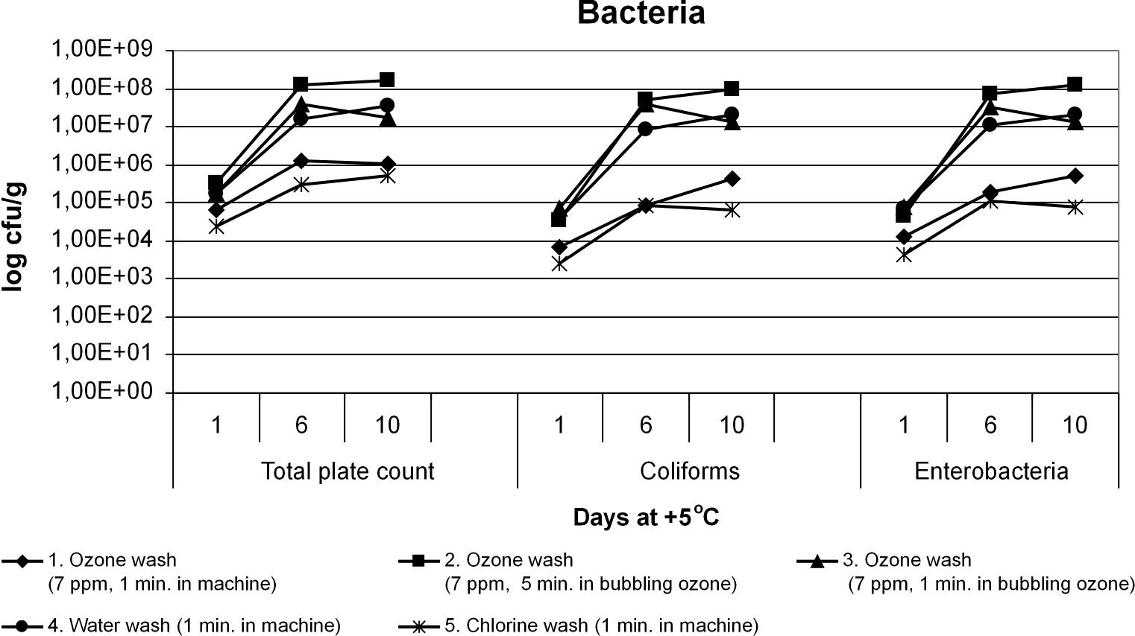
Figure 1: The effect of different washing treatments on the growth of bacteria during 10 days of storage at +5ºC.

samples where washed 1 min. in a Meiko washing machine with ozonated water (Fig. 1). The concentration of ozone was 7 ppm in the beginning of the process and the level of the ozone in the water declined very rapidly during the process being in the end of the process between 0.7-1.0 ppm. As a conclusion, if the level of ozone is high enough in the beginning of the process 1 min as a treatment time is adequate. The chlorine treatment was more effective washing method (p<0.05) than treatment no. 2. It can be concluded that 5 minutes ozone treatment is too long and possibly degrades the microbiological quality of the samples by providing excess oxygen to the microbes during the process. This conclusion is supported by the fact that even the water wash (treatment no. 4) gained lower microbe load than the treatment no. 2.

Concerning the sensory quality all samples endured all of the treatments well except the treatment no. 2 (7 ppm ozone dose for 5 min.). The samples were less fresh concerning the smell and taste (p<0.05), had more moisture on the surface (p<0.05) and had colour defects like greyish appearance after the treatment. The taste was also described more watery than the other samples. Because any severe discoloration did not occur in case of the other ozonated samples it can be concluded that discoloration is caused rather by the treatment time than the high level of the ozone dissolved in the water.

Conclusion

As a conclusion it can be stated that bubbling gaseous ozone in water can be as effective disinfection method as chlorine wash when the following processing parameters are taken into account: concentration of ozone during the whole process, exposure time, water temperature and the amount and type of the organic material. In order to develop an ozone water wash process applicable in industrial scale, proper testing at the plant must be conducted before applying the method in vegetable disinfection processing. Furthermore a better understanding of the mechanism involved in bacterial attachment on the surface of the fresh vegetable produce is necessary to improve the technology.

Acknowledgments

The authors gratefully acknowledge funding from the European Community financial participation under the Sixth Framework Programme for Research, Technological Development and Demonstration Activities, for the Integrated Project QUALITYLOWINPUTFOOD, FP6-FOOD-CT-2003- 506358.The results presented in this paper are based on the joint effort of the following research teams: University of Helsinki, Ruralia Institute (M. Särkkä-Tirkkonen, M. Leskinen), TÜBITAK Marmara Research Center (H. Ölmez), FiBL (CH: U. Kretzschmar).

References

Beltran, D., Selma, M. V., Marin, A., Gil, M. I. (2005): Ozonated water extends the shelf life of fresh-cut lettuce. J. Agric. Food Chem. 53:5654-5663.

Brackett, R.E. (2001): Fruits, vegetables, and grains. In Doyle, M.P., Beuchat, L.R., Montville, T.J. (eds.): Food microbiology: fundamentals and frontiers. ASM Press, Washington, p. 127-138.

EU Regulation No. 2092/91 on organic production of agricultural products and indications referring thereto on agricultural products and foodstuffs.

Garcia, A., Mount, J.R., Davidson, P.M. (2003): Ozone and chlorine treatment of minimally processed lettuce. J. Food Sci. 68:2747-2751.

Jin-Gab, K., Ahmed E.Y., Sandhya, D. (1999): Application of Ozone for Enhancing the microbiological safety and quality of foods: A review. J. Food Prot. 62:1071-1087.

Khadre, M.A., Yousef, A.E., Kim, J.-G. (2001): Microbiological aspects of ozone applications in food: A review. J.Food Sci. 66:1242-1252.

Kim, J.G., Yousef, A.E., Chism, G.W. (1999): Use of ozone to inactivate microorganisms on lettuce. J. Food Safety. 19:17-34.

Ölmez, H., Leskinen, M., Särkkä-Tirkkonen, M. (2007): Effect of ozonated water on the microbiological, physical and nutritional quality parameters of minimally processed lettuce during shelf life. In: Niggli U., Leifert C., Alföldi T., Lück L., Willer H. (eds.): Proceedings of the 3rd International congress of the European integrated project QualityLowInputFood (QLIF) ‘Improving suistainability in organic and low input food production systems’ 20th -23rd March 2007, Hohenheim. p. 392-397.

Singh, N., Singh, R.K., Bhunia, A.K., Stroshine, R.L. (2002): Efficacy of chlorine dioxide, ozone and thyme essential oil or a sequential washing in killing Eschericia coli O157:H7 on lettuce and baby carrots. Lebensm.-Wiss.u.-Technol. 35:720-729.

Wei, C.-I., Cook, D.L., Kirk, J.R. (1985): Use of chlorine compounds in the food industry. Food technol. 39:107-115.

University of Helsinki, Ruralia Institute, Lönnrotinkatu 7, FIN-50100 Mikkeli, Finland, Internet www.helsinki.fi/ruralia/mikkeli
2 TÜBITAK Marmara Research Center, Food Institute, P.O. Box 21, 41470 Gebze Kocaeli, Turkey

