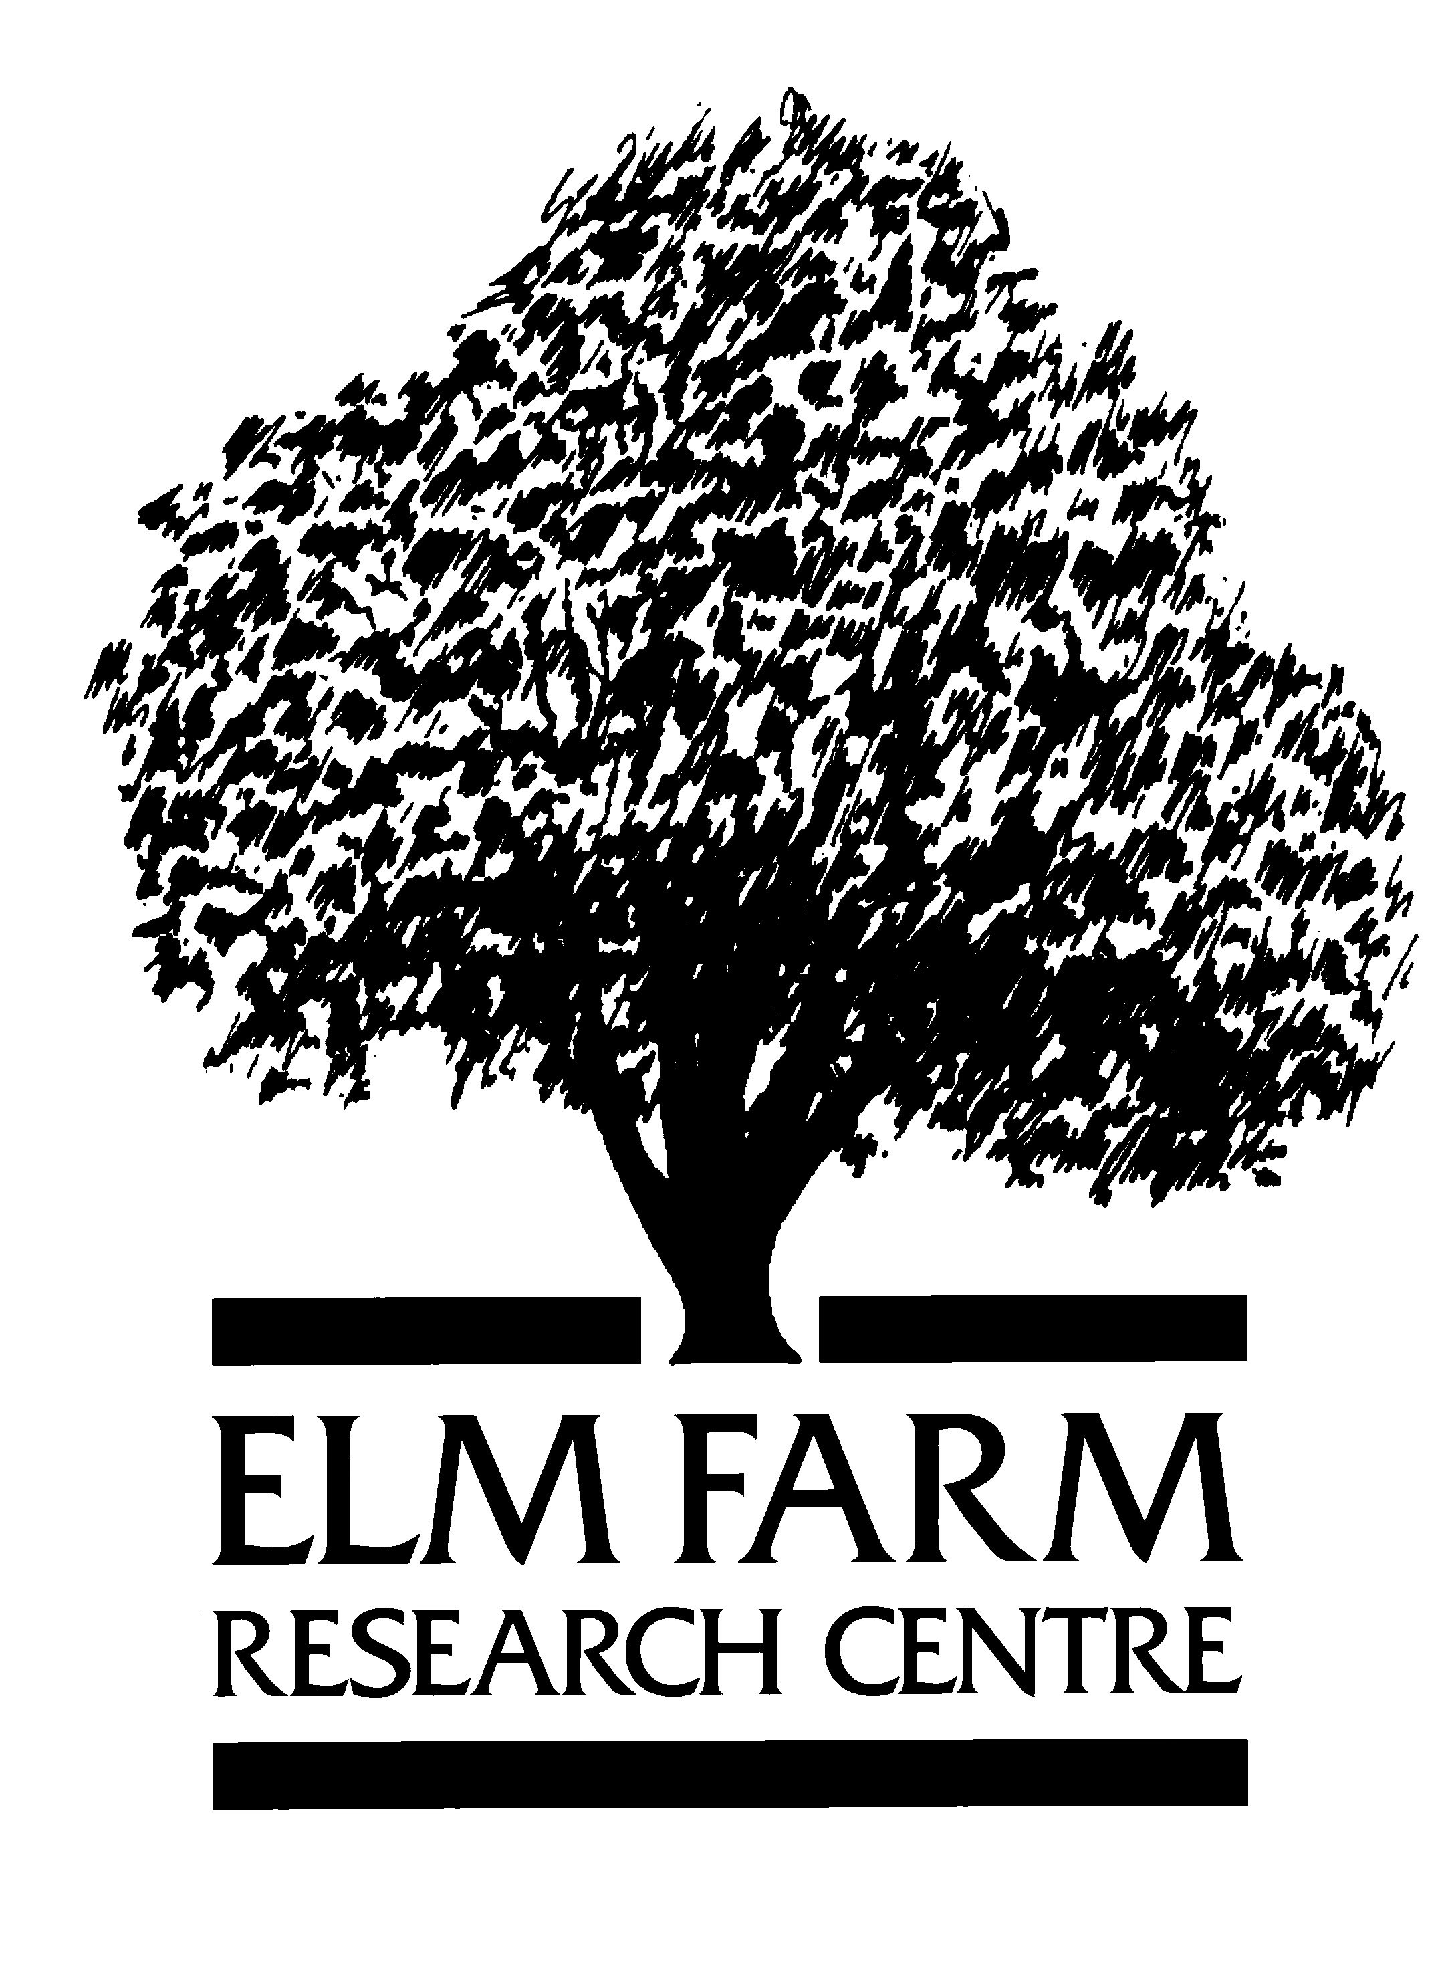
Sheepdrove

Organic Farm

SOF 001
Sheepdrove Organic Farm Soils Programme Report 2003.

Lois Philipps

Interim Report
October 2003.

Abstract.

Sheepdrove Organic Farm wishes to maintain or improve soil fertility (where appropriate) in accordance with organic principles and to gain a greater understanding of the biological activity with the soil ecosystems of the farm. In order to monitor changes in soil fertility a monitoring programme has been established to record all available past soils data and implement an ongoing programme that meets the agronomic needs of the farming enterprises and contributes to the ‘Sheepdrove Story’. From the limited data collected to date there is evidence that organic matter levels are higher than would be expected on these soil types and that past management has maintained major nutrient status at ‘conventional’ levels.

Objective.

  - To collect all available data and past research work

  - To put in place a comprehensive monitoring and recording programme

  - To use so far as practicable data that is commonly collected by the SOF enterprises.

Introduction.

  - Since the conversion of Sheepdrove Organic Farm (SOF) soil samples had been taken to inform the agronomic management of the farm. Samples had been taken by Courtyard Partnership.

  - There is no record of detailed soil classification having been carried out on the farm, however, the soil types are characteristic for a downland situation with shallow calcareous soils, with clay caps and deeper loamy soils in some places.

  - Sheepdrove Organic Farm wants to maintain or improve soil fertility in accordance with organic principles and to gain a greater understanding of the biological activity with the soil ecosystems of the farm.

Materials and Methods.

  - All data has been collected from the records maintained by Courtyard Partnership.

  - This data is now recorded on a computer based information storage system in accordance to the project plan. (SOF001).

  - An ongoing programme of soil monitoring has been established in accordance with the project plan (SOF002).

  - To improve the understanding of the soil biological activity, it was hoped to work with Reading University Masters students in 2003 to undertake a project to measure soil respiration rates as a measure of biological activity.

  - In addition to the potential masters projects in soil respiration rates, using a quick kit ‘Solvita’ were carried out in spring and will be carried out once the soils have returned to field capacity in the autumn.

  - Data from the PhD thesis from another Reading Student has been secured for SOF.

  - The Soil Life Poster is still in draft format.

Key Results.

  - Historical Data.

    - Data has been collected from 25% of the fields and has concentrated on fields in arable cropping, with little regard for the rotation.

    - Supplementary nutrients have been recommended in accordance with maintaining the conventional target of index 2+.

    - There has been no consistency in the laboratories performing the analysis.

    - The analysis of soil texture and soil organic matter has not been conducted.

    - No historical analysis (post 1996) has investigated trace element status.

    - The historical protocol allowed the data to over write the previous record giving no information on long term trends.

  - Past Research Projects.

    - A copy of the SOF data is now logged with SOF R&D manager from the Reading PhD thesis submitted by Mr Yappa. The principle findings from his work at SOF were that a relationship between soil stability, soil microbial activity and the length of organic status could be demonstrated. In addition the application of compost was also shown to have a positive effect of soil stability and soil microbial activity.

  - On-going Soil Monitoring.

    - Samples are to be taken from key points in the rotation, ie at the transition from ley to arable and from arable to ley phases.

    - Other samples will be taken if and when required.

    - The determents measured will include, P, K, Mg, pH, soil organic matter and soil texture in accordance with OAS standard soil analysis service. In addition the following trace elements will be monitored to build up a picture of the trace element status across the farm, Co, Cu, I and Se.

    - Baseline samples have been air dried and retained at the start of the monitoring period.

    - Within the protocol there are four reference fields that have been identified that will be monitored annually.

    - Sheepdrove are now entering the second year of this monitoring protocol, and the results to data show higher than expected soil organic matter levels, 6-12%. The expected value on this soil type would between 3 and 5 %.

    - Soil indices for P, K and Mg are higher than expected.

    - Where trace elements analysis has been undertaken there are average to low levels of Co, Cu Se and I.

  - Biological activity.

    - Using the Solvita test kit soil respiration rates in the spring were all above average. However, these findings were not supported by physical examination of the soil profile pits, dug on three fields slightly later in the spring. These showed poor aeration, poor nodulation and relatively little earthworm activity.

  - Soil Life Poster.

    - The picture components of the poster have been collected as has a large amount of supporting text, several draft versions have been produced. There is a planned meeting within the next 3 weeks with the artist who has been commissioned to construct the poster.

Conclusions & Recommendations.

  - Full nutrient budget to be completed autumn 2003.

  - Recommendations for supplementary nutrient programme to be produced.

  - Repeating the Solvita soil respiration measurements.

/tmp/in/input.doc
17/10/03 09:05

