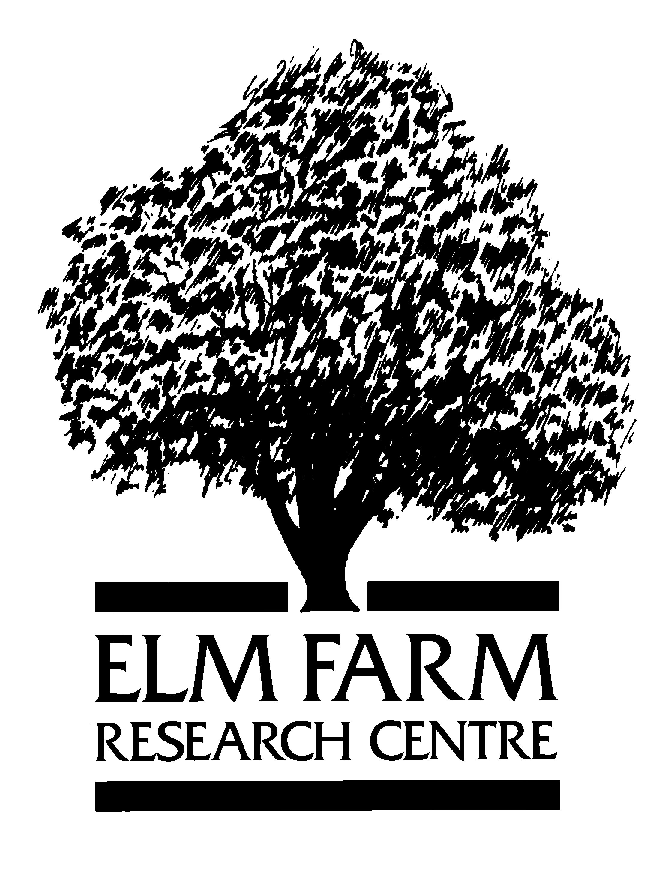
Sheepdrove

Organic Farm
Development of Cattle Housing for
Sheepdrove Organic Farm

Lois Philipps & Fergus Clark

Interim Report
October 2003.

- Background.

  - Housing criteria should be based around the fundamental concept that “the housing should be adapted to meet the needs of the animal and NOT the adaptation of the animal to meet the needs of the building”.

  - In practice this means housing conditions that meet the needs of the animals in terms of their social behaviour, eg subdominant animals must have the opportunity to withdraw or avoid higher status animals. This may mean greater space at feeding and watering sites greater space per cow alley widths sufficiently wide to allow free passage and the avoidance of dead ends. Good husbandry skills and herd stability are also important. (3rd NAHWOA Workshop 2002)

  - In order to achieve these criteria there are two areas under consideration, improvements to the existing sheds to house the spring calving herd and a new building for the autumn calving herd.

- Objectives.

  - To investigate ways of improving existing cattle sheds.

  - To confirm the site of the new cattle building

Existing building.

  - Objective.

    - To improve existing facilities for spring calving herd and reduce the incidence of pneumonia.

  - Actions taken.

    - Silsoe Research Institute modelled airflows. The possible changes to the existing structures were discussed.

Key Findings.

    - Reasonable air movement through out the building providing adequate ventilation. The lowest values were recorded in bay 5.

    - Rather than ventilation being a problem humidity was cited as the most likely cause of the health problems. The reasons for this were identified to be as a result of the lower stocking densities of cattle than the buildings were originally designed for and therefore the lack of ‘sensible heat’ to affect air movement and drying.

Recommendations.

    - To raise the floor levels by infilling the yards with hard core and chalk both currently available on site.

    - To ensure that bedding is managed to avoid increasing humidity particularly at times of the year when atmospheric humidity is high. This may result in removal of straw bedding on 2 or 3 more occasions over the winter.

    - To address the airflow problems within the centre of the shed ducting will be installed.

Provision of new building.

  - Objective.

    - To provide accommodation for autumn calving herd

  - To reiterate EFRC’s recommendations:

    - The new building must be compliant with organic standards.

    - The new building should provide the beef enterprise with highest consideration to animal health and welfare, including social and family group dynamics.

    - The new building must be flexible and allow different configurations of pens for trial purposes.

    - The provision for handling dirty water/slurry must comply with the highest environmental codes.

    - The new building must be able to accommodate gaseous emission guidelines (current or likely).

    - The management of rainwater/clean water from roof area etc must be able to demonstrate a sustainable approach to water usage and conservation.

    - The new building must be able to meet SOF requirements for the beef enterprise in the short, medium and long term. The design should be able to accommodate expansion of the herd size as the business develops without compromising any of SOF’s objectives for animal health & welfare and environmental impacts.

