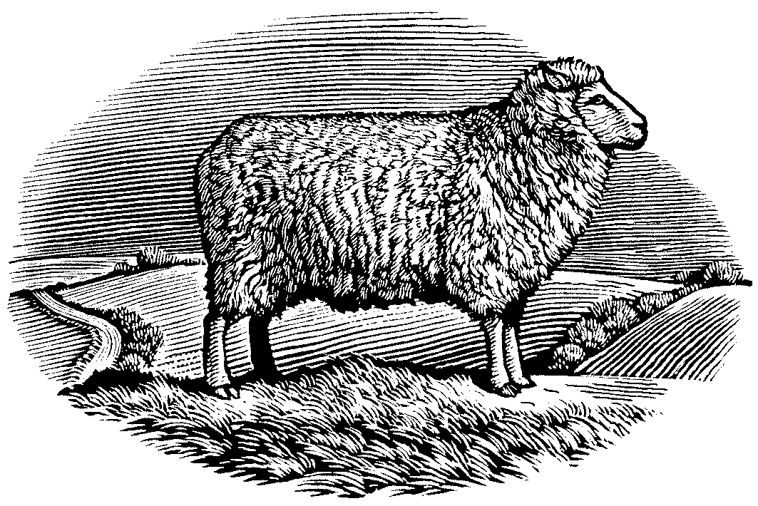

Sheepdrove Organic Farm / Elm Farm Research Centre
Research at Sheepdrove Organic Farm

Interim Report – Birds. JPBall Nov2003.
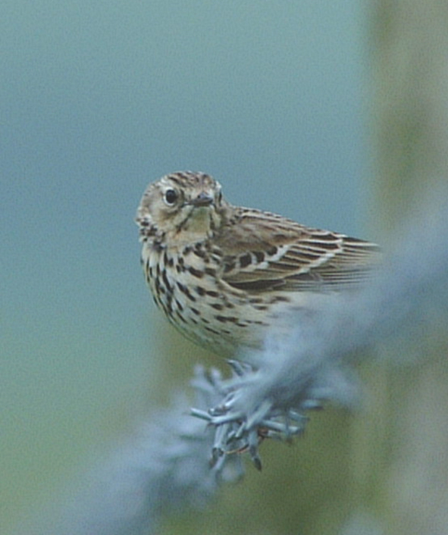

Project: SOF 024 Birds Benchmark Study

Abstract
Sheepdrove’s bird community includes many birds of conservation concern, in a substantial area of land farmed organically. The standard BBS (Breeding Bird Survey) sampling method was used to record bird species and counts at Sheepdrove Organic Farm during 2003 in 3 sampling areas (each 1km square). Normally BBS is only carried out during breeding season, but to gather broader data, extra survey visits were also carried out including autumn and winter surveys for records of winter migrants. Many common species were observed, and often those expected at farmland, including several species which have declined nationwide - birds of conservation concern on the Red and Amber List of the BTO (British Trust for Ornithology). There was an unusual sighting of Ring Ouzel, and also of Barn Owl, which is often missed during daytime surveys. Due to the extra survey visits, records were taken for winter migrants such as Fieldfare, and the incidence of winter flocks, e.g. of finches and Starling (many of which will be winter migrants). The results of this survey will serve as a benchmark for the biodiversity records of Sheepdrove Organic Farm.

Objective
Produce a benchmark record of the wild birds present at Sheepdrove Organic Farm, using repeatable, well-known methods to produce a set of results which can be referred to and compared in future.

Introduction
This project deals with a prominent group of wildlife noticed by visitors and important to the general public and UK biodiversity as a whole. Research has shown farming practice to be important to birds. Sheepdrove’s developments in farming methods and changes in land use may manifest effects and changes that affect the local success of different species of birds, over the long term.

This benchmark can support the future study of the effect that organic farming - and more specifically the combination of farming methods at Sheepdrove - may exert on the local breeding bird populations. Another point of interest for bird studies, now and in future, includes habitat change; e.g. recently developed conservation strips, the more established Countryside Stewardship features, the new reedbed water treatment system and the new poultry agroforestry system in place.

Method Summary
The BBS surveys are based on walking across 1 kilometre grid squares as marked on Ordnance Survey maps. A pair of transect lines are used to cover the area, each divided into 5 sections of 200 metres length. For this survey 3 different squares were studied: SU3481 at Bockhampton Down; SU3680 at Eastbury Bank and the Agroforestry system; and an offset square where Nut Wood, shelterbelt woodland and the main farm buildings are. Thus the sampling covered a variety of the farm’s habitats.

The square based around the Kindersley Centre area is an exception because it is based on a 1km-square slightly off the OS gridlines, so rather than using OS square SU3581, it would be labelled SU352814. This was to enable BBS sampling to be done near the farm’s most built-up area, and because there was a lack of workable transect lines within nearby OS squares.

Normally BBS is only carried out during breeding season, but to gather broader data and records of winter migrants the surveys were also carried out in autumn and winter. The final surveys of this project are yet to be done, but work will now begin on the data gathered so far.

1) Objective: Establish a detailed record of observations using the BBS survey method.
BBS sampling methods were used. BBS bird surveys took place in April, May, June, September and the last set of surveys will be carried out in January 2004. Habitat surveys of the sampling transects were done in early April.
Dates surveyed 2003: April 4th, 7th, 9th; May 20th, 22nd, 23rd; June 25th, 26th, 30th; October 20th, 21st, November 6th. The next survey target dates are January 5th, 6th, 7th.
2) Sub-objective: Provide a valuable benchmark study in preparation for future monitoring.
This sub-objective will be fulfilled by completing a report before February 2004, after which, ideally, the survey can be repeated to establish annual monitoring. Because the BTO sampling methods are nationally-recognised this project approach will be repeatable. The long-term aim of Sheepdrove Organic Farm is to have continuous monitoring of birds, and BBS methods can contribute strongly to this. An Excel spreadsheet will to enable year-by-year analysis and comparison of results. BBS input is now ‘digitised’ by BTO enabling direct data transfer to BTO via email or their website, thanks to funding from RSPB, but is only accessible by registered BBS recorders, which Jason is not. Of course this web-based system is actually only designed to deal with 2 visits per year. Jason will investigate the possibility of help from BTO in providing data analysis tools, such as a copy of the spreadsheet BTO use. (In recent contact with Project Coordinator Mike Raven.)
3) Sub-objective: Create a spreadsheet of all the 2003 bird observations data on Microsoft Excel.
This was not done straight after survey sessions, but would have been desirable. The spreadsheet will be finalised mid-December 2003 and early January 2004, to enable the summary report to be written in mid-February 2004.
4) Sub-objective: Produce a report summarising the findings for 2003 including a map of key species observations. Farm staff have contributed some non-survey observations, and a number of notable observations taken ad-hoc will be mapped (hopefully BBS can be combined with these at a later stage). The summary report will help make this a meaningful benchmark study which can be referred to in future.

Results
The final surveys of this project are yet to be done, but work will now begin on the data gathered so far.
At a later stage, a summary can be set out like this:
Altogether more than ** birds were observed of ** species.
** species were seen in the ** visits compared to ** species in the ** visits.
The species seen in the most transect sections were: ** (** sections in total) and ** (** sections in total). The highest counts were for **.

Discussion
Although a standard methodology was used, there are limitations within that method which should be considered, perhaps the main one being that this is a transect sample. So the results do not give a comprehensive list of the species present at Sheepdrove.

The main objective of this study was to produce a benchmark, and indeed this is a brief snapshot of the variety of birds at Sheepdrove from a single season’s observations.

For the long term national surveys by BTO, the same km grid squares are sampled year after year, and are randomly selected across different parts of the UK. In future, sampling here should be done at the same places to maximise comparability. The square based around the Kindersley Centre area is an exceptional one because it is based on a 1km-square slightly off the OS gridlines, and perhaps for increased comparability only proper OS grid squares should be used.

How much can we say about the birds at Sheepdrove, using the results of this study? While it does collect species and numbers, there are limits to what we can say about how good the farm is for birds, and questions such as “is organic good for birds?” cannot be answered from this study.

With combined studies linking organic and non-organic plots we can attempt to answer the question of organic farming effects. With studies based only at Sheepdrove, with its intrinsically unique characteristics, we can more easily explore the question “is Sheepdrove good for birds?” but we still need to employ more detailed methods of investigation.

In future we may be able to connect some of the findings from this project with specific methods of bird study, such as the CBC (Common Bird Census). While the BBS does record habitat alongside the transect lines, and links this with relative abundance of birds, the BBS method does not measure the way birds use territories, e.g. differences in activity across field centres or around features such as hedges.

Despite the name of the method – ‘Breeding Birds Survey,’ we cannot assume that the zones of highest counts were at the best breeding habitat. Birds observed during breeding season are those more likely to be part of Sheepdrove’s breeding bird community, but these results do not necessarily indicate that all are currently breeding at Sheepdrove Organic Farm. One notable exception are Rooks, whose breeding colonies were easily recorded.

However it can perhaps be argued that generally, the birds seen are present due to benefits they can gain here, e.g. food or water. Assessing the value of the farm to birds is not really possible within this method, but it does give some indication. In particular, birds seen within the farm and not simply flying at a distance can surely be considered as users of the farm. This is more likely to be true with birds recorded as stationary (no arrow noted by observer) or those landing or taking off (close arrow noted by observer) on Sheepdrove’s fields. Recorded notes also indicate how close to the transect the birds are seen (either within 25m, 100m, beyond 100m and in flight) which can help in assessing whether birds recorded were on Sheepdrove land or neighbouring land, when referring also to transect maps.

Further studies can be carried out to investigate issues such as the effect of habitat, field management, and organic farming. Weather data from Sheepdrove can be used to investigate the effect of different weather on the success of sampling, both during a single season, and between years.

Conclusions
Sheepdrove Organic Farm now has a benchmark sample of bird species in 3 sampling areas around the farm, which includes a good variety of the common UK birds.

A new species record for Ring Ouzel was obtained. However, due to the natural limitations of the survey methods, many species at Sheepdrove were not recorded in this study, e.g. Little Owl.

The results can be used to inform further study, either repeating the same sampling, or with added features to enable the study of different environmental/habitat factors.

This study will soon be re-evaluated once data has been fully collated and analysed. We can then better understand the quality of the data, make better inferences and further discuss any arising implications.

APPENDIX

Birds of Conservation Concern: 2002-2007.

RED LIST SPECIES - HIGH CONSERVATION CONCERN
Table Source: BTO. http://www.bto.org/psob/redlist.htm Note (1) means UK population >10,000 pairs
Those 16 species highlighted have been observed at Sheepdrove Organic Farm during 2002-03.
Species | IUCN | HD | BDp | BDr |  | BDMp | BDMr | SPEC  2 or 3 | BR | BL | WL | BI | WI
Species | Red Listing Criteria |  |  |  |  | Additional Amber-Listing Criteria
Bittern |  | * | * | * |  |  |  | * | * |  | *
Common Scoter |  |  |  | * |  | * |  |  | * |  | *
White-Tailed Eagle |  | * |  |  |  |  |  | * | *
Hen Harrier |  | * |  |  |  |  |  | *
Black Grouse |  | * | * |  |  |  | * | *
Capercaillie |  |  | * | *
Grey Partridge (1) |  |  | * |  |  |  |  | *
Quail |  | * |  |  |  |  | *
Corncrake | * | * |  | * |  |  |  |  |  | *
Stone-Curlew |  |  |  | * |  |  |  | * | *
Black-Tailed Godwit |  | * |  |  |  | * |  | * | * |  | * |  | *
Red-Necked Phalarope |  | * |  |  |  |  |  |  | *
Roseate Tern |  |  | * | * |  |  |  | * | *
Turtle Dove (1) |  |  | * |  |  |  |  | *
Nightjar |  |  |  | * |  |  |  | * |  | *
Wryneck |  | * | * | * |  |  |  | * | *
Lesser-Spotted Woodpecker |  |  | *
Woodlark |  |  |  | * |  |  |  | * |  | *
Skylark (1) |  |  | * |  |  |  |  | *
Ring Ouzel |  |  | * |  |  |  | *
Song Thrush (1) |  |  | *
Grasshopper Warbler (1) |  |  | * |  |  |  | *
Savi’s Warbler |  |  | * |  |  |  |  |  | *
Aquatic Warbler | * |  |  |  |  |  |  |  |  |  | *
Marsh Warbler |  |  | * |  |  |  | * |  | *
Spotted Flycatcher (1) |  |  | * |  |  |  |  | *
Marsh Tit (1) |  |  | *
Willow Tit (1) |  |  | *
Red-Backed Shrike |  | * | * | * |  |  |  | * | *
Starling (1) |  |  | *
House Sparrow (1) |  |  | *
Tree Sparrow (1) |  |  | *
Linnet (1) |  |  | *
Twite |  | *
Scottish Crossbill | * |  |  |  |  |  |  |  |  |  |  | *
Bullfinch (1) |  |  | *
Yellowhammer (1) |  |  | *
Cirl Bunting |  |  |  | *
Reed Bunting (1) |  |  | *
Corn Bunting (1) |  | * | * |  |  |  | *

RED LISTING CRITERIA
IUCN | Globally Threatened
HD | Historical population decline in UK during 1800-1995
BDp | Rapid (>50%) decline in UK breeding population over last 25 years
BDr | Rapid (>50%) contraction of UK breeding range over last 25 years

Birds of Conservation Concern: 2002-2007.

AMBER LIST SPECIES - MEDIUM CONSERVATION CONCERN
Table Source: BTO. http://www.bto.org/psob/amberlist.htm
This extract of the full BTO list are those recorded at Sheepdrove Organic Farm during 2002-03.

Species |  |  | HDrec | BDMp | BDMr | WDMp | SPEC  2 or 3 | BR | BL | WL | BI | WI
Mute Swan |  |  |  |  |  |  |  |  |  |  | *
Scaup |  |  |  |  |  |  | * | * |  | *
Red Kite |  |  | *
Montagu's Harrier |  |  |  |  | * |  |  | *
Kestrel |  |  |  | * |  |  | *
Merlin |  |  | *
Peregrine |  |  |  |  |  |  | *
Lapwing |  |  |  | * |  |  |  |  |  |  |  | *
Curlew |  |  |  |  |  |  | * |  |  |  | * | *
Green Sandpiper |  |  |  |  |  |  |  | *
Black-Headed Gull |  |  |  | * |  |  |  |  | *
Common Gull |  |  |  | * |  |  | * |  | *
Lesser Black-Backed Gull |  |  |  |  |  |  |  |  | * |  | *
Herring Gull |  |  |  | *(1) |  |  |  |  | *
Stock Dove |  |  |  |  |  |  |  |  |  |  | *
Cuckoo |  |  |  | *
Barn Owl |  |  |  |  | * |  | *
Short-Eared Owl |  |  |  |  |  |  | *
Green Woodpecker |  |  |  |  |  |  | *
Swallow |  |  |  |  |  |  | *
House Martin |  |  |  | *
Tree Pipit |  |  |  | *(1)
Meadow Pipit |  |  |  | *(1)
Yellow Wagtail |  |  |  | *
Grey Wagtail |  |  |  | *
Dunnock |  |  |  | *
Stonechat |  |  |  |  |  |  | *
Fieldfare |  |  |  | * |  |  |  | *
Redwing |  |  |  |  |  |  |  | *
Mistle Thrush |  |  |  | *
Willow Warbler |  |  |  | *
Goldcrest |  |  |  | *(1)
 | AMBER LIST CRITERIA
 | HDrec | Historical population decline during 1800-1995, but recovering: population size has more than doubled over last 25 years
 | BDMp | Moderate (25-49%) decline in UK breeding population over last 25 years
 | BDMr | Moderate (25-49%) contraction of UK breeding range over last 25 years
 | WDMp | Moderate (25-49%) decline in UK non-breeding population over last 25 years
 | SPEC  2 or 3 | Species with unfavourable conservation status in Europe  (SPEC = Species of European Conservation Concern)
 | BR | Five-year mean of 1-300 breeding pairs in UK
 | BL | >50% of UK breeding population in 10 or fewer sites, but not BR
 | WL | >50% of UK non-breeding population in 10 or fewer sites
 | BI | >20% of European breeding population in UK
 | WI | >20% of NW European (wildfowl), East Atlantic Flyway (waders) or European (others) non-breeding populations in UK

Sheepdrove Organic Farm / Elm Farm Research Centre
Sheepdrove Organic Farm Research Programme
Reviews for the Annual Report – September 2003

Review Points:
- The contribution that this project is making to understanding and developing the SOF goals of high quality organic food production whilst delivering high standards of animal health & welfare and meeting biodiversity and environmental objectives.
- The primary objective.
- Resources used.
- Principle results/findings with body of results being presented in annex.
- Any media profile or publications.
- Outline development or continuation work.
- Possible collaborative projects and external sources of funding.

Project: SOF 024 – Birds, Benchmark Study
- This project will contribute to the understanding of Sheepdrove’s biodiversity, for a group of fauna popular with the general public, and featured in the government’s ‘Quality of Life Barometer.” Farmland birds are a core biodiversity indicator on the farm, and the results from this study should help assess the effects of conservation efforts.
- Results will be a benchmark, derived from easily repeatable methods.
- No equipment has been bought for this project but some books were bought on birds during 2002 and 2003, which will aid the study of birds at Sheepdrove.
- The transect method will enable a comparison between different sections along a sampling line, so the results may indicate habitat association for farmland birds during breeding season, and are expected to show a good range of diversity in species.
- No media profile or publication.
- The BBS method can be used year after year, and comparisons can be made. Extending the sampling outside the normal season is a valid method of sampling wintering birds also.
- Data will be sent to BTO to contribute to BBS results for the UK, which are studied for the current year and longer-term trends.

Method Summary
1) Establish a detailed record of observations using the BBS survey method.
BBS sampling methods will be used. Farm staff will be consulted for their observations. Observations taken ad-hoc and by BBS will be mapped. BBS bird surveys will take place in April, June, September and December. HABITAT SURVEYS of the sampling transects will be done late March/early April = 6 hours approx. SAMPLING 5 sets of 3 sessions, each 2 hours long = 30 hours.
(Target Dates for 2003: April 8th, 9th, 10th; May 20th,22nd, 23rd, June 23rd, 24th, 25th; September 16th ,17th, 18th; and December 9th, 10th, 11th.)
2) Provide a valuable benchmark study in preparation for future monitoring.
This sub-objective will be fulfilled by completing a report before February 2004, at which point ideally the survey can be repeated to establish annual monitoring. An Excel spreadsheet will to enable year-by-year analysis and comparison of results. Because the BTO sampling methods are nationally-recognised and quite straightforward, this project approach will be repeatable. The long-term aim of Sheepdrove Organic Farm is to have continuous monitoring of birds, and BBS methods can contribute strongly to this. BBS should become ‘digitised’ in future, enabling direct data transfer to BTO via email or their website.
3) Create a spreadsheet of all the 2003 bird observations data on Microsoft Excel.
This will be done monthly for all observations. The spreadsheet will be finalised mid-December 2003 and early January 2004, to enable the summary report to be written in mid-February 2004.
4) Produce a report summarising the findings for 2003 including a map of key species observations. The summary report will help make this a meaningful benchmark study which can be referred to in future.

