Soil Monitoring Programmes at
Sheepdrove Organic Farm 2003-2004

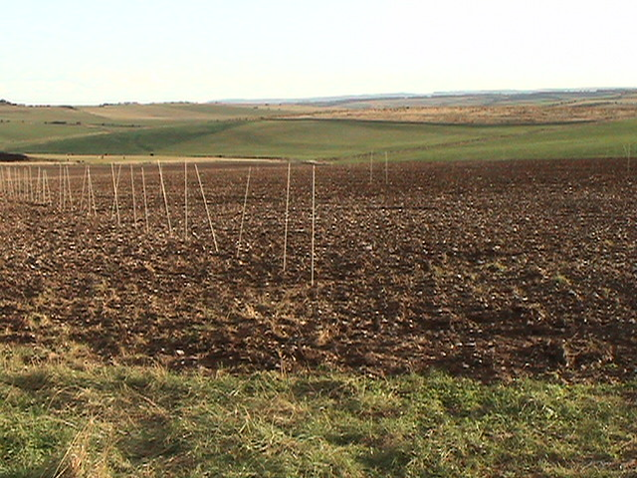

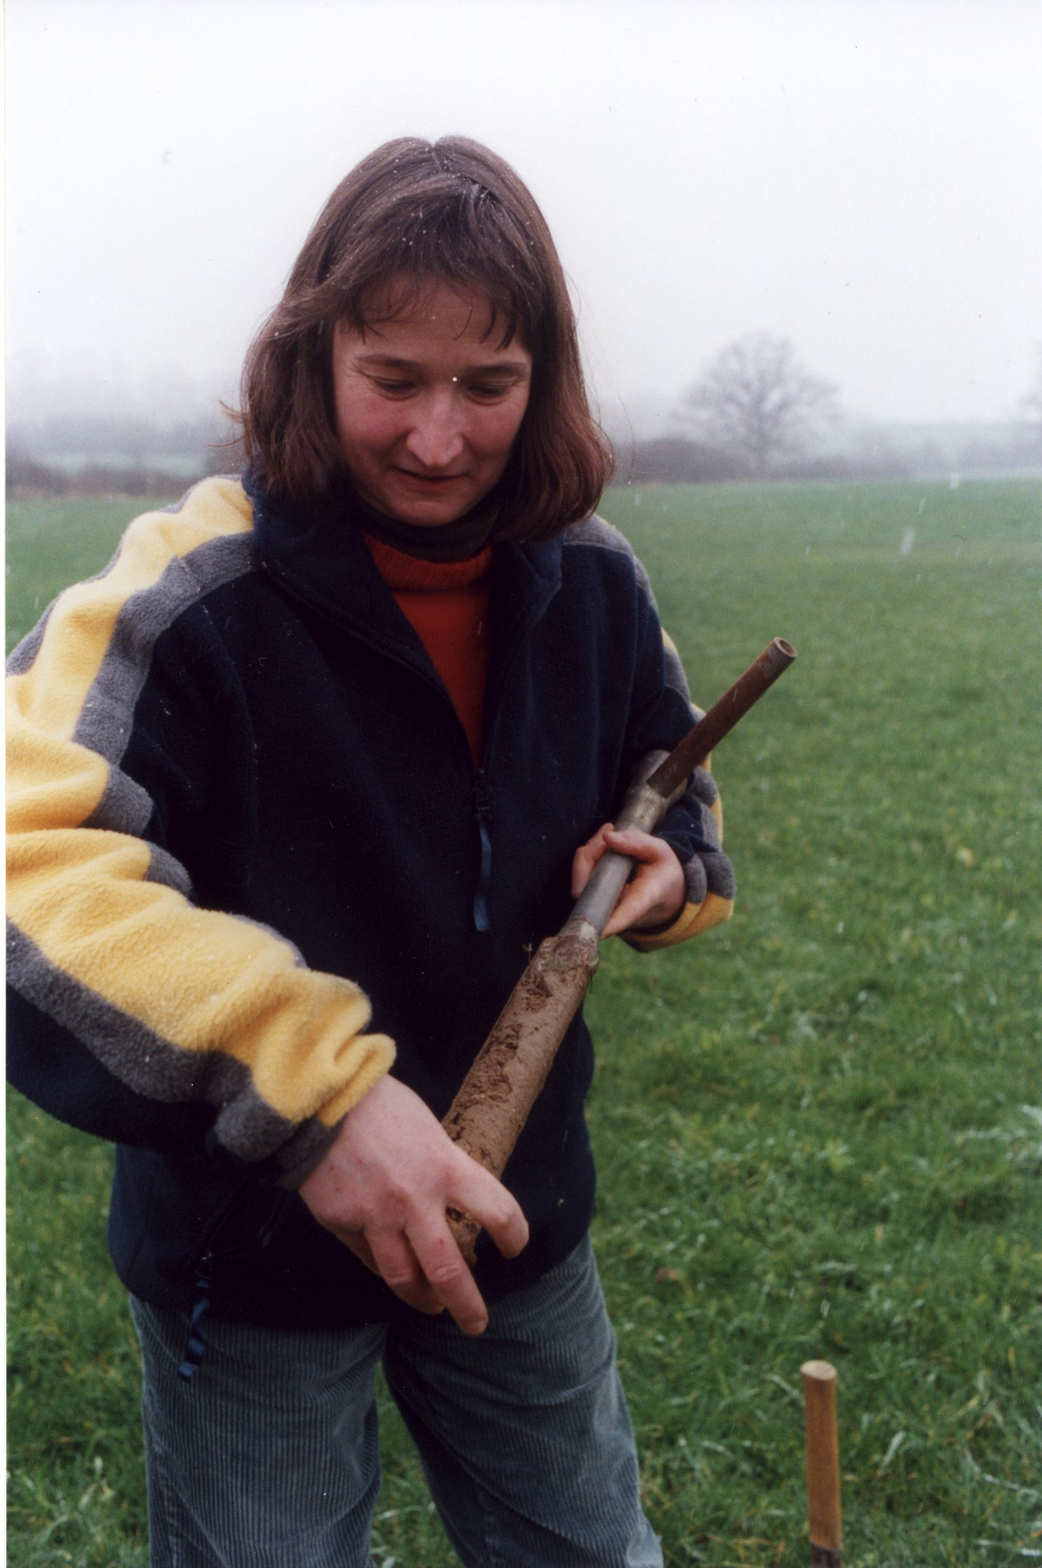

Sheepdrove
Organic Farm



November 2004

Executive Summary

Soil is a finite resource and is increasingly under pressure from a variety of human activities for example agriculture, construction and mineral extraction. However, for generations soil has been the basis for agricultural production, a raw material, which with sensitive management can be used year after year.

Sheepdrove Organic Farm is striving to reach its goal, of developing a high quality food production system with adherence to strict policies of high animal health and welfare and increasing biodiversity and environmental benefits.

Objective 1 is to implement a rolling soil analysis programme so that every year fields entering or leaving the fertility-building phase are sampled for soil nutrient status. The information gathered from this monitoring programme ensures that the farms soil and nutrient resources are used optimally.

Objective 2 is to assess the differential nutrient statuses between stable habitats, represented by old woodland and pasture, and more disturbed/dynamic habitats that occur within the ley-arable rotation.

Objective 3 is to measure the biological activity within the soil, by using a relatively quick and simple technique to measure gross soil respiration.

Objective 4 is to quantify the extent of the farming practices and associated activities are leading to increased nutrient loadings.

The average soil organic matter levels are twice the norm for an equivalent conventional farming system.

The major plant nutrients are higher than found on most organic farms

The combination of monitoring both a mature stable ecosystem (mature woodland) and a developing organic rotation is novel.

At the peak of soil biological activity, all sites demonstrated high levels of biological activity as measured by respiration of carbon dioxide.

The soil-monitoring programme has been a useful vehicle for engaging with other research teams operating at SOF.

There remains a considerable amount of developmental work needing to be done in the areas of understanding soil biodiversity and nutrient hot spots.

It is important to continue with the existing monitoring programme sampling at both the beginning and end of the fertility building phases and the seven reference sites for at least the next 3-5 years.
Soil Monitoring Programme
Sheepdrove Organic Farm 2003-2004

1. Background

Soil is a finite resource and is increasingly under pressure from a variety of human activities for example agriculture, construction and mineral extraction. However, for generations soil has been the basis for agricultural production, a raw material, which with sensitive management can be used year after year.

Organic farming practices seek to develop systems, which maintain or build soil fertility rather than exploiting the soil resource, by enhancing natural biological, chemical and physical processes within the lithosphere.

In striving to reach its goal, of developing a high quality food production system with adherence to strict policies of high animal health and welfare and increasing biodiversity and environmental benefits, Sheepdrove Organic Farm (SOF) needs to have an understanding of the soil and its processes.

Soil health is at the heart of successful organic production. The definition and measurement of soil health has been hotly debated in recent years by soil scientists. There is a general understanding that healthy soil requires a diverse and resilient population of soil micro and meso-organisms. There are numerous techniques available to measure both diversity and abundance. Soil respiration is an important aspect of soil quality and a good indicator of soil fertility. The development of the Solvita soil-life test kit has provided a tool to evaluate soil microbial respiration rates in an efficient and cost effective manner.

2. Objectives

The objective of this programme is to increases our understanding of soil and its processes at SOF. Whilst, evaluating the farming systems impact on the soil resource and environmental implications of the farming practices. The programme has four sub objectives:

SOF001 On-going soil analysis programme
This sub objective uses soil analysis to examine the overall health of the soil and its chemical balance providing an overview of trends, identifying deficiencies before they become major problems. The strategy for this on-going programme is to implement a rolling analysis programme so that every year field with entering or leaving the fertility-building phase are sampled for soil nutrient status. The information gathered from this monitoring programme ensures that the farms soil and nutrient resources are used optimally.

SOF 002 Monitoring of seven reference sites.
These reference sites represent a range of biotopes on the SOF estate and encompass both farmed and non-farmed areas. The objective of this component is to assess the differential nutrient statuses between stable habitats, represented by old woodland and pasture, and more disturbed/dynamic habitats that occur within the ley-arable rotation. This provides crucial information on the impact that the SOF farming system is having on the soil’s ecosystem. The information on soil nutrient status also informs the terrestrial invertebrate programme.

SOF 003 Soil biodiversity
This project measures the biological activity within the soil, by using a relatively quick and simple technique to measure gross soil respiration.

SOF004 Monitoring ‘Nutrient Hotspots’
Within the context of the whole farm plan (WFP) three operations at SOF have been identified as potential nutrient hot spots. The objective of this project is to quantify the extent of the farming practices and associated activities are leading to increased nutrient loadings.

3. Materials and Methods

For objectives 1 and 2 soil samples will be taken between October and March each year, from fields entering the arable phase of the rotation or entering the ley phase of the rotation and the four reference fields and the three additional non farmed sites added in 2004.

Soils will be sampled according to standard sampling procedure from a ‘W’’ In the field avoiding gate ways headland trough or feeder areas etc (MAFF 2000)

At least 25 sub cores will be taken from each 4 ha. Samples will be taken using a gouge auger.
Arable land will be sampled to a depth of 20cm.
Grassland will be sampled to a depth of 15cm

Sufficient samples from each field will be taken and homogenised and a sub-sample taken (at least 300g). These soil samples will be processed through OAS Soil Analysis Service, using Natural Resource Management (NRM) Limited laboratories.

Using standard analytical methods, as described in the MAFF (now Defra) reference book 427,soil samples will be analysed for:
pH
Available P reported as mg/l and defra indicies
Available K reported as mg/l and defra indicies
Available Mg reported as mg/l and defra indicies
Organic matter (Walkley Black, wet Oxidation) reported as % w/w

Where samples are taken from fields with suspected trace element problems the following additional analyses will be requested.
Available cobalt (Co) using acetic acid extraction and reporting as mg/l dry basis
Available copper (Cu) using EDTA extraction reporting as mg/l
Total selenium (Se) reported as mg/kg
Total iodine (I) reported as mg/kg dry basis

For objective 3, soil respiration measurements, the following methodology has been employed.

Soil samples will be taken between March and October each year from the reference sites.

Samples will be taken when the soil is in a moist condition, it may be necessary to moisten the soil during prolonged dry periods. Sub samples will be taken large stones will be removed and the sample vessel will be half –filled.

Using the treated paddle provided with the ‘Solvita’ test kit the paddle will be inserted into the soil with the gel side facing the clear side of the sample vessel. The lid eill be replaced and the samples will be stored at room temperature out of direct sunlight for 24 hours.

After 20-28 hours the paddle colour can be compared with the colour key. This key has been calibrated to estimate soil biological activity using soil respiration and estimated mineralization rates as indicators.

For objective 4 the nutrient hot spot monitoring it had been intended to use ceramic cup water samples as described in EFRC Research Note 19. However, a review of the current methodologies used for measuring nitrate leaching losses and following extensive discussions with CEH, March 2004, there are now considerable questions over the reliability of this approach of heavily fissured shallow chalk sites such as those at Sheepdrove Organic Farm. The CEH team have experienced difficulties in obtaining samples from porous cups when applying 3 bar pressure, the EFRC equipment is only capable of applying 0.8 bar pressure.

Given that CEH has a flagship project based at Sheepdrove, the LOCAR Project, EFRC and CEH have pursed additional funding sources to allow a joint project to be developed. The first round of this bid will to be announced by 1st December 2004 if successful a full proposal will be submitted by February 2005 and if successful a full-scale water, environment and agronomic project would start at the reaching of field capacity in 2005.

4. Results

SOF001 On-going soil analysis programme

Soil samples and subsequent analysis have been completed on key points in the rotation for three harvest years, 2002, 2003 and 2004, in accordance with the established protocols.

The majority of the fields based round the old Warren Farm site have been sampled.

Out lying fields are being included in the on-going programme as they enter either the start of the fertility building phase or at the completion of the fertility building. It is expected that this will take a number of years to have complete coverage of the whole farm.

Three-year averages have revealed pH values of 8.0. This pH reflects the under lying geology of the farm. At pH 7.2 and above there is a tendency towards nutrient lock up, both of major and trace elements. The use of FYM composts and regular soil analysis will help to address these issues.

The average soil organic matter levels for the same period is 6.2%. This is a good level of organic matter and consequent biological activity and fertility. Many conventional farms with similar soil types and history will typically have less than 3.0% organic matter. The levels recorded are possibly due to the past cropping, particularly on the old Warren Farm site, that would have been in a grassland rotation and received quantities of FYM, coupled with the use of compost from the SOF based compost enterprise.

There is no evidence that elevated levels of soil organic matter are detrimental to agronomic production, in deed in terms of soil protection higher levels of soil OM are major influence on reducing soil erosion. However, it is worth monitoring OM changes in the long term to establish if there is a maximum range of OM that can be tolerated.

The degree to which soil erosion might be of concern at SOF is being investigated as part of the CEH LOCAR project in the winter of 2004/05. This has been instigated as a result of EFRC liaising with the LOCAR team during the course of 2004.

The changes in both pH and soil organic matter levels with respect to position in the rotation conform to the expected pattern, both pH and OM being reduced after a period of arable cropping. Conversely pH and particularly OM levels increase as a field leaves the fertility building or ley phase of the rotation. The biggest reduction in pH is as a result of poultry being on the site, this conforms to expectation as the poultry excreta is acidic.

The Gunters Down samples have been included in the sampling strategy (2004) as the performance of the field was causing some concerns. Some previous soil analysis had revealed areas of lower pH this was confirmed by the type of vegetation growing in areas of the field. The lower than average OM levels may be a reflection of poor aeration, that in turn leads to poor biological activity. To correct this a programme of improving aeration/drainage and building OM needs to be introduced.

The averages for the major plant nutrients are as follows, available P is 24.1mg/l, K it is 197.0 mg/l and Mg is 65.3mg/l all these values are within the index 2. These nutrient levels are higher than found on most organic farms. (OAS data and MAFF OF0114)

Figure 1 shows the impact of rotational phase on soil pH and organic matter levels
Figure 2 shows the variation of soil P levels over time and rotational position

It has been well documented in a number of conversion studies, notably Terrington and Ty Gwyn and associated linked farms, that soil P and K levels fall, often dramatically, during conversion and then reach a lower equilibrium in the years following conversion. However, the SOF soil analysis data does not support this trend. This is attributable to previous management policies attempting to maintain ‘conventional’ levels of available soil nutrients.

On some fields P levels are exceeding soil index of 4, this is of concern as the Environment Agency believes that above this level P can be leached from the soil and contribute to a reduction in water quality (either in surface or ground water bodies).

The new management is more in keeping with the underpinning organic principles of recycling nutrients from within the farm system and less reliance of the importation of supplementary nutrients. Therefore it is probable that over the coming years available soil nutrient levels will fall but without detrimental effects on crop performance.

Figure 3 shows the variation of soil K levels over time and rotational position

As with available P potassium (K) levels are higher than would be expected on an organic farm recently having completed conversion. Most of the soils at SOF have a clay loam textural class and it would be expected that mineralization of clay minerals could supply sufficient K for crop requirements coupled with the returning FYM to field of high K off takes eg silage/hay crops.

Figure 4 shows the variation of soil Mg levels over time and rotational position

Magnesium levels are being maintained at an average soil index of 2. In a highly calcareous soil there is a degree of antagonism between cations, such that if calcium was severely limiting soil processes Mg levels would be reduced.

SOF002: Monitoring of seven reference sites.

Soil samples and subsequent analysis have been completed on four reference sites in 2003 W10, W11, W12, W13 .In 2004 three new sites were added Nutwood, The Rough and 100 Acres, these seven sites now correspond to the areas regularly being sampled within the environmental monitoring programme.

Table 1 shows the cropping/vegetation for the reference sites

Harvest Year | W10 | W11 | W12 | W13 | 100 Acres | The Rough | Nutwood
2003 | Spring wheat | White clover | Triticale | Spring wheat | Arable reversion grassland | Permanent pasture | Old mixed woodland
2004 | Winter wheat | White clover | Winter wheat | Winter wheat | Arable reversion grassland | Permanent pasture | Old mixed woodland
2005 | Winter beans | White clover | Winter beans | Forage rape, spring cereal | Arable reversion grassland | Permanent pasture | Old mixed woodland

The same determinants have been measured as for the on-going farm analysis. By using these two strategies it is possible to evaluate year on year variation as well as the influence of rotational position.

Figure 5 shows the organic matter levels for the reference sites for 2003 and 2004

The average organic matter levels for all sites for the two years is similar to the average for the farm (6.4%).

Soil pH levels, over all sites for both years is pH 7. Nutwood has the lowest recorded pH of 6.3 a reflection of the impact of 200 years of leaf litter being incorporated.

Figure 6 shows the available P levels for the reference sites for 2003 and 2004

Phosphorus levels are considerably higher in Nutwood at 54.2mg/l compared with the agricultural sites that range between 20.5 to 30.3 mg/l.

Figure 7 shows the available K levels for the reference sites for 2003 and 2004

All the W sites will have been receiving compost / FYM, this is reflected in the available K.

Figure 8 shows the available Mg levels for the reference sites for 2003 and 2004

Magnesium levels are what would be expected for the history of the reference sites, higher levels occurring where the soil recycling and ecosystem is more stable.

One of the most important aspects of this part of the programme is the range of land use types that it is monitoring. Most agricultural surveys do not include mature woodland and soil analysis within a conservation site does not have the range of agricultural land use that this project has included. This data set will become more valuable and informative over time. It has proved useful to establish these reference sites and an on-going annual monitoring programme is strongly recommended.

SOF 003 Soil biodiversity

The 2004 season was the first year that an attempt to measure soil biodiversity has been made. The method employed has the advantage of being reliable, quick, and cheap whilst being comparable with more sophisticated laboratory methods. Over the biologically active period March to October a number of soil respiration measurements were made with samples taken from the reference sites.

At the peak of soil biological activity, all sites demonstrated high levels of biological activity as measured by respiration of carbon dioxide.

Hundred Acres had the highest levels of CO₂ respiring in excess of 2000 mg CO₂ per kg of soil per week.

Nutwood, The Rough and W11 were respiring up to 1500 mg CO₂ per kg of soil per week.

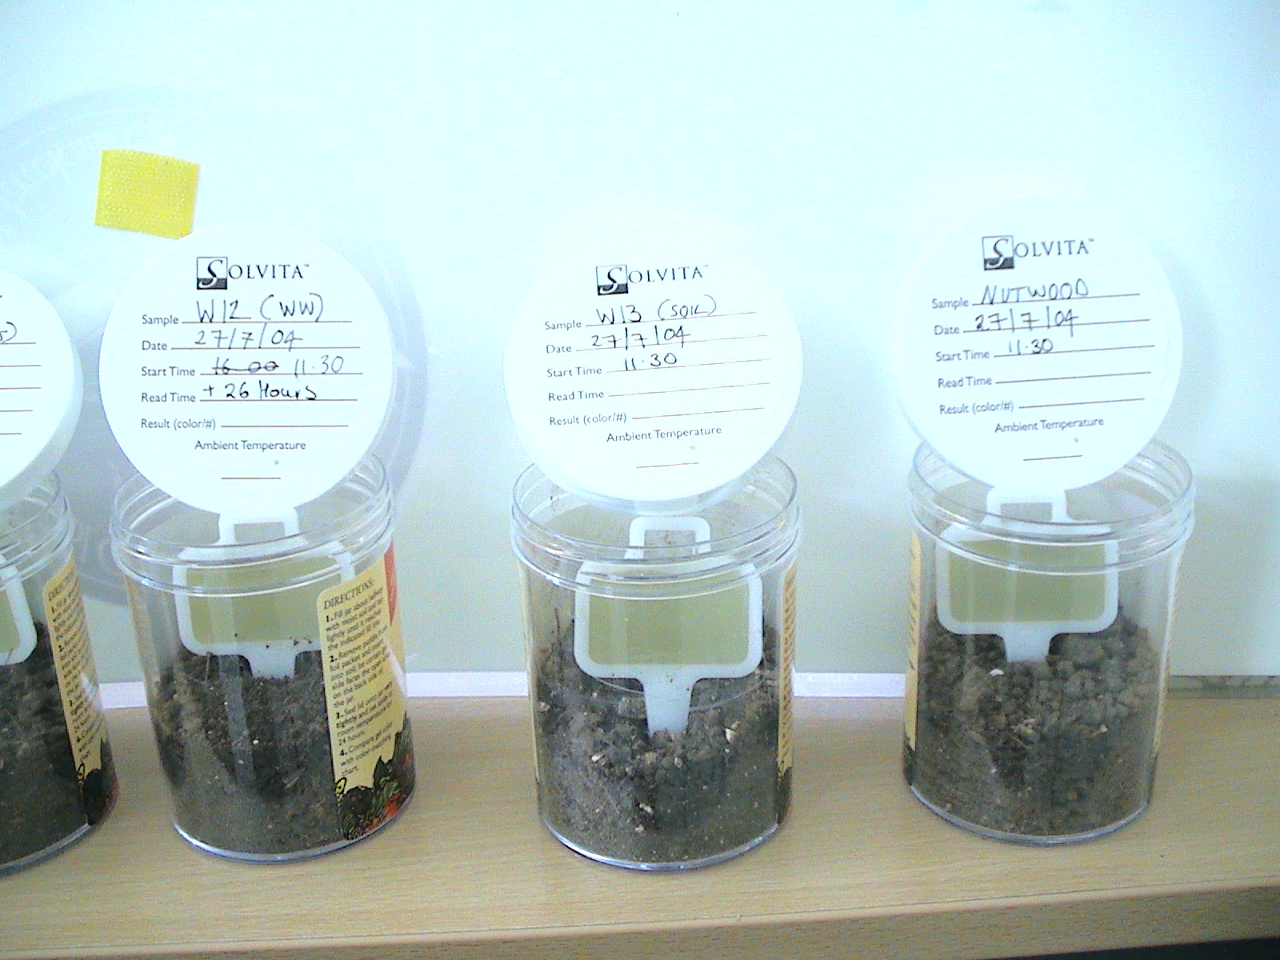

The two cultivated fields W12 and W13 were still biologically active and respiring more CO₂ than would be expected for a conventional arable field with rates of respiration amounting to 750 mg CO₂ per kg of soil per week.

This method has provided a degree of information about the biological activity within the soils at SOF. However, the current methods for measuring respiration rates are to broad to provide information on the different habitats being sampled.

- Conclusions and Recommendations

As the soil is Sheepdrove’s most important basic resource this monitoring programme is critical to developing the SOF system.

The soils monitoring programme has shown real benefits in understanding the agronomic performance of SOF and to reduce its reliance on supplementary nutrients. This in turn will have a economic benefit to the cropping gross margins provided that the yields and quality are maintained. It is therefore important to continue with the existing policy of sampling at the beginning and end of the fertility building phases.

The environmental monitoring programme will be greatly enhanced as the information about the soil processes increases. As the environmental monitoring of transects across the different biotopes includes vegetation, ground dwelling invertebrate and key indicator species (birds, butterflies and moths) all of which are inter related to the soil processes and function. A healthy soil produces healthy plants healthy animals and a healthy environment.

The soil-monitoring programme has been a useful vehicle for engaging with other research teams operating at SOF. This has lead to a significant proposal being submitted with two new collaborating partners.

There remains a considerable amount of developmental work needing to be done in the areas of understanding soil biodiversity and nutrient hot spots. Firstly by continuing with the respiration measurements and secondly developing a research programme(s) with Reading University or others to look at diversity and abundance of soil organisms along with function and resilience.

